Multiple Choice Quizzes
Below are a series of multiple choice quizzes on healthy eating, our existing which you can use to test your knowledge on a variety of topics that you have covered in class. Passing a quiz will also award you with a printable certificate!

Log into

Food A Fact Of Life: www.foodafactoflife.org.uk
Eat Well
- The Eatwell Guide quiz
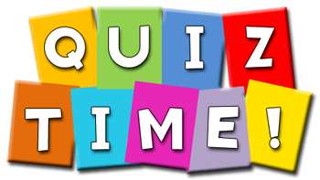
- Eight tips for healthy eating quiz
- Healthy hydration quiz
- 5-A-DAY quiz
Energy and nutrients
- Energy balance quiz
- Energy quiz
- Dietary fibre quiz
- Nutrients quiz
- Nutritional needs through life quiz
- Dietary Reference Values quiz
- Hydration quiz
Diet and health
- Diet and health quiz
- Unpleasant reactions to food quiz
- Healthy teeth quiz
Nutrition labels
- Food labelling quiz
Digestion
- The digestion process quiz
Activity
- The benefits of physical activity quiz
- Sports nutrition quiz
- Physical activity guidelines quiz

