Working in Early Learning and Childcare — HX1V 75
Outcome 2
- Describe the skills, knowledge and values required to work in the Early Learning and Childcare sector.
Development and Wellbeing of Children and Young People — HC3C 45
Outcomes 1 and 2
1. The principles of development for children and young people
2. The principles of wellbeing for children and young people
Children and Young People: Rights and Protection — HC38 45
Outcomes 1 and 2
- Describing children and young people’s rights to provision.
- Describing children and young people’s rights to protection.
- Describing children and young people’s rights to participation.

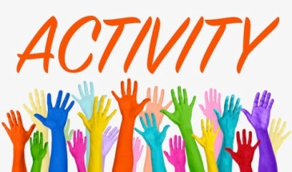
Watch this short video that will explain to you the topic that you will be investigating.

www.youtube.com (6.03 mins)

Adverse Childhood Experiences (ACEs): Impact on brain, body and behaviour•
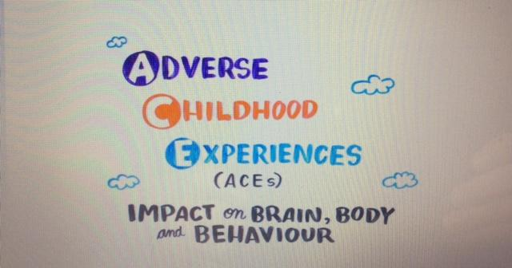
The illustrations on the next page outline what you will learn about.

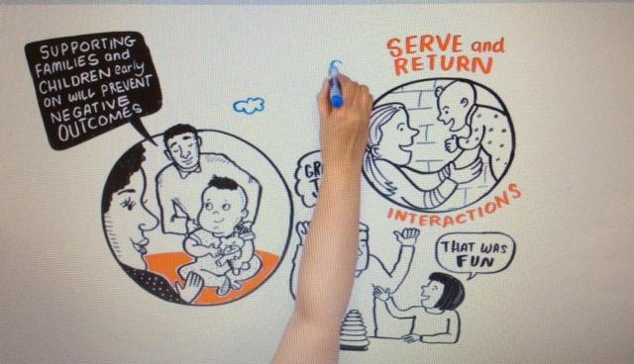
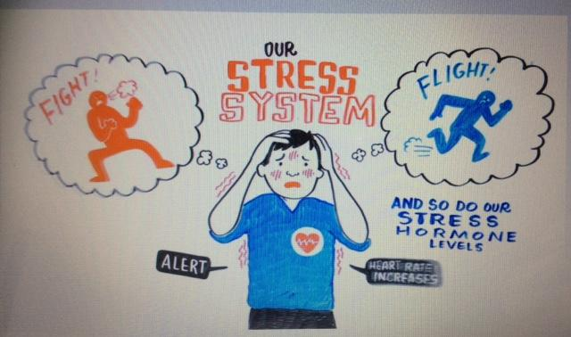
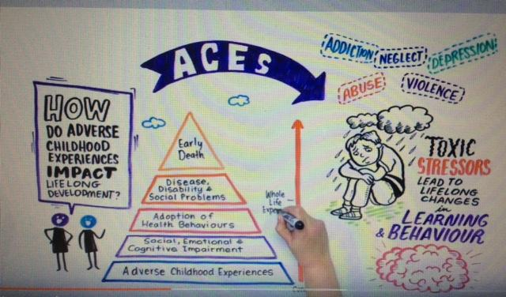
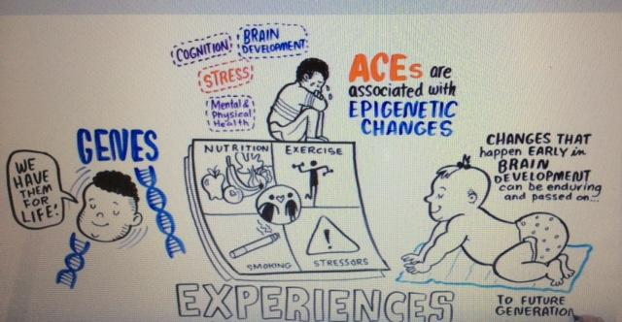
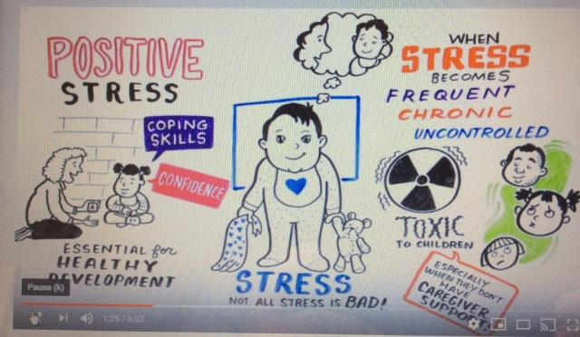
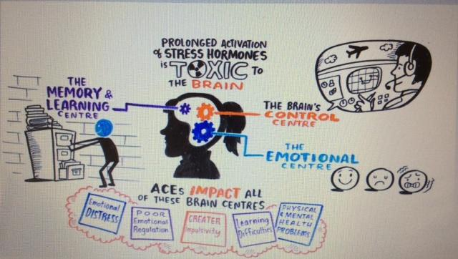
Now that you have had your introduction to Adverse Childhood Experiences (ACE’s) use the grid below identify some key facts. The first one is done as an example.
When stress becomes frequent, chronic or uncontrolled it can become toxic for developing children

Watch this short You Tube presentation (4.17 mins)

Adverse Childhood Experiences - NHS Health Scotland
NHS Health Scotland

NHS Health Scotland has produced this short animation to contribute to raising awareness about the impact of childhood adversity. Its aim is to stimulate thinking and discussion about what action can be taken to both prevent and respond to early adversity.
Produce a short report that will explain the impact of Adverse Childhood Experiences can have on child development and health.
The sentence starters on the following pages will help you to structure the report.
Adverse Childhood Experiences
What happens as a child has a huge impact on a child’s future health and wellbeing for the rest of their lives.
Some children grow up in a happy supportive environment where positive relations make them feel safe. Others grow up facing difficulties which .............

These experiences Adverse Childhood Experiences are called ACE’s. Studies carried out in America show stressful events in a child’s life can …………………

These stressful experiences in childhood include ……………….

The more ACE’s a child experiences in childhood can put children at risk of suffering from ……………

N Scotland more than 26,000 people live in poverty which can impact on life outcomes. Other inequalities impact on life outcomes such as …………………….

There are thing you can do to prevent ACES such as ………..

When working with children there are strategies you can put in place to support children who have experienced ACES ………………………………..

Introduction to Adverse Childhood Experiences
Early Trauma Online Learning Duration: 50 minutes
https://www.acesonlinelearning.com/

The course covers:
- An introduction to ACEs
- Brain Development in the Early Years
- The Impact of Childhood Adversity
- Social, Health and Community Impacts of ACEs
- Protective Factors
- Looking at Aces through a Trauma Informed Lens
- Building Resilience

You will get a certificate at the end of it if you answer 90% of the Knowledge Check questions correctly.

