My World of Work- support for school leavers
My World of Work is here to help you with up-to-date careers information, advice and tools. To access the tools on My World of Work check that you are registered and that your current year group is correct within your settings.
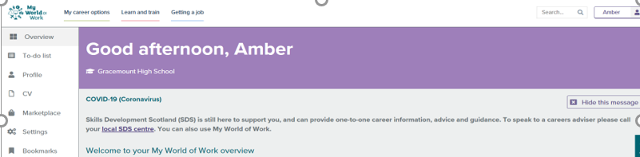

In your account page select the ‘to-do list’ within the left-hand navigation. This will give you tasks and reading to support you with your next steps. Here are examples of the to-do list tasks:

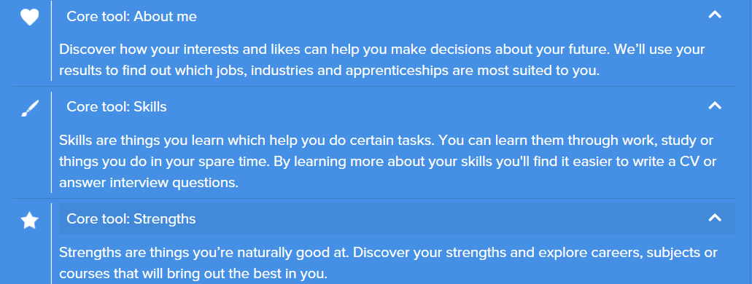
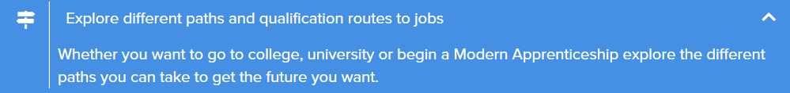
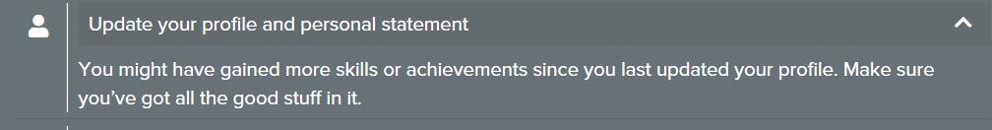
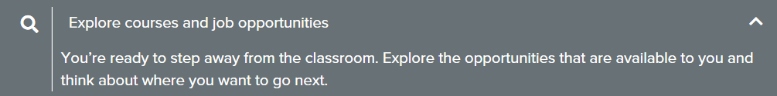
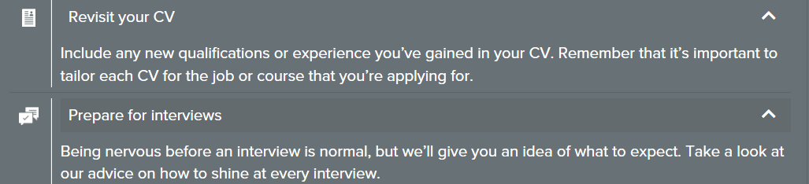

Please find below other useful sections on My World of Work and Apprenticeship.scot

Applying for Apprenticeships and jobs:

Covid 19 FAQs on Apprenticeships (including information on vacancies)
https://www.apprenticeships.scot/covid-19-faqs/covid-19-faqs-for-apprentices/

How to write a CV: https://www.myworldofwork.co.uk/getting-job/building-cv

Cover letters: https://www.myworldofwork.co.uk/cover-letters

Application forms: https://www.myworldofwork.co.uk/application-forms

Interview advice (including telephone and online interviews): https://www.myworldofwork.co.uk/interviews-0

Applying for College and University:

Applying for courses: https://www.myworldofwork.co.uk/applying-courses-0

Nail that College interview: https://www.myworldofwork.co.uk/nail-your-college-interview

Volunteering:

https://www.myworldofwork.co.uk/learn-and-train/volunteering

Careers Advisers top tip: “make sure that you apply for back up options, because there are lots of different routes to get you to where you want to be”

Skills Development Scotland is still here to support you.
You can speak to a careers adviser to get career information, advice and guidance by calling your local Skills Development Scotland centre, or by using our live chat.
To speak to your school careers adviser, you can call your local centre and ask for them by name.

