Read for the Stars
Our ‘Read for the Stars’ Summer Reading Challenge will have to be slightly different this year.
The challenge is to read as many books as you can between now and the end of August. You can use:
- Books you have at home
- Books you have read during ‘lockdown’
- You can borrow eBooks from the public library
If you are not already a member of the public library all you have to do is:
- Email - informationdigital@edinburgh.gov.uk - with your name, date of birth, home address and parent/guardian's name and email address.
- When you join online you will receive a temporary library number and PIN allowing you to borrow up to 3 books straight away. This number will be valid for 6 months.

After you have read a book, send a short ‘blurb’, in an email, about it to Mrs Boal at christine.boal@leith.edin.sch.uk. Remember no ‘spoilers’. If it’s hard for you to email, just keep a note of what you’ve read & what you thought about it and we’ll type it up in August.
To help with this and to give you some suggestions we have put together a bookshelf of books you might like to try – but you can read ANYTHING!
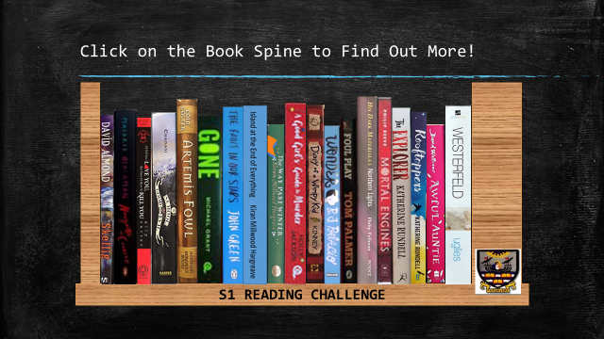
In the S1 Reading Challenge PowerPoint, click on a book spine & you will find out about the book, other books in the series or other books written by the same author.
When we have all the book reviews in we will make a bookshelf for each class. These will be displayed around the school and be available for everyone to use.

Which class can build the BIGGEST bookshelf?

