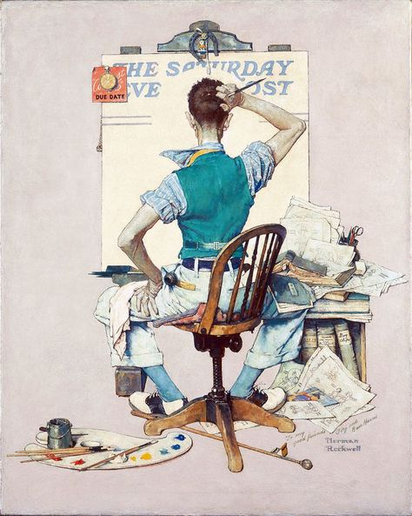
The Royal Scottish Academy (RSA) National Competition
All entries for the RSA Competition must be received by Friday 10 March 2021 to:- lucy.thomson@leith.edin.sch.uk.
Gracie Gaughan , a Leith Academy pupil, won £250 last year
Junior (S1 & S2) Category
2021 Format
• No restrictions for materials or size
• Entries will be submitted digitally. The Awards Ceremony will be hosted via a zoom event
• A virtual Exhibition of winners work will be hosted via an online viewing room microsite
Prizes
Five judges, including the President of the RSA, will award:
First prize of £250, second prize of £150 and
third prize of £100 in each category.
Highly Commended Certificates awarded to 10 entries in each category.
Format to present work
Photos of your artwork, which can be on any subject matter, must be at least 1Mb and saved as a jpeg. Label each photo with the pupil name, school and category (what year you are in at school).
The Royal Scottish Academy (RSA) National Competition
All entries for the RSA Competition must be received by Friday 10 March 2021 to:- lucy.thomson@leith.edin.sch.uk.
Gracie Gaughan , a Leith Academy pupil, won £250 last year
Intermediate (S3&S4) Category
Format
• No restrictions on: subject mater, materials snd size
• Entries will be submitted digitally. The Awards Ceremony will be hosted via a zoom event
• A virtual Exhibition of winners work will be hosted via an online viewing room microsite
Prizes
Five judges, including the President of the RSA, will award:
First prize of £250, second prize of £150 and
third prize of £100 in each category.
Highly Commended Certificates awarded to 10 entries in each category.
Format to present work
Photos of your artwork, which can be on any subject matter, must be at least 1Mb and saved as a jpeg. Label each photo with the pupil’s name, school and category (what year you are in at school)
The Royal Scottish Academy (RSA) National Competition
All entries for the RSA Competition must be received by Friday 10 March 2021 to:- lucy.thomson@leith.edin.sch.uk.
Gracie Gaughan , a Leith Academy pupil, won £250 last year
Senior (S5 & S6) Category
Format
• No restrictions on: subject mater, materials snd size
• Entries will be submitted digitally. The Awards Ceremony will be hosted via a zoom event
• A virtual Exhibition of winners work will be hosted via an online viewing room microsite
Prizes
Five judges, including the President of the RSA, will award:
First prize of £250, second prize of £150 and
third prize of £100 in each category.
Highly Commended Certificates awarded to 10 entries in each category.
Format to present work
Photos of your artwork, which can be on any subject matter, must be at least 1Mb and saved as a jpeg. Label each photo with the your name, school and category (what year you are in at school)

