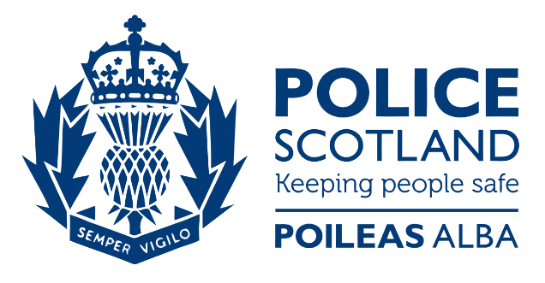

OPERATION PROUST – DISORDER IMPACTING LOTHIAN BUS SERVICES

Lothian Buses provides a high quality service to thousands of people – many of them travelling out of necessity to get to vital jobs or to help care for others.
Any disorder that impacts the safe and efficient operation of bus services is unacceptable.
Several areas of Edinburgh have experienced incidents resulting in serious disruption to services, including significant damage to buses resulting in service withdrawal and, in the most concerning cases, drivers have been injured.
No one should face the risk or fear of serious disruption or injury when they go to work or when they use public transport.
You can help us address this problem:
- Tell the police if you know someone who has targeted buses – help keep our city safe for everyone. Call 101 (999 in an emergency) or call CrimeStoppers anonymously on 0800 555 111
- If you have footage of anyone taking part in disorder, let the police see it – call 101 or email your local policing team via the Police Scotland website
- Help educate young people you know on the importance of our bus services, make sure they know the impact of actions – and have consequences for them too

Through Operation Proust, Police Scotland and Lothian Buses are working in partnership to keep our city safe and ensure every person who targets our buses is held to account for their actions.
Scan the QR code or click the link to find more about the real-life impact of attacks on buses:
https://vimeo.com/522789290/24ca9d959f

