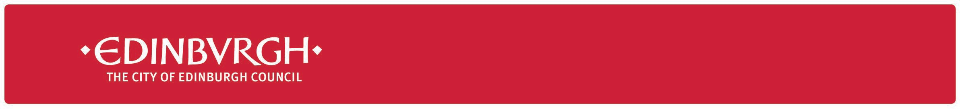

|  |  |
| --- | --- |
| **Date** | 16 August 2021 |
| **Your ref** |  |
| **Our ref** | S&LL/LF/CT |

Dear Parent/Carer

Welcome to Session 21/22

It’s that time of year again when we warmly welcome pupils back to school after a long, sunny holiday. A very special welcome to our new Primary 1 children too! We are all delighted to be returning to school with some relaxation of key rules, however most remain and others have changed.

The main change for the first six weeks is the removal of class and year group bubbles, and contract tracing by schools.

I have highlighted 10 key things for you to know below.

1. **Groupings (Bubbles)**

There is no longer a need to work in ‘bubbles.’ This means that children will now be able to mix with those from other classes both for their learning and during social times, however large gatherings such as assemblies cannot yet take place.

1. **Contact Tracing & Self-Isolation**

Schools will no longer need to identify close contacts and ask whole classes to self-isolate. Contact tracing will be done by Test and Protect (TAP). Only those at the highest risk of being exposed to infection will be asked to self-isolate until they have received a negative PCR test. This will include young people with a specific health-related vulnerability.

**It is important that school staff know which children have a health-related vulnerability. If this applies to your child, please contact the school to discuss the need to record this in a Health Care Plan.**

The definition of who is considered a close contact can be found here.

<https://www.gov.scot/publications/coronavirus-covid-19-guidance-on-reducing-the-risks-in-schools/pages/changes-to-previous-guidance/#Self-isolation%20policy%20(including%20contact%20tracing%20and%20testing)>

1. **What to do if your child is COVID-19 positive**

If your child is COVID-19 positive, please contact the school with their name, date of birth and date of Positive PCR test. This will allow the school to issue the Warn and Inform letters to staff and other parents/carers, letting them know that there has been a case(s) in school.

1. **Warn & Inform – steps for you to take**

When schools become aware of a positive case in school, they will issue a “Warn & Inform” letter which will tell you what to do next.

1. **Face Coverings**

Guidance has not changed.

**Primary Sector**

Unless exempt, face coverings should be worn by adults only

**Secondary Sector**

Unless exempt, face coverings should be worn at all times by all adults and learners.

1. **LFD Testing**

Secondary pupils should continue to take an LFD test twice weekly.

**Please ensure your child has taken a test before returning to school**.

1. **Visitors to schools**

In the short term, visitors to schools will be for essential learning purposes only. It is not yet possible to drop in to school unless this has been pre-arranged, for example for enhanced transition.

**If you need to visit the school, please arrange this with the school office. Staff will ensure that a risk assessment is in place.**

1. **Drop-off/Pick-up**

Schools will continue with their current drop-off/pick-up arrangement which may include staggered times in the short term. Please continue to follow the procedure in place in your child’s school.

1. **Ventilation**

Good ventilation is important to reduce the spread of infection. We use monitors to check ventilation and more will be bought by the Council as winter approaches. The main way we improve ventilation is by opening windows.

**10. Extra-Curricular Activity**

We are looking forward to these starting up soon. Schools are working with partners to ensure a gradual and safe resumption of a wide range of extra-curricular activity.

I hope that by following the guidance, we will continue to have safe schools and healthy, thriving pupils. Any changes to guidance will be fully considered and sent out in advance of the new changes taking place.

If anything is not clear, please do get in touch with your child’s Headteacher in the first instance.

Kind regards and thanks for all your hard work so far in keeping yourselves and your families safe.



# Lorna French

**Acting Chief Education Officer**