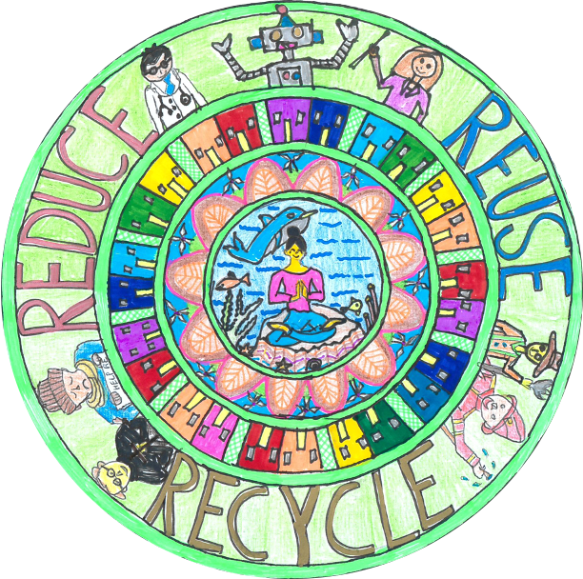
- UpGlasgow will host the
- 26th UN Climate Change Conference of the Parties (COP26)
- on 31 October – 12 November 2021
- Create a piece of art on climate change. Any media can be used: collage, sculpture, paint, pen for example. Your work will be photographed and used as an illustration on t-shirts (t-shirts or bags 4, 5 and 6th Years) for the COP 26 summit in a circle that fits the full width of an A3 sheet of paper.
- (A3 Paper will be provided by the art and design department)
- Countries are coming together to accelerate action towards the goals of the Paris Agreement and the UN Framework Convention on Climate Change.
- The Paris Agreement is a legally binding treaty adopted by 196 countries at the climate change conference in Paris in 2015 (known as COP 21). The main goal of the agreement is to
- cut global greenhouse gases
- in order to limit global temperature increases as close as possible to
- 1.5 degrees Celsius.
Winners will be judged in five categories:
1st Year, 2nd Year, 3rd Year,4th Year, 5th Year and 6th Year

A prize of £20 Waterstone Book token will be given to the three winners in each category. They will also receive a t-shirt with their design printed on it.

Rules
The competition will launch on 25th of August 2021. It will close at 3pm on Monday 15 of October 2021 Place your entry for the competition in a folder in the Art Base in the Art and Design department or by sending it digitally to lucy.thomson.edin.sch.uk
Art and design, Design Technology, Geography teachers and members of the Student’s Council on Climate Change will judge the t-shirt competition.
Five winning designs will be printed on t-shirts and bags.
Forty-five other students who have taken part in other projects with in the school related to the environment and climate change will also be eligible to receive a t-shirt or bag with the winning designs on it. Pupils achieving excellence focusing on environmental issues in any subject area may be chosen by subject teachers around the school and the Student’s Council on Climate Change.
Management in the school may want to recognise that some students have been particularly good at recycling litter.
These students will be given the option of wearing their winning t-shirt during the days of the conference to show support for climate change.

