Lothian NHS Board
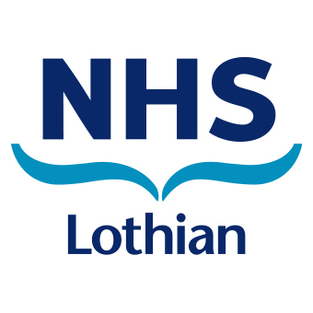
Waverley Gate
2-4 Waterloo Place
Edinburgh
EH1 3EG
www.nhslothian.scot.nhs.uk

Advice to parents/carers
Our Ref Health Protection Team

Dear Parent/Carer

In recent days we have been made aware of a member(s) of LEITH ACADEMY who has tested positive for COVID-19. This letter is to keep you informed.

There is no need for your child to isolate unless contacted separately by Test and Protect and asked to do so. School remains open and your child should continue to attend if they are well.

The public health judgement that these types of contact are low risk is based on a range of factors, including vaccination rates, evidence about transmission from children and young people, and the low risk of direct health harms to children.

If you or your child do develop any symptoms of COVID-19, they must not come to school – they should have a test as soon as possible, and your whole household should stay at home until the test result comes back. Further information on testing, and the rules around self-isolation, can be found on www.nhsinform.scot or by phoning 119 if you cannot book online.

The most common symptoms of coronavirus (COVID-19) are recent onset of: new continuous cough; high temperature; or a loss of, or change in, normal sense of taste or smell (anosmia).
Please be reassured that for most people coronavirus (COVID-19) will be a mild illness. Children are at particularly low risk of illness from coronavirus infection. For those people who are eligible, vaccination is highly effective at preventing severe disease.

To help reduce the risk to your family and your school community, please also:

- Ensure your child takes a lateral flow test before returning to school. This can help reduce the likelihood of spread in schools, by catching infections early.

  - If your child is in primary school, you can support them to take a test before returning if you and they wish to do so. This is not required, but can provide you, your child and their school community with reassurance. There is no need for your child to continue to test regularly as part of attending primary school.

  - If your child is in secondary school, they should take a test before returning wherever possible, and continue to test regularly (twice-weekly) thereafter.

  - Free at-home LFD test kits are available for you and your primary-school aged children by collection from COVID test centres or pharmacies, or delivery by ordering online. More information can be found at: www.gov.scot/publications/coronavirus-covid-19-getting-tested/pages/no-covid-symptoms.

  - Free test kits are available to all secondary school children from the school. Please contact the school directly if they have any problems accessing tests.

  - Please ensure that all test results, whether positive, negative or void, are recorded on the online portal at: www.covidtest.scot OR by phoning 119.

  - Your child should not take a lateral flow test if they have tested positive for coronavirus in the last 90 days.

- Arrange vaccination as soon as possible, if you or anyone eligible in your family have not yet been vaccinated. www.nhsinform.scot/covid-19-vaccine. Vaccination is our best defence against COVID-19 causing anyone to become seriously unwell.

- Wear a face covering in line with guidance, keep your distance, keep rooms ventilated, and wash your hands with soap and water regularly.

You can find more trusted advice on www.nhsinform.scot.

Yours faithfully,

Health Protection Team
NHS Lothian

