

**LEITH**

**ACADEMY**

**SENIOR PHASE**

**HANDBOOK**

**&**

**LEARNER PATHWAYS**

**2023/24**

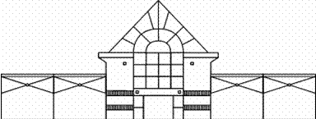

Leith Academy

Senior School Handbook & Learner Pathways

Session 2023/24

CONTENTS



**Item Page**

Foreword 2

Introduction 3

General Information 3

Senior School Contracts 6

**Subjects:**

*Business Education…………………………………………………….. 8*

*Computing Science…………………………………………………….14*

*Design & Technology .15*

*Health & Food Technology/ELC/Practical Cookery…....21*

*Physical Education 34*

*Religious, Moral and Philosophical Studies 45*

*Geography 51*

*History 53*

*Modern Studies 56*

*Travel and Tourism 59*

*People & Society 61*

*Mathematics 62*

*Modern Languages 69*

*Languages for Work 79*

*Art and Design 81*

*Drama/Beauty/Musical Theatre 90*

*Music 99*

*Biology 108*

*Chemistry 114*

*Physics 119*

*Psychology………………………………………………………………..124*

*Health Sector 126*

*English, ESOL & Media 128*

*Work Experience 140*

*College Courses 141*

*J.E.T. 143*

*Learner Pathways……………………………………………………. 145*

**Foreword**

Welcome to the Leith Academy Senior School Handbook & Learner Pathways. This is just one of the resources that can give you information to help you understand and plan your time in senior school.

Information is also available from key people, from other publications and on the internet. The most important part of your process of choice should be **an honest and realistic assessment** of your own strengths, interests and ambitions. Our application, negotiation and interview processes will support you in making these important choices.

This Handbook gives general information about senior school and details of the courses on offer at Leith Academy. It is important to note that these will only run provided that sufficient numbers of pupils choose them. In addition to the courses in Leith Academy, there are opportunities for senior pupils to study courses at Edinburgh College and at some of our neighbourhood schools. Details of college courses are provided in this handbook.

At Leith Academy, we want all young people to achieve their full potential. To do this, we aim to create an atmosphere of positive achievement which will benefit all learners. We regard the members of the senior school as a key group in helping to produce a positive ethos. As a role model for the rest of the school, you are expected to demonstrate commitment not only to your work but also all other aspects of school life. This is embodied in the S4 and S5/6 contracts.

For this session, the Senior Coursing team will comprise:

**Anderson - Miss Watson, DHT and Mr Fox, House Head**

**Barton - Miss Watson, DHT and Miss Lindsay, House Head**

**Cowan - Mr Stewart, DHT and Mrs Connell, House Head**

**Port - Mr Stewart, DHT and Mr Connor, House Head**

**Skills Development Scotland Advisor, Maya Stone**

SECTION 1: INTRODUCTION

# ABOUT THIS BOOKLET

This course booklet provides details of senior school arrangements for session 2023-24. The booklet covers the following:

* advice to senior school pupils
* the school’s expectation of senior pupils
* the personal development programme
* senior school contracts
* the courses on offer

**SECTION 2: GENERAL INFORMATION – MOSTLY FOR PUPILS CONSIDERING RETURNING FOR FIFTH OR SIXTH YEAR**

**NB: S4 Coursing – Commences on the 6th of March 2023.**

ALTERNATIVES AFTER FOURTH YEAR

**School Leaving Dates**

1. If you are 16 between 1 October and 28 February, you may leave at Christmas.
2. If you are 16 between 1 March and 30 September, you may leave at the end of May.

**The options available:**

**If you are old enough to leave you may:**

* Leave to employment or training
* Leave to a college course
* Return to a course at school

**If your leaving date is at Christmas you may:**

### Apply for a course at college

* Return for a course at school
* Organise long-term work experience

## ADVICE FOR THOSE RETURNING FOR FIFTH YEAR

* Your course of study in some subjects will be dependent on your achievements in S4, building into certification at Higher or new National Qualifications.Each course should offer a chance to progress either into sixth year at school or to courses at college.

1. Highers are the main entrance qualification to courses at universities and colleges throughout Britain. They are very demanding and intensive and require a great commitment to work and study. The recommended entry for most Highers is a National 5.
2. The Scottish Government, City of Edinburgh Council and Leith Academy are all committed to achieving and improving standards in education; Leith Academy is particularly anxious to ensure that your level of commitment to study and improving your standards is equally high.
3. Entrance to college or university (or to employment requiring qualifications for entrance) usually demands that you should have at least a National 4 award in English and Maths or an equivalent qualification. Employers demand literacy and numeracy as core skills therefore most S5 pupils are required to take English and most are encouraged to take Maths.
4. **Wider Achievement:** In addition to National and Higher qualifications in S5, some pupils will also be coursed for Wider Achievement periods. These will be single periods during the week when pupils will be able to opt into an activity led by a teacher and outwith the normal curriculum. There will be a range of these opportunities available throughout the year and the content of each opportunity will be determined by the member of staff delivering it. Some examples of Wider Achievement experiences might be Practical Cookery Young Stem Leaders, Statistics, German, Bike Repair, Philosophy, Personal Development, Creative Writing, Additional Maths and English, Beginners’ Mandarin or private study.

## ADVICE FOR THOSE RETURNING FOR SIXTH YEAR

1. Please read the Fifth Year section - all of it applies to you.
2. In addition to National 4/5 and Higher, some subjects may be studied at Advanced Higher. A Higher pass (A or B) is required before a place is given on an Advanced Higher course. Advanced Higher requires more personal, unsupervised study and independent research. Pupils have to be prepared to study in greater depth than at Higher. Advanced Higher is excellent preparation for study at college or university. The City of Edinburgh Council is currently exploring new ways of offering Advanced Higher on a neighbourhood basis. You will be kept informed of developments in this area.
3. Other new choices of subjects may be available to you this session, or you may decide to re-sit one of last session’s Highers/Nationals. Please note that if you are resitting to improve a grade you must work harder than last year to improve - there is always the danger that you relax because you have done it before.
4. Courses are also available at other neighbourhood schools. Please ask for details if we cannot tailor a course to meet your needs at Leith Academy.
5. Volunteering in junior classes will also be available for some pupils in S6.

# APPLICATION PROCESS

# Leith Academy has an application process for senior school that involves each pupil who wishes to return completing an application form and attending an interview. This gives pupils and staff an opportunity to negotiate an appropriate course for each individual. It also gives each pupil practice in participating in a proper selection process comparable to those encountered beyond school. The application form enables course planning and also encourages target setting.

# APPLYING FOR S5

If your leaving date is at Christmas, you must complete either an application form for S5 or one for college. You should also arrange a careers interview with Maya Stone, our Skills Development Scotland Careers Advisor.

All application forms should be filled in carefully. They will be considered as an important part of your application. The S5 Application form is your opportunity to ensure you are following an appropriate course. All those who have completed a form will be considered for entry to S5. Students who need to be re-coursed or for whom school may not be the best option will be interviewed.

S5 interviews will take place from **20th February 2023 onwards.**

# APPLYING FOR S6

The S6 Application form is your opportunity to plan an appropriate course. All those who have completed a form will be interviewed and considered for entry to S6.

S6 interviews will take place from **20th February 2023 onwards**.

WHAT TO CONSIDER WHEN APPLYING TO RETURN FOR A FIFTH OR SIXTH YEAR:

When considering a return to school you should consider the following factors:

* your long term aims
* your interests
* your performance so far at school
* your record in terms of behaviour and effort
* your record of attendance and punctuality
* your commitment to the school values
* your commitment to helping the school set high standards of achievement and behaviour

SOURCES OF ADVICE AND HELP WHEN CONSIDERING YOUR APPLICATION:

## Resources

* Careers Library
* Leaflets, Brochures, Colleges, Internet
* Senior School Handbook

## People

* Careers Advisor
* Parents/Carers
* Teachers
* Your House Head
* The Senior Management Team

# COMMITMENTS

The school and its staff aim to deliver a high quality education service to you in the senior school to meet your needs in preparing for the rest of your life. If you are unhappy with any aspect of the service, you can raise concerns with the Headteacher.

As part of the partnership between the school, pupil, and home, we expect from each pupil a commitment to the school, to attendance, to study and to each course that has been agreed. This commitment will be formalised in a contract to ensure the maximum benefit to each student (see next page). If a breach of contract occurs, discussions take place to resolve the problem.

# PERSONAL DEVELOPMENT PROGRAMME IN S5

Every pupil participates in the **Personal Development Programme**. This aims to provide a programme of events to help pupils plan and prepare for the rest of their lives. Your programme will be negotiated with your PD tutor and will include regular reviews of progress and target setting, input on study skills, preparation for life after school and lectures on relevant social issues. The Personal Development Programme offers opportunities to participate in a number of activities that broaden the pupil’s experience such as work shadowing, community placements, first aid, and a range of leisure and recreation activities. A programme of individual interviews with your tutor is built in to allow you to discuss your progress and achieve success.

Every pupil is expected to attend a Key Adult group. This is an opportunity for passing on important information, for building a feeling of teamwork, for reviewing reports and agreeing targets for improvement, and for sharing the school’s values with the senior school. It is also the forum in which achievement in the school is celebrated.

Fifth year pupils are expected to set an example in terms of punctuality, attendance, study, and good relationships.

# PERSONAL DEVELOPMENT PROGRAMME IN S6

Every pupil participates in the **Personal Development Programme**. This aims to provide a programme of events to help pupils plan and prepare for the rest of their lives. Your programme will be negotiated with your PD tutor and will include regular reviews of progress and target setting, input on study skills, preparation for life after school and lectures on relevant social issues. The Personal Development Programme offers opportunities to participate in a number of activities that broaden the pupil’s experience such as work shadowing, community placements, first aid, and a range of leisure and recreation activities. A programme of individual interviews with your tutor is built in to allow you to discuss your progress and achieve success.

# SECTION 3: SENIOR SCHOOL CONTRACTS

It is the policy of the school to try to create an environment in which all senior pupils fully develop their **academic, social and personal** potential. As part of that process, all pupils must enter into a **contract** with the school so that together we try to achieve the ambitions above. We will expect you to fulfil certain conditions set out below so that the education process can provide you with the maximum benefit. In return, the school will endeavour to provide you with a **quality** educational experience to help you achieve your aims and ambitions.

For example, the issues covered by the current S5/6 contract are that all S5/6 pupils:

* must attend the classes of the agreed courses.
* must only change course with the agreement of House Head or Depute Head, parent and department.
* must carry out the necessary study and homework for each course.
* must attend school and every agreed class.
* must attend Key Adult Time (registration) each morning promptly, and explain all absences and lateness to their House Head by letter/email from their parents/carers and notify the school of any planned absence.
* must attend PSE/PD.
* must be smart in appearance and give a lead to other pupils in promoting school dress and uniform.
* must behave appropriately in and around the school and set a good example to younger pupils by following the behaviour guidelines and co-operating fully with staff.



**Subjects**

**and**

**Course Info**

**BUSINESS/COMPUTING – POTENTIAL PATHWAYS**

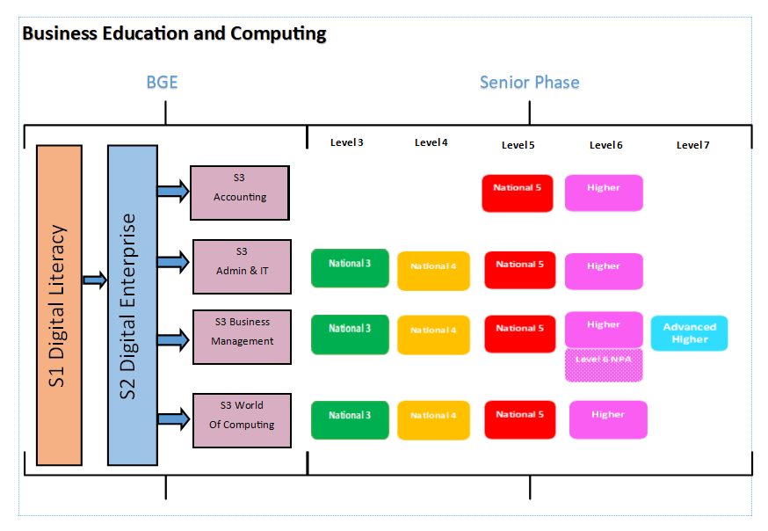

**BUSINESS EDUCATION**

|  |
| --- |
| **Accounting – N5, Higher** |
| **Introduction** |
| These courses enable candidates to:   * Develop an awareness of the function that accounting performs in industry and society * Prepare, present, interpret and analyse accounting information. * Apply a systematic approach to solving financial problems by using relevant accounting concepts and techniques * Combine both the practical and theoretical aspects of learning related to accounting, allowing candidates to use digital technology to complete tasks. * N5 focus is on sole trader businesses while Higher focuses on Partnerships and Limited Companies   Every course provides opportunities for candidates to develop breadth, challenge and application. The focus and balance of assessment is tailored to each level of study. |
| **Course Structure** |
| These courses consist of two areas of study:   * Financial accounting * Management accounting |
| **Assessment** |
| * Component 1 – Question paper * Component 2 – Assignment |
| **Entry Requirements** |
| * N5 – candidates studying N4/5 Maths * Higher – N5 Accounting or pupils with A/B pass at N5 Maths |
| **Progression** |
| * College * University * Modern Apprenticeships * Professional Accountancy Qualifications: CA, ACCA, CIMA * Employment |
| **Useful Websites** |
| <https://www.sqa.org.uk/sqa/45944.html> |

|  |
| --- |
| **Administration and IT – N3, N4, N5, Higher** |
| **Introduction** |
| Administration and IT skills cut across all sectors of the economy and offer wide-ranging employment opportunities.    These courses provide candidates with experience of authentic administration tasks and engaging practical activities relevant to the world of work. The course helps candidates to develop administrative skills and digital literacy, enabling them to contribute to the effective functioning of organisations in administrative positions.    Every course provides opportunities for candidates to develop breadth, challenge and application. The focus and balance of assessment is tailored to each level of study. |
| **Course Structure** |
| These courses consist of the following areas of study:   * Administrative Theory in the Workplace * IT Solutions for Administrators – Word Processing, Spreadsheets, Databases, Presentations * Electronic Communications |
| **Assessment** |
| Higher & N5:   * Component 1 – Question Paper * Component 2 – Assignment   N3/4 – Internal Unit Assessment |
| **Entry Requirements** |
| * N3/4 – no entry requirements * N5 – no entry requirements * Higher – N5 Administration and IT. Also suitable as a crash higher |
| **Progression** |
| * College * University * Modern Apprenticeships * Employment |
| **Useful Websites** |
| <https://www.sqa.org.uk/sqa/47918.html> |

|  |
| --- |
| **Business Management – N3, N4, N5, Higher** |
| **Introduction** |
| These courses are suitable for candidates who are interested in entering the world of business, as a manager, employee or self-employed person, and exploring the activities of different types of business.  Business plays an important role in society, as it creates wealth, prosperity, jobs, and choices for consumers. It is therefore essential to have effective businesses and business managers to sustain this role.    This course helps candidates understand the dynamic, changing and competitive environment of industry and commerce, and the environment that organisations operate in. It develops skills in communicating and presenting business-related information to stakeholders of an organisation.  Every course provides opportunities for candidates to develop breadth, challenge and application. The focus and balance of assessment is tailored to each level of study. |
| **Course Structure** |
| These courses consist of the following areas of study:   * Understanding Business * Marketing and Operations * Human Resources and Finance |
| **Assessment** |
| Higher & N5:   * Component 1 – Question Paper * Component 2 – Assignment   N3/4 – Internal Unit Assessment |
| **Entry Requirements** |
| * N3/4 – no entry requirements * N5 – candidates studying N5 English * Higher – N5 Business Management and candidates studying Higher English |
| **Progression** |
| * Higher Economics * College * University * Modern Apprenticeships * Employment |
| **Useful Websites** |
| <https://www.sqa.org.uk/sqa/47919.html> |

|  |
| --- |
| **Economics – Higher** |
| **Introduction** |
| [Economics is about choice and the impact of our choices on each other.](http://whystudyeconomics.ac.uk/what-is-economics/) It relates to every aspect of our lives, from the decisions we make as individuals or families to the structures created by governments and businesses. The economic way of thinking can help us make better choices. If you are curious about everything that happens around you, *studying economics will satisfy your curiosity*.  This course helps candidates develop an appreciation of how markets and governments work, and how decisions taken in these economic contexts affect everyday life. It develops the ability to think logically and to consider the reasons for, and the effects of, economic decisions and policies. |
| **Course Structure** |
| These courses consist of the following areas of study:   * Economics of the Market * UK Economic Activity * Global Economic Activity |
| **Assessment** |
| Higher:   * Component 1 – Question Paper * Component 2 – Assignment |
| **Entry Requirements** |
| This is a crash higher suitable for anyone who has achieved or is currently studying any of the following:   * Higher Business Management * Higher English * Higher Modern Studies |
| **Progression** |
| * Higher Economics * College * University * Modern Apprenticeships * Employment |
| **Useful Websites** |
| https://www.sqa.org.uk/sqa/47920.html |

|  |
| --- |
| **Business with Information Technology – SCQF Level 6 (NPA)** |
| **Introduction** |
| The NPA aims:   * To develop candidates’ knowledge and understanding of the role of business in society. * To develop candidates’ knowledge, application and usage of a variety of software packages and to develop these to an advanced level. |
| **Course Structure** |
| These courses consist of the following areas of study:   * Understanding Business * Management of Marketing and Operations * IT Solutions for Administrators * Communication in Administration |
| **Assessment** |
| Internal Unit Assessments |
| **Entry Requirements** |
| * Must be in S5 or S6 * Ideally have studied Business Management and/or Administration and IT at level 5 |
| **Progression** |
| * College * Modern Apprenticeships * Employment |
| **Useful Websites** |
| <https://www.sqa.org.uk/sqa/46767.html> |

**COMPUTING SCIENCE**

|  |
| --- |
| **Computing Science – N3, N4, N5, Higher** |
| **Introduction** |
| These courses help candidates to understand computational processes and thinking. It covers a number of unifying themes that are used to explore a variety of specialist areas, through practical and investigative tasks.  The course highlights how computing professionals are problem-solvers and designers, and the far-reaching impact of information technology on our environment and society.  It enables candidates to:   * + Apply computational-thinking skills across a range of contemporary contexts   + Apply knowledge and understanding of key concepts and processes in computing science   + Apply skills and knowledge in analysis, design, implementation, testing and evaluation to a range of digital solutions   + Develop an understanding of the role and impact of computing science in changing and influencing our environment and society |
| **Course Structure** |
| These courses consist of the following areas of study:   * Software Design & Development * Computer Systems * Database Design & Development * Web Design & Development |
| **Assessment** |
| Higher & N5:   * Component 1 – Question Paper * Component 2 – Assignment   N3/4 – Internal Unit Assessment |
| **Entry Requirements** |
| * N3/4 – no entry requirements * N5 – no entry requirements * Higher – N5 Computing Science |
| **Progression** |
| * College * University * Modern Apprenticeships * Employment |
| **Useful Websites** |
| <https://www.sqa.org.uk/sqa/48477.html> |

**DESIGN & TECHNOLOGY – POTENTIAL PATHWAYS**

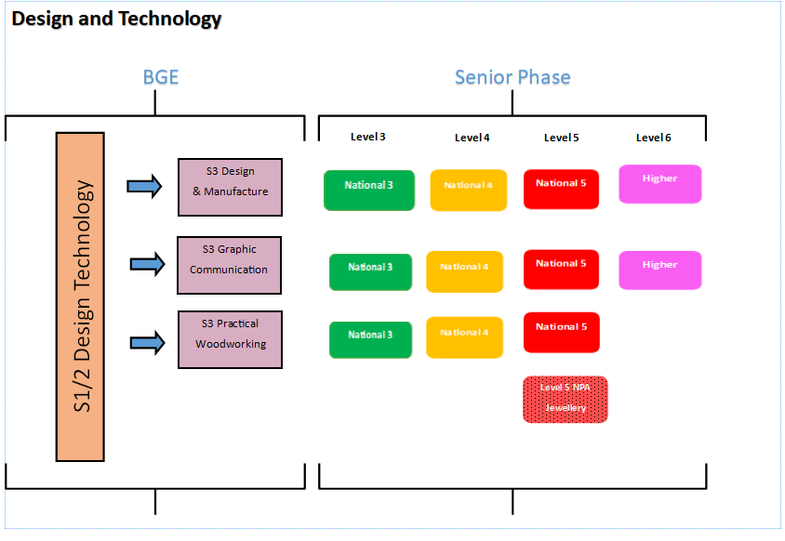

|  |
| --- |
| **Design and Manufacture – N4, N5, Higher** |
| **Introduction** |
| These courses enable candidates to:   * Design and manufacture models, prototypes and products. * Develop creative skills such as sketching, modelling and practical application * Learn about different manufacturing processes and materials * Explore sustainability around design and manufacturing technologies |
| **Course Structure** |
| These courses consist of two areas of study:   * Design * Materials and Manufacture |
| **Assessment** |
| * Component 1 – Question paper * Component 2 – Assignment |
| **Entry Requirements** |
| * N4 – No requirements but subject taken in S3 is advised * N5 – Subject taken in S3 is advised or N4 Design and Manufacture * Higher – N5 Design and Manufacture |
| **Progression** |
| * College * University * Modern Apprenticeships * Employment |
| **Useful Websites** |
| https://www.sqa.org.uk/sqa/45645.html |

|  |
| --- |
| **Graphic Communication – N4, N5** |
| **Introduction** |
| This course helps to enable learners to:   * Develop skills in graphic techniques such as sketching, modelling and use of computer 2D/3D software * Learn about graphic communication drawing standards and conventions used in the department and world of work * Explore the impact of graphic communication technologies on the environment and society |
| **Course Structure** |
| These courses consist of the following areas of study:   * 2D Graphic Communication * 3D Graphic Communication |
| **Assessment** |
| N5   * Component 1 – Question Paper * Component 2 – Assignment   N4 – Internal Unit Assessment |
| **Entry Requirements** |
| * N4 – no entry requirements * N5 – no entry requirements |
| **Progression** |
| * College * University * Modern Apprenticeships * Employment |
| **Useful Websites** |
| https://www.sqa.org.uk/sqa/45651.html |

|  |
| --- |
| **Practical Woodworking – N4, N5** |
| **Introduction** |
| This course helps to enable learners to:   * Learn how to make various types of woodwork joints to create different styles of products * Develop a vocabulary on tool/machinery names and explain their uses in context * Develop their practical and problem-solving skills when creating products * Apply safe working practices in a workshop which can be transferred to the world of work * Develop understanding of materials and issues around sustainability in a workshop context |
| **Course Structure** |
| These courses consist of the following areas of study:   * Carcase Construction * Flat Frame Construction * Machining and Finishing |
| **Assessment** |
| N5   * Component 1 – Question Paper * Component 2 – Assignment   N4 – Internal Unit Assessment |
| **Entry Requirements** |
| * N4 – No entry requirements * N5 – No entry requirements but subject taken in S3/N4 is advised |
| **Progression** |
| * College * University * Modern Apprenticeships * Employment |
| **Useful Websites** |
| <https://www.sqa.org.uk/sqa/45660.html> |

|  |
| --- |
| **Jewellery: Basic/Advanced Techniques – NPA Level 5/6** |
| **Introduction** |
| This course enables learners to:   * Use a range of metalworking tools and equipment * Explore general jewellery techniques such as hot metal forming and soldering * Explore cleaning and finishing techniques to produced polished items * Develop skills in stone setting, gemology and repairs * Build a portfolio of design work and products for entrance to creative industries |
| **Course Structure** |
| These courses consist of the following areas of study:   * Basic Techniques 1 (SCQF level 5) * Basic Techniques 2 (SCQF level 5) * Advanced Techniques 1 (SCQF level 6) |
| **Assessment** |
| * All units are internally assessed * No examination |
| **Entry Requirements** |
| * Level 5 – N4/5 Design and Manufacture, Graphic Communication or Art and Design – Entry at the discretion of the department |
| **Progression** |
| * College * University * Modern Apprenticeships * Employment |
| **Useful Websites** |
| <https://www.sqa.org.uk/sqa/57979.html> |

|  |
| --- |
| **Creative Graphics –SCQF Level 5 and Level 6 (Equivalent to N5 and Higher)** |
| **Introduction** |
| This course is suitable for candidates who are interested in the creative industries, and the course has been developed in conjunction with many well-known brands and organisations including: Glasgow School of Art; Napier University; Edinburgh College; and Lego to name a few.  Learners are encouraged to think differently, break rules, fail, collaborate and generate creative, innovative solutions and ideas. The course supports creative thinking and helps students to learn what makes them uniquely human, creative and brave!  The course is based on a simple creative process and is assessed through 5 broad learning outcomes: Research; Conceptualise; Fail and Fix; Communicate; and Evaluate. The emphasis is on the process rather than the product, highlighting the importance of the learners’ journey and encouraging them to reflect on the strategies they have used to thinking creatively. |
| **Course Structure** |
| During the course students will complete 4 design projects.   * Circular Brand: Creating your own circular fashion brand. * Campaign for Kindness: Learn about campaigns, use creativity and empathy to make the world a little kinder. * Van of Dreams: Creating an interactive mobile space for your chosen community. * Thoughts Become Things: Experimental design creating the design for an art installation. |
| **Assessment** |
| Level 5 and Level 6   * Folio based on the 4 design projects. * No exam |
| **Entry Requirements** |
| * N4/N5 Graphics * N4/N5 Design and Manufacture * N4/N5 Art and Design |
| **Progression** |
| Creative Industries:   * College * University * Art School * Modern Apprenticeship |
| **Useful Websites** |
| Www.daydreambelievers.co.uk |

**HEALTH & FOOD TECHNOLOGY**

**National 4 Health and Food Technology**

**Course Outline**

The purpose of this Course is to allow you to develop practical and technological skills and knowledge and understanding to make informed food and consumer choices.

The Course has six broad and inter-related aims which allow you to:

* develop knowledge of the relationships between health, food and nutrition
* develop knowledge of the functional properties of food
* make informed food and consumer choices
* develop the skills to apply your knowledge in practical contexts
* develop organisational and technological skills to make food products
* develop safe and hygienic practices in practical food preparation

The Course uses an experiential, practical and problem-solving approach to learning and to develop knowledge, understanding and practical skills.

There are three compulsory Units in this Course:

**Health and Food Technology: Food for Health (National 4)**

The aim of this Unit is to develop your knowledge of the relationship between food, health and nutrition. You will develop knowledge of dietary needs of individuals at various stages of life and describe current dietary advice. Through practical activities, you will produce food products which meet individual needs.

**Health and Food Technology: Food Product Development (National 4)**

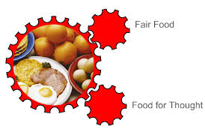The aim of this Unit is to allow you to develop knowledge and understanding of the functional properties of ingredients in food and their use in developing food products. You will develop a basic understanding of the stages involved in developing a food product. Through a problem-solving approach, you will make a food product to meet specified needs. You will develop and apply a basic knowledge and understanding of safe and hygienic food practices and techniques.

**Health and Food Technology: Contemporary Food Issues (National 4)**

In this Unit you will develop knowledge of consumer food choices. You will consider factors which may affect food choices and develop knowledge of contemporary food issues. You will consider technological developments in food and organisations which protect consumer interests. You will also develop knowledge of food labelling and how it helps consumers make informed food choices.

**Added Value Unit: Health and Food Technology Assignment (National 4)**

The general aim of this Unit is to enable you to provide evidence of added value for the National 4 Health and Food Technology Course through the carrying out of an assignment.

You will apply the skills you have learned during the Course. This will be assessed through an **assignment.**

**Assessment**

To achieve the National 4 Health and Food Technology Course, you must pass all of the required Units, including the Added Value Unit.

National 4 Courses are not graded.

**Progression**

This Course or its Units may provide progression to:

* National 5 Health and Food Technology Course
* other SQA qualifications in health and food technology, hospitality or related areas
* further study, employment or training

**Other Information**

There is a cost implication for this course of approximately £25.00 to cover the costs of materials that pupils will take home directly; this can be paid in instalments to the office throughout the year. If you are interested in the course but are concerned about the payment please speak to Mrs Dewar in PE or request a ‘Financial Support for Families’ information booklet from the school office.

**National 5 Health and Food Technology**

**Aims of the Course**

The purpose of this Course is to allow you to develop and apply practical and technological skills, knowledge and understanding to make informed food and consumer choices.

The Course has six aims which allow you to:



* develop knowledge and understanding of the relationships between health, food and nutrition
* develop knowledge and understanding of the functional properties of food
* make informed food and consumer choices
* develop the skills to apply their knowledge in practical contexts
* develop organisational and technological skills to make food products
* develop and apply safe and hygienic practices in practical food preparation

The Course uses an experiential, practical and problem solving approach to learning and to develop knowledge and understanding and practical skills.

**Recommended Entry**

You would normally be expected to have attained the skills and knowledge required by the following or by equivalent qualifications and/or experience:

* National 4 Health and Food Technology Course or relevant component Units
* National 4 in English

National 5 Health and Food Technology looks at three main themes:

**Food for Health**

This section of the course aims to develop your knowledge and understanding of the relationship between food, health and nutrition. You will also develop knowledge and understanding of dietary needs for individuals at various stages of life and explain current dietary advice. Through practical activities, the learner will produce and reflect on food products which meet individual needs.

**Food Product Development**

This section of the course allows you to develop knowledge and understanding of the functional properties of ingredients in food and their use in developing new food products. You will develop an understanding of the stages involved in developing food products and, through a problem-solving approach, produce a food product to meet specified needs. You will also develop and apply knowledge and understanding of safe and hygienic food practices.

**Contemporary Food Issues**

This section of the course allows you to develop knowledge and understanding of consumer food choices. You will explore factors which may affect food choices and develop knowledge and understanding of contemporary food issues. You will investigate technological developments in food and organisations which protect consumer interests. You will also develop knowledge and understanding of food labelling and how it helps consumers make informed food choices.

**Assessment**

The course assessment in this Course will be as follows:

**Assignment (50%)**

This will be completed in class time prior to exam leave. The assignment gives pupils the opportunity to investigate and solve a design brief. There will be a practical element within the assignment as well as the opportunity to evaluate.

**Question paper** **(50%)**

This will be completed within the exam diet and will focus on each of the three main themes of the course. It allows pupils to demonstrate their knowledge and understanding of a variety of

**Progression**

This Course or its Units may provide progression to:

* Higher Health and Food Technology Course or relevant component Units
* other SQA qualifications in health and food technology, hospitality or related areas
* further study, employment or training.

**Other Information**

There is a cost implication for this course of approximately £25.00 to cover the costs of materials that pupils will take home directly; this can be paid in instalments to the office throughout the year. If you are interested in the course but are concerned about the payment please speak to Mrs Dewar in PE or request a ‘Financial Support for Families’ information booklet from the school office.

**HEALTH AND FOOD TECHNOLOGY: HIGHER**

**Purpose and aims of the Course**

The Higher Health and Food Technology Course addresses contemporary issues affecting food and nutrition and how they affect consumer choices. These include: ethical and moral considerations, sustainability of sources, and food production and development. Learners analyse the relationships between health, food and nutrition, and plan, make and evaluate food products for a range of dietary and lifestyle needs.

The course is made up of three main units:

**Food for Health**

The general aim of this Unit is to develop learners’ knowledge, understanding and skills to enable them to analyse the relationship between health, food and nutrition. Learners will also analyse dietary needs for individuals at various stages of life and explain current dietary advice. Through practical activities, the learner will produce and evaluate food products which meet individual needs.

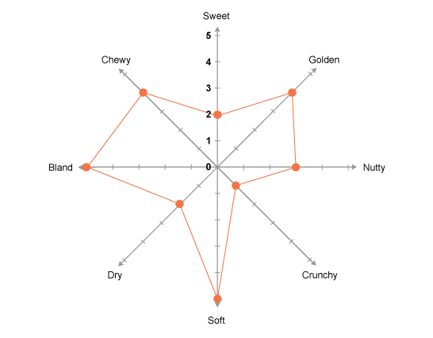**Food Product Development**

The general aim of this Unit is to allow learners to develop knowledge and understanding of the functional properties of ingredients in food and their use in developing food products. Learners will develop an understanding of the stages involved in developing a food product. Through a problem solving approach, learners will produce food products to meet a range of consumer needs. They will also apply knowledge and understanding of safe and hygienic food practices and techniques.

**Contemporary Food Issues**

In this Unit, learners will investigate a range of contemporary food issues. They will explain how these issues influence decisions taken by consumers when making food choices.

**Course Assessment**

Learners will be assessed by an assignment and a question paper.

|  |  |
| --- | --- |
| Course Assignment (50%)  The assignment will require application of skills, knowledge and understanding from across the Units. Learners will develop a product(s) to meet a given brief. The assignment will be sufficiently open and flexible to allow for personalisation and choice. | Question Paper (50%)  The question paper will require integration of knowledge and understanding from across the Units |

**Other Information**

There is a cost implication for this course of approximately £70.00 to cover the costs of materials that pupils will take home directly; this can be paid in instalments to the office throughout the year. If you are interested in the course but are concerned about the payment please speak to Mrs Dewar in PE or request a ‘Financial Support for Families’ information booklet from the school office.

**Hospitality - Practical Cookery: National 4**

**National 4 Hospitality: Practical Cookery**

**Course Outline**

This Course aims to provide a set of skills that enables you to learn how to prepare and cook food. It also develops your organisational and management skills.

The Course aims to enables you to:

* use a range of cookery skills, food preparation techniques and cookery processes when following recipes
* select and use ingredients to produce and garnish or decorate dishes
* develop an understanding of ingredients and their uses and an awareness of responsible sourcing
* develop an awareness of current dietary advice relating to the use of ingredients
* work safely and hygienically.

This Course is made up four compulsory Units, including the Added Value Unit.

**Cookery Skills, Techniques and Processes (National 4)**

This Unit develops your cookery skills, food preparation techniques, and your ability to follow cookery processes. You will also develop an understanding of the importance of safety and hygiene and the ability to follow safe and hygienic practices.

**Understanding and Using Ingredients (National 4)**

This Unit develops your knowledge and understanding of ingredients from a

variety of different sources and their uses. It also looks at the importance of responsible sourcing of ingredients and of current dietary advice. You will develop an ability to select and use suitable ingredients, in the preparation of dishes and to do so safely and hygienically.

**Organisational Skills for Cooking (National 4)**

This Unit develops your organisational and time management skills. You will learn how to follow recipes and time plans to produce dishes, with minimal guidance, and to work safely and hygienically. You will also develop the ability to carry out an evaluation of the product.

**Added Value Unit: Producing a Meal (National 4)**

This Unit enables you to bring together the knowledge, understanding and skills developed in the other three Units. You will carry out a practical activity which will require you to prepare, cook and present a two-course meal to a plan within a timescale.

**Assessment**

To achieve the National 4 Hospitality: Practical Cookery Course, you must pass all

of the Units, including the Added Value Unit. They will be assessed on a pass/fail basis

**Progression**

This Course or its Units may provide progression to:

* other qualifications in Hospitality (National 5) or related areas
* further study, employment or training

**Additional Information:**

There is a cost implication for this course of a contribution of £60.00 to cover the costs of materials that pupils will take home directly; this can be paid in instalments to the office throughout the year. If you are interested in the course but are concerned about the payment please speak to Mrs Dewar in PE or request a ‘Financial Support for Families’ information booklet from the school office.

Appropriate health and safety procedures must be followed.

**Hospitality - Practical Cookery: National 5**



**Recommended entry:**

You should have achieved National 4 Hospitality: Practical Cookery or equivalent qualifications and / or experience before starting the course. National 4 English is also essential.

In this course there is an emphasis on skills development and organisational skills. The course contains a significant practical component supported by related theory.

The course is designed for people who are interested in food and being creative with cooking. Its contribution to vocational education allows progression to a range of careers in the hospitality industry.

**This course aims to support you to:**

* Use a range of cookery skills, food preparation techniques and cookery processes
* Select and use ingredients to produce and garnish dishes
* Develop an understanding of the characteristics of ingredients and an awareness of their sustainability
* Develop an understanding of current dietary advice relating to the use of ingredients
* Plan and produce meals
* Carry out costing exercises
* Be aware of safe storage of ingredients to reduce hazards and eliminate cross contamination
* Selecting and using appropriate equipment
* Evaluate dishes for taste, texture and presentation
* Work safely and hygienically

**Assessment**

The course is assessed through the following components:

|  |  |
| --- | --- |
| **Component** | **Marks** |
| Question paper | 30 |
| Assignment | 18 |
| Practical activity | 82 |

The assignment is submitted to the SQA for marking.

The practical activity is marked by school staff and verified by the SQA.

**Question Paper**

This will assess your ability to integrate and apply your knowledge and understanding of the course work and skills you have experienced. It will ask you to state, name, give, identify, describe, explain, calculate and evaluate.

**Assignment and Practical Activity**

The assignment and practical activity are linked. The purpose is to assess your ability to plan, prepare and present a three course meal to a given specification within a timescale. The SQA provide a brief which states the dishes to be produced.

Stage 1: planning (assignment)

Stage 2: implementing (practical activity)

**Where can this course take you?**

This course can provide you with opportunities to progress to:

* NC Hospitality
* A Scottish Vocational Qualification (SVQ) in Catering and Hospitality
* Training or employment

**Recommended entry:**

You should have achieved National 4 Hospitality: Practical Cookery or equivalent qualifications and / or experience before starting the course. National 4 English is also essential.

**Additional Information:**

There is a cost implication for this course of a contribution of £60.00 to cover the costs of materials that pupils will take home directly; this can be paid in instalments to the office throughout the year. If you are interested in the course but are concerned about the payment please speak to Mrs Dewar in PE or request a ‘Financial Support for Families’ information booklet from the school office.

Appropriate health and safety procedures must be followed.

**Early Learning and Childcare**

**National 4 and 5 - Course outline**

These Courses are one of a range of National Courses known as Skills for Work Courses. You will be introduced to key knowledge and skills and develop positive attitudes that will allow you to progress onto other care related courses, eg social care, or into employment out with the early education and childcare sector.

Skills for Work Courses are designed to help you to develop:

* skills and knowledge in a broad vocational area
* core Skills
* an understanding of the workplace
* positive attitudes to learning
* skills and attitudes for employability

A key feature of these Courses is the emphasis on *experiential learning*. This means learning through practical experience and learning by reflecting on experience.

The five Core Skills are:

* Communication
* Numeracy
* Information Technology
* Problem Solving
* Working with Others

You will take part in an interview during your application for this course

The courses have three compulsory units and a choice of one optional unit.

**The compulsory Units are:**

|  |  |
| --- | --- |
| **National 4**  **(C782 74)** | **National 5** |
| **HX1L 74 Child Development** | **HC3C 45 Development and Wellbeing of Children and Young People** |
| **HX1R 74 Play in Early Learning and Childcare** | **HX1R 75 Play in Early Learning and Childcare** |
| **HX1V 74 Working in Early Learning and Childcare** | **HX1V 75 Working in Early Learning and Childcare** |

**The optional Unit is:**

|  |  |
| --- | --- |
| **National 4** | **National 5** |
| **HX1T 74 Maintenance of a Safe Environment for Children** | **HC38 45 Children and Young People: Rights and Protection** |

**Course Assessment**

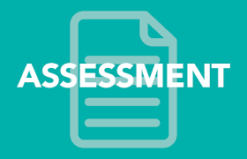There is no external assessment for these Courses. To achieve the Course award you must successfully achieve all the Units which make up the Course

Assessment objectives

The assessment approaches used in this Course will allow you to demonstrate an ability in key knowledge, skills and attitudes required to be employed in the early education and childcare sector. These include

knowledge and understanding of:

* the importance of child development
* the role of the adult in supporting the care, learning and development of the child
* the importance of play to the developing child
* the skills required to be a parent
* support available to parents in the community and from the family
* the scope of the early education and childcare sector
* the basic needs of children
* the roles of the employee and employer in relation to health and safety practice

**National 4**

**Summary of Unit Content - Compulsory Section**

**Child Development**

This Unit is designed to introduce you to aspects of child development and the key milestones of development for children aged 0–12 years. Building on this knowledge you will, working as part of a group, investigate one aspect of child development in detail. You will present your findings and review and evaluate both the investigative process and the presentation.

**Working in Early Education and Childcare**

This Unit allows you to develop a basic understanding of different types of provision in the early education and childcare area and to describe how the area supports children and families. You will discuss some of the main skills and qualities required to work with children aged 0–12 years.



**Play in Early Education and Childcare**

This is an introductory Unit which allows you to develop a basic understanding of a variety of types of play and how play contributes to the development of the child. It should allow you to explore a variety of play types and describe a range of play experiences within each type of play. You should demonstrate an understanding of the appropriateness and value of play opportunities for the development of children aged 0–12 years. You will have the opportunity for practical play experiences**.**

**Optional Unit**

Maintenance of a Safe Environment for Children 

This Unit enables you to develop an awareness of current health and safety legislation related to an early education and childcare environment. It allows you the opportunity to identify potential risks and hazards within settings, to carry out a risk assessment and to demonstrate possible strategies for dealing with these.



**National 5**

The aims of this Course are to:

* increase your awareness of the factors that impact on the lives of children, their parents and carers
* provide an insight into working in early education and childcare
* increase your awareness of the necessity to view all aspects of early education and childcare holistically
* increase your awareness of the scope of the early education and childcare sector and the opportunities for employment in the sector
* allow you to develop key life skills
* allow you to develop communication skills by working in groups and with others in a variety of contexts
* allow you to develop investigative skills using a variety of research methods
* allow you to develop presentation skills
* allow you to develop self-evaluation skills
* give you confidence to set achievable goals
* allow you the opportunity to develop skills required for possible employment in the early education and childcare sector, particularly personal/interpersonal, basic communication and practical caring skills
* allow you to develop skills required for employment in other sectors

You do not require to have a work placement to complete either course but may benefit from visiting early education and childcare settings that offer high quality, child-centred provision.

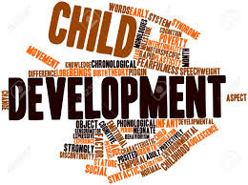

**Summary of Unit content - Compulsory section**

**Development and Wellbeing of Children and Young People**

This Unit is designed to introduce you to the principles of child development from 0–16 years. You will learn what is meant by sequences and patterns in child development and the inter- relationship between all aspects of that development. You will also learn about the health needs of children and how health factors may affect the development of children.

**Play in Early Education and Childcare**

This Unit allows you to develop an understanding of the benefits of a variety of types of play to children aged 0-12 years. You will learn how children benefit from a range of play experiences through planning, setting up and reviewing play experiences, either in a real or simulated context.

**Working in Early Education and Childcare**

This Unit allows you to develop an understanding of the

early education and childcare sector and to explain ways

in which the sector meets the care, learning and

development needs of children aged 0-12 years. You

will consider career options within the sector and the

skills, qualities and qualifications required to fulfil these

roles. You will reflect on your own skills, qualities and

achievements in relation to these.

**Optional Unit**

**Children and Young People: Rights and Protection**

This unit is designed to allow you to investigate the rights that children and young people should have today in society in relation to the United Nations Convention on the Rights of the Child. You will explore these rights in relation to national and current legislation and in relation to policies and practice within settings for children and young people.

**PHYSICAL EDUCATION – POTENTIAL PATHWAYS**

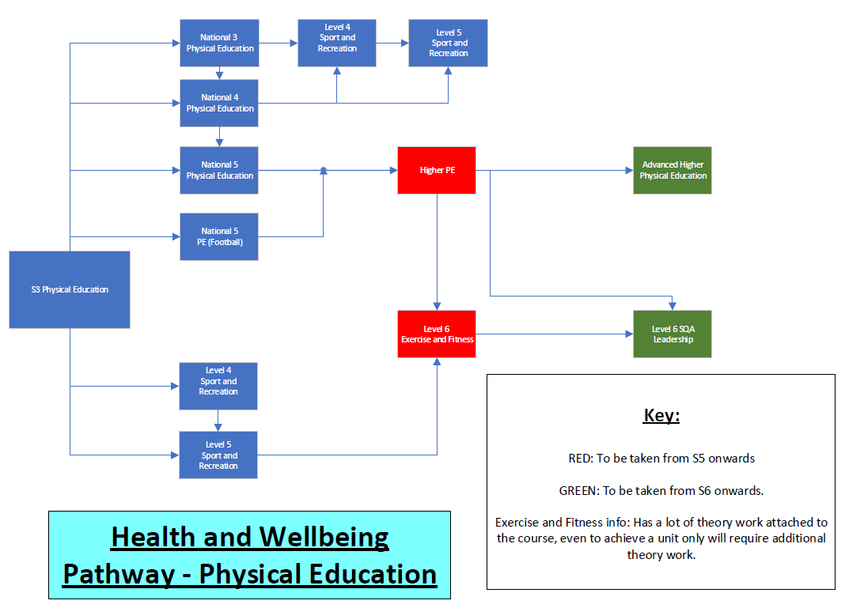

**PHYSICAL EDUCATION: NATIONAL 4**

**Purpose**

In this Course, and its component Units, there will be an emphasis on skills development and the application of those skills. The main purpose of the Course is to develop and demonstrate movement and performance skills in physical activities. By engaging in practical activities, learners can demonstrate initiative, decision-making and problem-solving. Learners will consider the effects of ***mental, emotional, social and physical factors*** on performance, and will develop an understanding of how to plan for, monitor, record and evaluate the process of personal performance.

**Course Details**

This course also comprises of two mandatory INTERNAL UNITS:

|  |  |
| --- | --- |
| **PERFORMANCE SKILLS**  Demonstrating overall practical ability in TWO activities throughout the year | **FACTORS IMPACTING ON PERFORMANCE**  A written project focusing on how different factors impact positively or negatively on a performance and how they can be developed through training. |

The course also offers an ADDED VALUE UNIT:

|  |  |  |
| --- | --- | --- |
| **PLANNING AND PREPARATION**  Pupils must plan how they are going to prepare for the one off performance by demonstrating their knowledge of warming up and approaching various challenges. | **ONE OFF PERFORMANCE**  Pupils will participate in a one off performance of an activity of their choice and demonstrate high skill level, control, fluency, decision making and etiquette and knowledge of rules. | **EVALUATION**  Pupils must accurately evaluate their performance and comment on their future targets for an improved performance. |

*To gain the award of the Course, the learner must pass all of the Units as well as the Course assessment.*

**Entry**

S3 Elective Physical Education Course, National 3 PE, National 3 English (or equivalent) and commitment to improving physical ability and knowledge.

**Progression**

This course or its units may provide progression to:

* National 5 Physical Education Course (depending on quality of extended written answers.
* Sport and Recreation – SCQF Level 5
* Other qualifications in Physical Education or related areas
* Employment or training

**PHYSICAL EDUCATION: NATIONAL 5**

**Purpose**

In this Course, and its component Units, there will be an emphasis on skills development and the application of those skills. The main purpose of the Course is to develop and demonstrate movement and performance skills in physical activities. By engaging in practical activities, learners can demonstrate initiative, decision-making and problem-solving. Learners will consider the effects of ***mental, emotional, social and physical factors*** on performance, and will develop an understanding of how to plan for, monitor, record and evaluate the process of personal performance.

**OVERALL COURSE ASSESSMENT SUMMARY (GRADE)**

|  |  |
| --- | --- |
| **ONE OFF**  **PERFORMANCES**  **50%**  In two activities of your choosing.  Pupils will perform in a competitive situation and be assessed internally. | **WRITTEN**  **PORTFOLIO**  **50%**  A written project that gives pupils the opportunity to demonstrate:   * Understanding factors that impact on performance * Plan and implement approaches to enhance performance * Monitor and evaluate development   Decision making and problem solving. |

*.*

**Entry**

National 4 Physical Education Course is recommended or relevant component Units, National 4 English and successful completion of S3 Elective Course also recommended but not essential.

**Progression**

This course or its units may provide progression to:

* Higher Physical Education Course
* Other qualifications in Physical Education or related areas – Sport and Rec/Exercise and Fitness
* Employment or training.

**PHYSICAL EDUCATION: HIGHER**

**Purpose**

This course will offer students the opportunity to study Physical Education at a challenging level. The course will have performance as its prime focus and students will be engaged in integrated practical experiential studies which will advance their skills and techniques while developing knowledge and understanding of ***mental, emotional, social and physical fitness***. The course will contribute to the personal and social development of students.

**OVERALL COURSE ASSESSMENT SUMMARY (GRADE)**

|  |  |
| --- | --- |
| **ONE OFF**  **PERFORMANCE**  **50%**  **In two activities of your choosing (30 marks each).** | **WRITTEN**  **EXAMINATION**  **50%**  **Extended written answers in examination conditions** |

**Recommended Entry**

Students would be expected to have attained a pass at National 5 in Physical Education and English.

Other relevant prior experience in physical education, including experience gained outwith certificated courses (e.g. playing for a club/representing a group) is highly beneficial to achieving in this course.

**Progression**

* An Advanced Higher course or units in Physical Education
* An HNC/HND in associated subject areas in college
* NPA Level 6 Exercise and Fitness Leadership
* A degree in Physical Education or related discipline
* A career in amateur/professional sport or dance
* Employment in the fitness, health, leisure and recreation industries
* Employment in sports/dance development.

**SQA LEADERSHIP AWARD in PE**

(SCQF Level 6)

**Purpose**

This course will offer motivated students the opportunity to develop leadership skills in many activities. This SQA award and associated qualifications use the medium of sport to help people to learn to lead younger pupils. Students will learn the essential skills of leadership: communication, organisation and motivation, but in addition to this will grow in confidence and self-belief. The personal journeys that people undertake whilst learning to lead, stand them in good stead for their university/college interviews, future careers and life itself. The students are also expected to act as senior role models within the school community, promoting physical activity and a healthy lifestyle.

**Recommended Entry**

* Students will be expected to have demonstrated, in school and beyond, an interest in sport, physical activity and health & wellbeing.  The opportunity to develop communication, leadership and responsibility should also be appealing.
* Participation in sport outwith school or participation in an after school sports club

**Course Details**

|  |  |
| --- | --- |
| **Leadership: An Introduction (approx. 20hrs)**  Pupils will submit a research project on Leadership styles, skills and qualities, known leaders and their knowledge and experience of leadership. | **Leadership in Practice**  **(approx. 40hrs)**  Pupils will undertake a placement (primary school or club) where they deliver quality PE lessons based on improving young people’s health and well-being.  Pupils will carry out events within Leith Academy to promote Health and Wellbeing across the school acting as positive role models to their peers. |
| **Personal Development : Self Awareness (SCQF 5)**  Pupils will reflect on strengths and weaknesses that they have. Pupils will then have the opportunity to develop and work on areas of improvement. | **Personal Development : Self and Work (SCQF 5)**  Pupils will experience work placements where they develop vital skills needed in a work place. |
| **Prepare to Volunteer ( SCQF 5)**  Pupils will learn about what it means to be a volunteer. You will have the chance to explore volunteering opportunities in your local area.  You will complete a CV, practice interview skills and then participate in a volunteering opportunity. | **Saltire Award**  Pupils will record all placement hours, which will allow them to receive a Saltire Award. |

Opportunities will be given throughout to gain ***additional qualifications*** and ***coaching badges***.

**Assessment**

**Internal Assessment**

Demonstrate competency through a variety of recording, reporting, planning and monitoring progress throughout the course by teacher and internal verifier.

Attendance rate must be over 90% for the year.

**External Assessment**

Verification from representative of SQA

Clear evidence of research and knowledge of leadership identified through project.

Successful external assessment report from placement supervisor

**Progression**

University course in PE, Sport, Health or associated disciplines.

College course in Sports Coaching & Development (HNC/HND)

A career in the Leisure or associated Industry.

A career in the Leisure or associated Industry.

**PHYSICAL EDUCATION: ADVANCED HIGHER**

**Purpose**

The Course has six broad and inter-related aims to enable learners to:

* investigate and evaluate how a range of factors impact on performance
* understand and apply methods to develop performance
* develop independent research and investigation skills to analyse how skills, techniques and strategies combine to produce effective performance
* select and apply a range of movement and performance skills, by making informed decisions during high-level performance
* carry out high-level personal performance in a selected physical activity
* analyse and evaluate the process of performance development

**OVERALL COURSE ASSESSMENT SUMMARY (GRADE)**

|  |  |
| --- | --- |
| **ONE OFF**  **PERFORMANCE**  **30%**  In an activity of your choosing. | **WRITTEN**  **PROJECT**  **70%**  The project will have four stages:  1. Project proposal  2. Research  3. Performance Development Plan (PDP) record  4. Post-PDP analysis and evaluation |

**Recommended Entry**

Students would be expected to have attained an A or B pass at Higher in Physical Education and an A or B in Higher English.

Other relevant prior experience in physical education, including experience gained outwith certificated courses (e.g. playing for a club/representing a group) is highly beneficial to achieving in this course.

**Progression**

* This Course or its Units may provide progression to:
* Higher National Diplomas in areas such as sports science, sports coaching, or health and fitness
* degrees in areas such as physical education, physical activity and health, sport and exercise science, health promotion, or sports psychology
* further study, employment and/or training related to personal training or health promotion

**National 5: Skills for Work - SPORT AND RECREATION**

The course comprises the following mandatory units all completed within the PE practical setting:

Sport and Recreation: Assist with a Component of Activity Sessions

Sport and Recreation: Employment Opportunities in the Sport and Recreation Industry

Sport and Recreation: Assist with Fitness Programming

Sport and Recreation: Assist with Daily Centre Duties

Pupils will also have the opportunity to develop 5 Core Skills:

♦ Communication

♦ Numeracy

♦ Information and Communication Technology (ICT)

♦ Problem Solving

♦ Working with Others

**Recommended Entry**

While entry is at the discretion of the PE Department, it would be beneficial for learners to have attained the following or equivalent:

* National 4 Skills for Work Sport and Recreation or any of its units Progression.
* An interest in physical activity demonstrated through core PE in S3
* National 4 Physical Education

**Progression**

This course or its components may provide progression to:

* SQCF Level 6 Exercise and Fitness Leadership
* SCQF Level 6 Leadership Award
* Scottish Vocational Qualifications (SVQs) in Sport and Recreation
* Further study, employment and/or training Core Skills

**Exercise and Fitness NPA Level 6**

The National Progression Award (NPA level 6) in Exercise and Fitness Leadership provides an opportunity for students to experience a number of recognised ways of leading others in fitness training. It allows students to develop their personal leadership qualities, knowledge and skills in fitness programming and basic physiology.

Students will complete 3 of the following units:

**Circuit Training (Higher)**

**Cardiovascular Training (Higher)**

**Free Weight Training (Higher)**

**Exercise to Music (Higher)**

A variety of approaches will be used for gathering evidence:

* Observation and assessment of practical performance
* Presentations
* Session Plans
* Extended response questioning- closed book

Cardiovascular Training involves use of exercise machines- treadmill, rowing machine and cross trainer. It also involves calculating and working in all 5 training zones though fartlek training, continuous training and interval training.

Free weights training involves weight training using dumbbells, barbells and cables. Students must be able to perform and coach 8 compound movements. Pupils will hopefully get the opportunity to train at Elysium Gym.

**ADDITIONAL INFO:**

* It is essential you keep up to date with your paperwork and theory- there is no final exam and all assessments throughout the year must be passed.
* If the timetable allows it, S1/S2 students will be used as the clients for practice & assessment (Circuit Training is perfect for this!)
* For assessment it is Pass or Fail but be aware that the candidate must pass every question in every outcome for each Unit.
* In the CV Unit there is a lot of Human Biology that students need to know
* In the Free Weight Unit there is a lot of bio-mechanics that students need to know

**Entry Requirements**:

Students would normally have completed Sport and Recreation or Physical Education at National 5 or Higher level.  Where this is not possible students should be actively involved in fitness training outwith school and have a strong interest in pursuing further study or employment in the health and fitness industry.

**Future Progression Routes in Subject:**

The award is designed to articulate with current HNC/D Fitness, Health and Exercise and aims to equip candidates with the skills, knowledge and understanding required for progression to further academic and/or professional qualifications in health and fitness.

**SOCIAL SUBJECTS – POTENTIAL PATHWAYS**

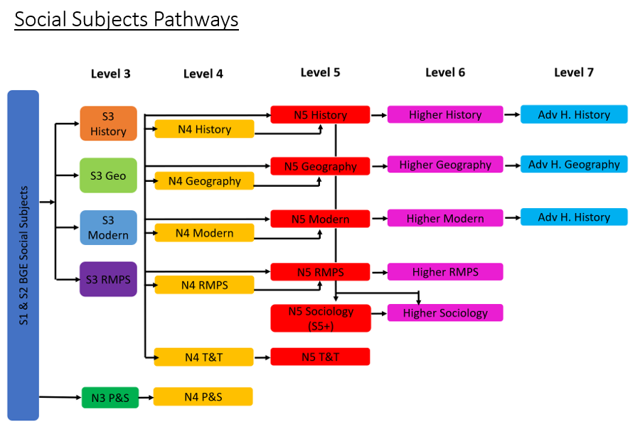

**RELIGIOUS, MORAL AND PHILOSPHICAL STUDIES**

**RELIGIOUS, MORAL AND PHILOSOPHICAL STUDIES: NATIONAL 4**

[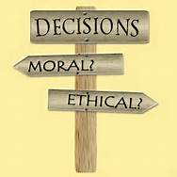](http://www.bing.com/images/search?q=moral+and+religious+studies&view=detailv2&&id=25048EA8655537F19E27213A7DD2F7AFB52C6578&selectedIndex=0&ccid=BjDm6ul9&simid=607999359454744098&thid=OIP.M0630e6eae97dd4d2183be3b5a62ec675o0)**Purpose and Aims of the Course**

The purpose of this course is to develop knowledge and understanding of religious, moral and philosophical issues that affect the world today. Religious and non-religious perspectives will be included. The course will explore the questions they raise and the solutions or approaches they offer. Learners will have opportunities to reflect on these and on their own experience and views. This will be achieved through successful study of the course units.

This course will require learners to study aspects of a world religion, understand contemporary moral issues and responses, and study key aspects of religious and philosophical questions.



The course will help learners develop an understanding of religious, moral and philosophical issues of relevance in the world today. Learners will develop skills which are transferable to other areas of study and which they will use in everyday life.

The main aims of the course are to enable learners to develop:

* the ability to understand and reflect on, religious, moral and philosophical questions and their impact;
* a range of skills including investigating and describing religious, moral and philosophical questions and responses, making comparisons, and the ability to express reasoned views;
* straightforward knowledge and understanding of beliefs, practices and sources related to world religions;
* straightforward knowledge and understanding of religious, moral and philosophical questions and responses to them.

**Mandatory Units**

**World Religion**

In this unit, learners will develop skills to describe and comment on the meaning and context of sources related to the religion selected for study. They will develop straightforward knowledge and understanding of the impact and significance of religion today through studying some key beliefs, practices and sources found within one of the world’s six major religions (Buddhism, Christianity, Hinduism, Islam, Judaism or Sikhism) and the contribution these make to the lives of followers.

**Morality and Belief**

In this unit, learners will develop skills to describe and express views about contemporary moral questions and responses. They will develop straightforward knowledge and understanding of contemporary moral questions and religious and non-religious responses. The range of contexts for study will be flexible to allow for personalisation and choice. Religious viewpoints studied must be from one of the world’s six major religions (Buddhism, Christianity, Hinduism, Islam, Judaism or Sikhism).

**Religious and Philosophical Questions**

In this unit, learners will develop skills to describe religious and philosophical questions and responses. They will develop straightforward knowledge and understanding of these. The range of contexts for study will be flexible to allow for personalisation and choice. Religious viewpoints studied must be from one of the world’s six major religions (Buddhism, Christianity, Hinduism, Islam, Judaism or Sikhism).

**Added Value Unit: Religious, Moral and Philosophical Studies Assignment**

In this unit, learners will exercise choice in selecting an issue or topic for personal study drawn from religious, moral or philosophical contexts. They will research their chosen issue or topic and communicate their findings. Through this activity, they will have opportunities to demonstrate greater depth or extension of knowledge and skills as they draw on and apply the skills and knowledge acquired in the other units of the course.

**Unit Assessment**

To achieve the National 4 Religious, Moral and Philosophical Studies course, learners must pass all of the required units, including the Added Value Unit.

National 4 Courses are not graded.

All Units are internally assessed.

**Progression**

This course or its units may provide progression to:

* National 5 Religious, Moral and Philosophical Studies course or its units.
* Further study, employment and/or training.

**RELIGIOUS, MORAL AND PHILOSOPHICAL STUDIES:**

**NATIONAL 5**

**Purpose and aims of the Course**

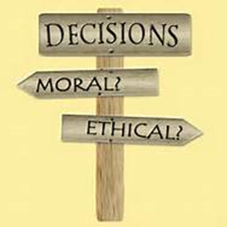

The purpose of this Course is to develop knowledge and understanding of religious, moral and philosophical issues that affect the world today. Religious and non-religious perspectives will be included. The Course will explore the questions they raise and the solutions or approaches they offer. Learners will have opportunities to reflect on these and on their own experience and views. This will be achieved through successful study of the Course Units.



The Course will require learners to study a world religion in detail, understand contemporary moral issues and responses, and study key aspects of religious and philosophical questions.

The Course will help learners develop an understanding of religious, moral and philosophical issues of relevance in the world today. Learners will develop skills which are transferable to other areas of study and which they will use in everyday life.

The main aims of the Course are to enable learners to develop:

* the ability to analyse and reflect on religious, moral and philosophical questions and their impact
* a range of skills including investigating and explaining religious, moral and philosophical questions and responses, making comparisons and the ability to express detailed and reasoned views
* detailed factual and abstract knowledge and understanding of beliefs, practices and sources related to world religions
* detailed factual and theoretical knowledge and understanding of religious, moral and philosophical questions and responses to them

**Recommended Entry**

Learners would normally be expected to have attained the skills, knowledge and understanding required by the following, or equivalent qualifications and/or experience:

* National 4 Religious, Moral and Philosophical Studies Course or relevant component Units

In terms of prior learning and experience, relevant experiences and outcomes may also provide an appropriate basis for doing this Course.

The Course has three mandatory Units:

**World Religion**

In this Unit, learners will develop skills to explain and comment on the meaning and context of sources related to the religion selected for study. They will develop detailed factual and abstract knowledge and understanding of the impact and significance of religion today through studying some key beliefs, practices and sources found within one of the world’s six major religions (Buddhism, Christianity, Hinduism, Islam, Judaism or Sikhism) and the contribution these make to the lives of followers.

**Morality and Belief**

In this Unit, learners will develop skills to explain and express reasoned views about contemporary moral questions and responses. They will develop detailed factual and theoretical understanding of contemporary moral questions and religious and non-religious responses. The range of contexts for study will be flexible to allow for personalisation and choice. Religious viewpoints studied must be from one of the word’s six major religions (Buddhism, Christianity, Hinduism, Islam, Judaism or Sikhism).

**Religious and Philosophical Questions**

In this Unit, learners will develop skills to analyse religious and philosophical questions and responses. They will develop factual and theoretical knowledge and understanding of these. The range of contexts for study will be flexible to allow for personalisation and choice. Religious viewpoints studied must be from one of the world’s six major religions (Buddhism, Christianity, Hinduism, Islam, Judaism or Sikhism).

**Assessment**

The National 5 course includes assessment of added value. To achieve the National 5 Religious, Moral and Philosophical Studies Course, learners must pass all of the required Units, including the Added Value Unit.

All Units are internally assessed. They will be assessed on a pass/fail basis

The added value for the Course must address the key purposes and aims of the Course. In the National 5 Religious, Moral and Philosophical Studies Course, added value will focus on:

* breadth
* challenge
* application

Learners will draw on, extend and apply the skills, knowledge and understanding they have learned during the Course. This will be assessed by a combination of a question paper and an assignment.

The question paper will require demonstration of a breadth of skills, knowledge and understanding from across the Course. The assignment will require learners to draw on, extend and apply their knowledge and skills and will be sufficiently open and flexible to allow for personalisation and choice.

**Progression**

This Course or its Units may provide progression to:

* Higher Religious, Moral and Philosophical Studies Course or its Units
* further study, employment and/or training

**RELIGIOUS, MORAL AND PHILOSOPHICAL STUDIES: HIGHER**

The main aims of the Course are to enable learners to develop:

* the ability to critically analyse, reflect on and express reasoned views about religious, moral and philosophical questions and their impact
* a range of skills including investigating religious, moral and philosophical questions and responses, critical analysis, evaluation, and the ability to express detailed, reasoned and well-structured views
* in-depth factual and abstract knowledge and understanding of beliefs, practices and sources related to world religions
* in-depth factual and theoretical knowledge and understanding of religious, moral and philosophical questions and responses to them

**Recommended Entry**

Entry to this Course is at the discretion of the centre. However, learners would normally be expected to have attained the skills, knowledge and understanding required by the following, or equivalent qualifications and/or experience:

* National 5 Religious, Moral and Philosophical Studies Course or relevant component Units

The Course has three mandatory Units:

**World Religion (Higher)**

In this Unit, learners will develop skills to interpret and comment on the meaning and context of sources related to the religion selected for study. They will develop in-depth factual and abstract knowledge and understanding of the impact and significance of religion today through studying some key beliefs, practices and sources found within one of the world’s six major religions (Buddhism, Christianity, Hinduism, Islam, Judaism or Sikhism) and the contribution these make to the lives of followers.

**Morality and Belief (Higher)**

In this Unit, learners will develop skills to evaluate and express detailed, reasoned and well-structured views about contemporary moral questions and responses. They will develop in-depth factual and theoretical knowledge and understanding of contemporary moral questions and religious and non-religious responses. The range of contexts for study will be flexible to allow for personalisation and choice. Religious viewpoints studied must be from one of the world’s six major religions (Buddhism, Christianity, Hinduism, Islam, Judaism or Sikhism).

**Religious and Philosophical Questions (Higher)**

In this Unit, learners will develop skills to critically analyse religious and philosophical questions and responses. They will develop in-depth factual and theoretical knowledge and understanding of these. The range of contexts for study will be flexible to allow for personalisation and choice. Religious viewpoints studied must be from one of the world’s six major religions (Buddhism, Christianity, Hinduism, Islam, Judaism or Sikhism).

**Assessment**

To achieve the Higher Religious, Moral and Philosophical Studies Course, learners must pass all of the required Units, including the Added Value Unit.

All Units are internally assessed.

They will be assessed on a pass/fail basis

The Higher courser includes assessment of added value. At National 5, Higher and Advanced Higher, the added value will be assessed in the Course assessment. The added value for the Course must address the key purposes and aims of the Course. In the Higher Religious, Moral and Philosophical Studies Course, added value will focus on:

* breadth
* challenge
* application

Learners will draw on, extend and apply the skills, knowledge and understanding they have learned during the Course. This will be assessed by a combination of a question paper and an assignment.

The question paper will require demonstration of a breadth of skills, knowledge and understanding from across the Course. The assignment will require learners to draw on, extend and apply their knowledge and skills and will be sufficiently open and flexible to allow for personalisation and choice.

**Progression**

This Course or its Units may provide progression to:

* Advanced Higher Religious, Moral and Philosophical Studies or its Units
* further study, employment and/or training

 GEOGRAPHY

**GEOGRAPHY: NATIONAL 4 AND 5**

**Why study Geography?**

Geography is a hugely relevant subject in our ever changing world. It opens up the physical environment around you and the ways in which people interact with their environment. The study of geography develops a sense of responsible citizenship. If you choose this course you will develop a knowledge and understanding of current events from the local area to the global. It will provide you with a range of skills such as map reading, data collection, ICT and problem solving. The course develops active learning including fieldwork. You will develop skills which are transferable to other areas of study, encouraging enterprise and employability.

**Course Outline:**

**Geography: Physical Environments**

Learners will study a selection of landscape types within Scotland and the UK: glaciated landscapes, upland limestone, coastal landscapes and rivers and their valleys.

**Geography: Human Environments**

Learners will study and compare developed and developing countries. Key topics will include world population and issues in changing urban and rural landscapes.

**Geography: Global Issues**

* Learners will study a number of major global issues from the following: climate change, environmental hazards, trade and globalisation, development and health tourism.

**Geography Assignment**

* Learners will get the opportunity to investigate a topic in detail and produce a report on their research in a medium they have chosen.

**Assessment**

National 4 is internally assessed.

National 5 has an external assessment:

• Component 1 – question paper 60 marks

• Component 2 – assignment 20 marks

**Total marks 80 marks**

**Progression**

This Course or its Units may provide progression to:

1. Geography Course or its Units at a higher National level e.g. N3 to N4 or N4 to N5, N5 to Higher.
   1. **OR**
2. a move to another Social Subject such as History or Modern Studies.
3. **OR**
4. further study, employment and/or training such as:

Urban Planner/Community Development

Cartographer

GIS Specialist

Climatologist

Transportation management

Environmental Management

Writer/Researcher

**GEOGRAPHY: HIGHER**

**Content**

The purpose of the course is to help students to understand the reality of the world around them. The course will add breadth and depth to the understanding of physical and human environments and their interactions. It also seeks to extend the use of evaluative skills and a range of geographical methods and techniques.

The course is divided into three separate units. Each unit should take up to a maximum of 40 hours for teaching. Additional course time is allocated for revision and preparation for assessment.

Unit 1 ***Physical Environments*** (Atmosphere, Hydrosphere, Lithosphere, Biosphere).

Unit 2 ***Human Environments*** (Population, Rural, Industrial Urban).

Unit 3 ***Global Issues*** A choice of two of the following: River Basin Management, Global Climate Change; Trade, Aid and Geopolitics; Energy; Development and Health.

Unit 4: ***Geographical Skills***

**Recommended Entry**

National 5 Geography A or B.

Or a Higher course in another social subject or their units.

**Assessment**

* **External Exam – 60 marks**
* **Assignment – 30 marks**
* **Ongoing unit assessments throughout the course**

**Progression**

From the achievement of a Higher course, the student may be able to progress to Geography Advanced Higher. On leaving school, the broad and flexible training which Geography provides, and the spatial awareness which is part of its teaching, make a Geography qualification both highly regarded and much sought after. Because the subject is not narrowly focused, the range of career opportunities is almost limitless, ranging from planning, research and education to cartography, oceanography, conservation and recreation.

Team workers, self-starters, IT literate, good data interpretation and research skills - these are all attributes where Geographers ‘tick the box’.

** HISTORY**

**HISTORY: NATIONAL 4 AND 5**

**Why Study History?**

In History, learners develop their understanding of the world by learning about other people and their values. This Course will encourage learners to develop important attitudes, including: an open mind and respect for the values, beliefs and cultures of others; an openness to new thinking and ideas, and a sense of responsibility and global citizenship. Students will learn about the past and develop an appreciation and understanding of the forces which have shaped the world today.

**What Will I learn?**

**Historical Study: Scottish – Migration and Empire, 1830-1930**

In this Unit, you will develop techniques to use, interpret and evaluate a range of primary and secondary sources.

**Historical Study: British – The Making of Modern Britain, 1851-1957**

You will develop techniques to explain and present information and draw conclusions about important historical themes and events.

**Historical Study: European and World – The Road to War, 1933-39**

You will develop techniques to compare differing historical viewpoints taking into account their content and context.

**Assessment**

National 4 is internally assessed.

National 5 has an external assessment:

• Component 1 – question paper 60 marks

• Component 2 – assignment 20 marks

**Recommended Entry**

Entry to this Course is at the discretion of the centre. However, learners would normally be expected to have attained the skills, knowledge and understanding required by the following or equivalent qualifications and/or experience:

1. National 3 History Course or relevant component Units to move to National 4
2. **OR**
3. National 4 History Course or relevant component Units to move to National 5

In terms of prior learning and experience, relevant experiences and outcomes may also provide an appropriate basis for doing this Course.

**Progression**

This Course or its Units may provide progression to:

History Course or its component Units at a higher National level e.g. N4 to N5.

**OR**

a move to another Social Subject such as Geography or Modern Studies.

**OR**

further study, employment and/or training in:

**Law and Accountancy Communications Publishing and the Arts**

**Academia and Education Industry and Business**

**HISTORY: HIGHER**

**Entry**

The normal entry requirement for the Higher course is National 5 History. The course is also open to pupils who have not taken a History course in S3/4, depending on grades achieved in other Social Subjects and in English.

**Content**

Three 40 hour units are covered in the course. The first covers Scottish and British History, the second covers European and World History, and the third is a special in-depth study.

* ***Britain 1850 – 1951***

This includes the growth of democracy in Britain from 1850 to 1928: how and why women gained the vote in 1918; liberal reforms from 1906-1914 and success of these reforms in tackling poverty; the Post WWII labour government and development of welfare state.

* ***Appeasement and the Road to War, to 1939***

The topics covered in this unit are an evaluation of the aggressive nature of the foreign policies of Germany and Italy in the 1930s; an assessment of methods used by Germany and Italy to pursue Foreign Policy ambitions; an evaluation of reasons why Britain followed appeasement 1936 - 1938; an assessment of the success of British Foreign policy in containing fascist aggression 1935 – March 1938; an assessment of the Munich agreement; and an assessment of why Britain abandoned the policy of appeasement and why war broke out in 1939.

Special Topic

* ***Scottish History***

‘The Wars of Independence’ 1286–1328. A study of Political change and military conflict arising from the Wars of Independence, illustrating the themes of authority, conflict and identity.

**Assessment**

The external assessment of the Higher course will consist of an 80 minute exam with two essay type questions, a second 80 minute exam with short answer questions based on sources, and an extended essay (2 hours) prepared in advance and written up under exam conditions with the aid a 200 word plan.

.

**Progression**

From the achievement of a Higher unit or course students may be able to progress to:

* Advanced Higher in History or course units at that level
* Higher education courses in History, Humanities and Social Sciences, Law
* In addition, Higher History will contribute to Scottish Group Awards.

**HISTORY: ADVANCED HIGHER**

A wide choice exists in Advanced Higher. Several topics are available for study including:

* American Civil War

Candidates will complete an external exam worth 90 marks. They will also complete a dissertation worth 50 marks. An A pass at Higher is an essential entry requirement.

History provides students with a wide range of transferable skills, which are important in many career fields. Understanding and analysis of issues and events are of key importance to historians and can be applied in many other fields of work. Other skill areas developed in studying history include:

* an ability for clear oral and written expression,
* putting forward ideas in a concise manner
* gathering, investigating and assessing material
* condensing facts and ideas.
* basing conclusions on research

**Careers which value students with a History background include:**

* Law and Accountancy
* Communications
* Publishing and the Arts
* Academia and Education
* Industry and Commerce

**MODERN STUDIES**

**MODERN STUDIES: NATIONAL 4 AND 5**



**Rationale - Why Choose Modern Studies?**

In an ever changing world understanding how to participate in the democratic process, how decisions are made and about the social and economic issues that affect people makes Modern Studies a hugely relevant subject.

Modern Studies encourages problem solving and it provides learners with a range of skills such as detecting bias in the media, justifying a particular point of view, ICT and problem solving. The course develops active learning through participation and involvement in lessons. Modern Studies develops skills which are transferable to other areas of study, encouraging enterprise and employability.

**What Will You Study?**

**Study themes for units of work:**

* **Democracy in the United Kingdom**: This unit looks at how we can participate in politics as well as what our representatives can do for us.
* **Social Issues in the United Kingdom**: This unit looks at Health and Wealth – the causes of inequality in society; the consequences of these problems; government and other organisations’ approaches to tackling these issues.
* **International Issues**: Investigates either the USA or China as a World Power. Social, economic and political issues within China will be studied as well as examining the role which either the USA or China plays on the world stage.
* **Modern Studies Assignment**: This unit gives pupils the opportunity to investigate a topic they have found interesting. Through a variety of research methods pupils test a hypothesis and come to a conclusion about whether or not their hypothesis is correct.

**Assessment**

National 4 is internally assessed and successful candidates will need to pass an assessment on each of the study themes above.

National 5 has an external assessment:

• Component 1 – question paper 60 marks

• Component 2 – assignment 20 marks

**Progression**

From the achievement of a National 5 course candidates may progress to:

* a course in Modern Studies at Higher.
* a National 5 in another Social Subject.
* a VQ or NC course.
* to employment – see options under Advanced Higher.

**MODERN STUDIES: HIGHER**

**Entry**

A National 5 in Modern Studies, History or Geography is the basic entry requirement for Higher. The course is also very useful and popular for candidates in S6 who already have other Higher grade passes.

**Content**

The course deals with British, American and Chinese current affairs issues. We look at social issues such as why Scotland has the reputation of being the “sick man” of Europe, why 40 years after the Equal Pay Act woman still suffer unequal treatment and to what extent racial inequalities still exist in the UK.

The course will cover three areas of study:

* Democracy in Scotland and the UK.
* Social Issues in the UK.
* International Issues.

These areas will be examined in:

* a 60 mark exam paper.
* a 30 mark assignment; this will be a piece of independent research of an issue linked to the course.

**Progression**

Students who are successful in the Higher course could progress to:

* Advanced Higher Modern Studies or to a Higher course in another social subject.
* HNC or HND awards.
* use the Higher qualification for general entrance to university or to particular degree courses in social sciences such as Politics, Sociology and International Relations or in Public Administration.
* employment in local government or social science related work.

**MODERN STUDIES: ADVANCED HIGHER**

**Purpose**

The purpose of this course is to provide opportunities for students to develop further their knowledge and understanding of political, social and international issues and the theories underpinning them and to promote the development of the critical skills of analysis, synthesis and evaluating. Students will also have the opportunity to assess critically social science research methods and carry out independent research in a selected area of study.

**Recommended Entry**

Students would normally be expected to have attained either the Higher course in Modern Studies or the three component Higher units as part of a two-year course.

**Course Details**

The course comprises one 80 hour unit and one 40 hour Advanced Higher unit, plus 40 hours flexible time.

* **Social Issues and Research Methods:** Learners will develop an in depth knowledge and understanding of issues in the UK and will be able to compare this issue in the international context.
* **Researching Contemporary Issues:** Learners will develop and employ the skills to undertake independent research of an issue of their choice.

**Assessment**

**3 Hour Exam Paper – 90 marks**

**Dissertation – 50 marks**

Modern Studies can prepare you for the following careers:

* Law
* Police
* Teaching
* Social Work
* Journalism
* The Armed Forces
* Nursing
* Banking
* Management
* Office Work
* Local Govt.
* The Church
* Sociology
* Insurance
* The Media
* Advertising
* Clerical Work
* Administration
* Social Sciences
* Trade Union Work
* Community Education
* Building Society Work
* International Relations
* Town & Country Planning
* Health Service Administration
* Consumer Protection
* Social Care
* Civil Service

**TRAVEL AND TOURISM**

**TRAVEL AND TOURISM: SKILLS FOR WORK**

**NATIONAL 4 AND 5**

**Do you have an interest in working in the travel and tourism industry? Then this course is just for you.**

National 4 and 5 Skills for Work: Travel and Tourism is an introductory qualification in travel and tourism. It develops the skills, knowledge and attitudes, needed for work in the industry.

**Learners will develop:**

* skills to become effective job-seekers and employees;
* skills to deal effectively with all aspects of customer care and customer service in travel and tourism;
* the product knowledge and skills to deal effectively with customer enquiries in relation to travel and tourism in Scotland, the rest of the United Kingdom and worldwide.

**What Will You Study?**

**There are 4 compulsory units which have to be studied and these are:**

**Employability**

**Customer Service**

**Scotland**

**UK and Worldwide**

**Assessment**

There is no external assessment for this Course. Learners must successfully complete each Unit to achieve the Course.

**Progression**

Skills for Work in Travel and Tourism at National 5 may provide progression to:

* other SQA Hospitality Courses or to Scottish Vocational Qualifications (SVQs) in Travel and Tourism;
* further education;
* either employment in the travel and tourism industry; for example it could lead to a career in/as:
* a travel agent
* working in a tourist attraction
* hospitality
* hotels and restaurants
* a holiday rep
* an air steward
* a tour guide.

**People & Society: National 3/4**

People & Society develops knowledge and understanding from across the social subjects. There will be aspects of Geography, Modern Studies, History and RMPS in the curse. People & Society will help to create a sense of responsible citizenship within those who study it. The course is geared towards National 3 and 4 pupils.

**Learners will develop:**

* The ability to compare and contrast information.
* The ability to evaluate information and make informed decisions using that information.
* The research skills necessary to investigate a topic of their choice.
* The presentation skills to put forward their point of view.

**What will you study?**

There are four units of work to be completed:

* **Investigating Skills** – this unit will focus on the topic of crime and the law.
* **Comparing and Contrasting** – this unit will be geared towards knowledge and comparison of world religions.
* **Making Decisions** – in this unit pupils will look at controversial issues, make a decision about them and then justify their point of view.
* **Added Value Unit** – pupils will be given an opportunity to carry out research on a topic of their choice.

**Assessment**

There is no external assessment for this unit but learners must successfully pass the internal assessments for each.

**Progression**

* Pupils achieving a pass at N3 or N4 People in Society may decide to study a discrete Social Subject such as Geography, History, Modern Studies, RMPS or Travel & Tourism at N 4 /5 level.

MATHEMATICS – POTENTIAL PATHWAYS

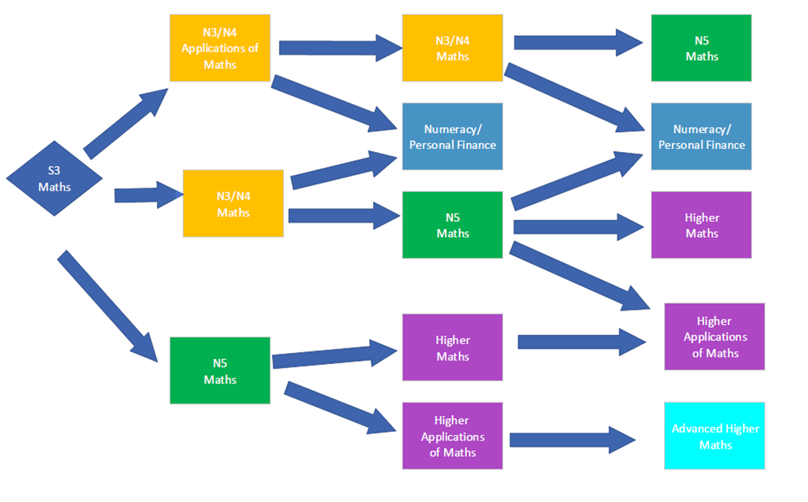

**MATHEMATICS: NATIONAL 4 APPLICATIONS OF MATHS**

**(SCQF Level 4)**

**Rationale**

The purpose of the National 4 Applications of Mathematics Course is to motivate and challenge learners by enabling them to think through real-life situations involving mathematics and to form a plan of action based on logic.

**Course Details**

**Shape, Space and Measure**

* Time Intervals
* Volume
* Area
* Scale drawings
* Bearings
* Calculating scale
* Container Packing
* Pythagoras’ Theorem
* Patterns

**Numeracy**

* 4 operations
* Percentages
* Fractions
* Reading scales
* Reading graphs
* Reading tables
* Probability
* Speed, distance, time
* Ratio and proportion

**Manage Money and Data**

* Wages
* Overtime
* Budgeting
* Savings
* Borrowing money
* Best Buys
* Graphs
* Charts
* Tables

**Course Assessment**

To attain a pass in National 4 Applications of Mathematics pupils must pass all of the mandatory units. Achievement is on a pass/fail basis for the outcomes.

|  |  |  |
| --- | --- | --- |
| **Component** | **Marks** | **Calculator/ Non Calculator** |
| Question paper | **Managing Finance and Statistics** | **Calculator** |
| Question paper | **Geometry and Measures** | **Calculator** |
| Question paper | **Numeracy** | **Calculator** |
| Question paper | **Added Value Unit** | **Non Calculator** |
| Question paper | **Added Value Unit** | **Calculator** |

Ownership of a suitable calculator is vital for this course. The Mathematics faculty sells calculators for £5.

**Recommended Entry**

* Level 3 mathematics and numeracy experiences and outcomes covered in the broad general education.

**Progression**

This Course or its Units may provide progression to:

* Personal Finance/Numeracy Award (level 4 or 5).
* National 4 Mathematics Course.

MATHEMATICS

**MATHEMATICS: NATIONAL 4 MATHS**

**(SCQF Level 4)**

**Rationale**

The Course will develop skills for further learning, as well as skills for life and work.

**Course Details**

**Expressions and Formulae**

* Creating formulae
* Brackets and simplifying expressions
* Substitution
* Symmetry
* Area
* Gradient
* Volume
* Tables

**Relationships**

* Pythagoras’ Theorem
* Trigonometry
* Scale
* Enlargement
* Angles
* Straight Line
* Solving equations
* Graphs

**Numeracy**

* 4 operations
* Percentages
* Fractions
* Reading scales
* Reading graphs
* Reading tables
* Probability
* Speed, distance, time
* Ratio and proportion

**Course Assessment**

To attain a pass in National 4 Mathematics pupils must pass all of the mandatory units. Achievement is on a pass/fail basis for the outcomes.

|  |  |  |
| --- | --- | --- |
| **Component** | **Marks** | **Calculator/ Non Calculator** |
| Question paper | **Expressions and Formulae** | **Calculator** |
| Question paper | **Relationships** | **Calculator** |
| Question paper | **Numeracy** | **Calculator** |
| Question paper | **Added Value Unit** | **Non Calculator** |
| Question paper | **Added Value Unit** | **Calculator** |

Ownership of a suitable calculator is vital for this course. The Mathematics faculty sells calculators for £5.



**Recommended Entry**

* Level 3 mathematics and numeracy experiences and outcomes covered in the broad general education.

**Progression**

This Course or its Units may provide progression to:

* National 5 Mathematics Course
* Personal Finance/Numeracy Award (level 4 or 5).

These skills can also support progression into Skills for Work Courses, National Progression Awards, National Certificate Group Awards and employment.

MATHEMATICS

**MATHEMATICS: NATIONAL 5 MATHS**

**(SCQF Level 5)**

**Rationale**

Mathematics is important in everyday life, allowing us to make sense of the world around us and to manage our lives. This course enables learners to model real life situations and make connections and informed predictions. It equips learners with the skills we need to interpret and analyse information, simplify and solve problems, assess risk and make informed decisions.

**Course Details**

Topics covered in this course include:

**Applications**

* Area of a Triangle
* Sine Rule
* Cosine Rule
* Bearings
* Vectors
* Percentages
* Statistics

**Relationships**

* Simultaneous Equations
* Inequations
* Straight Line
* Quadratic Graphs
* Quadratic Equations
* Changing the subject of a formula

**Expressions and Formulae**

* Surds and Indices
* Scientific Notation
* Multiplying out brackets
* Factorising
* Algebraic Fractions
* Gradient
* Volume

**Course Assessment**

To gain the award of the course, the learner must pass the course assessment is an exam consisting of a non-calculator paper (1 hour 15 minutes) and a calculator paper (1 hour and 50 minutes). Pupils are graded in this exam.

Ownership of a suitable calculator is vital for this course. The Mathematics faculty sells calculators for £5.



**Recommended Entry**

* Level 4 mathematics and numeracy experiences and outcomes covered in the broad general education.
* National 4 Mathematics Course.

**Progression**

This Course or its Units may provide progression to:

* Higher Mathematics.
* Personal Finance/Numeracy Award (level 5).

These skills can also support progression into Skills for Work Courses, National Progression Awards, National Certificate Group Awards and employment.

MATHEMATICS

**NATIONAL 5 NUMERACY AND PERSONAL FINANCE AWARD**

**(SCQF Level 4 and Level 5)**

**Purpose**

Personal Finance builds on the mathematical and financial skills learned in Applications of Maths National 4. The content of the course is based in real-life examples and is useful preparation for the workplace and for everyday life.

The Numeracy aspect is a level 5 course and the personal finance is assessed at level 4 or level 5 as appropriate.

**Course Details**

Topics covered in this course include:

**National 5 Numeracy**

* 4 operations
* Percentages
* Fractions
* Reading scales
* Reading graphs
* Reading tables
* Probability
* Speed, distance, time
* Ratio and proportion
* Problem solving

**Personal Finance**

* Working with money
* Origins of money
* Payslips
* Wages
* Tax
* Benefits
* Insurance
* Credit and debit
* Budgeting
* Foreign currency
* Bills and Costs

**Assessment**

There is an assessment at the end of each unit. Candidates must pass each test, in a maximum of two attempts.

Pupils are expected to revise regularly, especially on the lead up to assessments, and will receive regular formal homework exercises.

Ownership of a suitable scientific calculator is vital for this course. The Mathematics faculty sells calculators for £5.

**Recommended Entry**

Students would normally be expected to have attained a minimum of Applications of Maths National 4 or National 4 Maths.

**Progression**

This Course or its Units may provide progression to:

* Personal Finance (level 5).
* National 5 Applications of Maths.

National 5 Numeracy is a mathematics unit that can be used as an entry to some college courses. Personal Finance is at SCQF level 4 or SCQF level 5 and can assist in entry to college.

MATHEMATICS

**HIGHER** **MATHEMATICS**

**Purpose**

The aim of this course is to build upon and extend students’ mathematical learning in the areas of algebra, geometry and trigonometry and to introduce students to elementary calculus. Higher Mathematics is the entry requirement for a number of university courses.

This is a level 6 course.

**Recommended Entry**

Students would normally be expected to have attained Mathematics National 5.

**Course Details**

The course has three units Applications, Relationships and Calculus, and Expressions and Functions. The topics from the units are taught in four blocks, as shown below.

Block 1

This will involve the study of vectors, functions, graphs, straight line, polynomials and quadratics.

Block 2

This will involve the study of calculus and circles.

Block 3

This will involve the study of recurrence relations, solving trigonometric equations, addition formula, double angle formula and the wave function.

Block 4

This will involve the study of the uses of calculus, logarithms and exponentials.

**Assessment**

There will be a test at the end of each block of work.

Pupils will be given a prelim exam in December.

At the end of the course there is a final external exam consisting of two papers, paper 1 without a calculator and paper 2 using a calculator.

In order to be successful it is vital that candidates revise regularly! They will receive regular formal homework exercises.

Ownership of a suitable scientific calculator is vital for this course. The Mathematics faculty sells calculators for £5.

**Progression**

On successful completion of Higher Maths students may progress to Advanced Higher Mathematics. Higher maths is used as an entry qualification for many university and college courses especially in the fields of mathematics, engineering and science.

MATHEMATICS

**ADVANCED HIGHER MATHEMATICS**

**Purpose**

Advanced Higher develops and expands a range of mathematical skills. It allows the learner to develop further skills in calculus and algebra. Areas such as number theory (which helps keep the internet secure), complex numbers (the uses of which are ubiquitous, ranging from the solution of equations to the description of electronic circuits) and matrices (used in game theory and economics) are introduced. The learner’s mathematical thinking will also benefit from examples of rigorous proof.

This is a level 7 course.

**Recommended Entry**

Students would normally be expected to have attained Higher award at grades A or B.

**Course Content**

Unit 1 – Methods in Algebra and Calculus

The Outcomes cover partial fractions, standard procedures for both differential calculus and integral calculus, as well as methods for solving both first order and second order differential equations. The importance of logical thinking and proof is emphasised throughout.

Unit 2 – Applications of Algebra and Calculus

The Outcomes cover the binomial theorem, the algebra of complex numbers, properties of functions, rates of change and volumes of revolution. Aspects of sequences and series are introduced, including summations, proved by induction.

Unit 3 – Geometry, Proof and Systems of Equations

The Outcomes cover matrices, vectors, solving systems of equations, the geometry of complex numbers, as well as processes of rigorous proof.

**Assessment**

There is an assessment at the end of each unit.

There is a prelim exam in December and a final external exam at the end of the course in May.

Ownership of a suitable scientific calculator is vital for this course. The Mathematics faculty sells calculators for £5.

**Progression**

On successful completion of this Course, learners could progress to a course in higher education. This could be in mathematics or in a mathematics-related area such as science or engineering. Students who study Advanced Higher find it benefits them in first and second year at university.

There are many careers where mathematical skills are important, and this level would be useful in areas of science, engineering and technology, through the use of mathematical modelling. There are applications in computer technology, encryption security, equipment design, and in the design and analysis of experiments and tests. There is use throughout the financial services sector, such as in economics, accountancy and actuarial work.

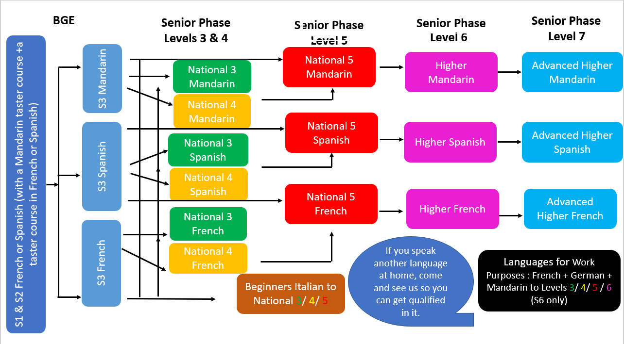**MODERN LANGUAGES - POTENTIAL PATHWAYS**

**MODERN LANGUAGES**

**[](http://www.google.com/url?sa=i&rct=j&q=&esrc=s&frm=1&source=images&cd=&cad=rja&uact=8&ved=0ahUKEwiXvtO41KbKAhUFNxQKHQvHDR8QjRwIBw&url=http://www.forbes.com/sites/chriswright/2014/12/09/how-sovereign-wealth-funds-bought-spain/&psig=AFQjCNF6Ibkupa1m9nCciQmiOfPxsoWvwQ&ust=1452770020436214)[](https://www.google.com/url?sa=i&rct=j&q=&esrc=s&frm=1&source=images&cd=&cad=rja&uact=8&ved=0ahUKEwjSotvJ06bKAhUGThQKHcWADiIQjRwIBw&url=https://thimble.webmaker.org/project/156784/remix&psig=AFQjCNFthE7AF9pnz7J9AzPCE082me9aYQ&ust=1452769850059099)[](http://www.google.com/url?sa=i&rct=j&q=&esrc=s&frm=1&source=images&cd=&cad=rja&uact=8&ved=0ahUKEwjx15zz1KbKAhVHRBQKHSa-BS0QjRwIBw&url=http://3dprint.com/109668/3d-printing-future-of-china/&bvm=bv.111396085,d.d2s&psig=AFQjCNF75IgAOaDcmqcVqjTlrjmaS_a6sg&ust=1452770136323524)[](https://www.google.com/url?sa=i&rct=j&q=&esrc=s&frm=1&source=images&cd=&cad=rja&uact=8&ved=0ahUKEwj9yfXf1abKAhVC5RoKHfgDBfUQjRwIBw&url=https://commons.wikimedia.org/wiki/File:Flag_map_of_Germany.svg&bvm=bv.111396085,d.d2s&psig=AFQjCNH0UsFS9_41gdgXTlYRDRFOvE12MA&ust=1452770413157521)**

**MODERN LANGUAGES: NATIONAL 3**

**Rationale**

Learning a new language enables learners to make connections with different people and their cultures, and to play a fuller part as global citizens.

Language is at the core of thinking. Learners reflect, communicate and develop ideas through language. Building on the four capacities, the Course enables learners to communicate, be critical thinkers, develop cultural awareness, and be creative.

The National 3 Course provides learners with the opportunity to develop skills in listening and talking, reading and writing, which are essential for learning, work and life; to use different media effectively for learning and communication; and to develop understanding of how language works, and use language to communicate ideas and information.

Learners encounter a wide range of different types of texts in different media while they study topics such as family and friends, lifestyles, media, citizenship, education, jobs, work and CV, holiday, countries, cultural events and aspects of other countries.

**Course Outline**

**SCQF:** level 3

**Mandatory Units:**

**Modern Languages: Understanding Language (National 3) 9 SCQF credit points**

**Modern Languages: Using Language (National 3) 9 SCQF credit points**

**Course Assessment**

All Units are internally assessed. They will be assessed on a pass/fail basis.

They can be assessed on a Unit-by-Unit basis or by combined assessment.

The assessment of the Units in this Course will be as follows:

**Modern Languages: Understanding Language (National 3)**

The purpose of this Unit is to provide learners with the opportunity to develop reading and listening skills in the modern language and to develop their knowledge of simple language in the contexts of society, learning, employability, and culture.

**Modern Languages: Using Language (National 3)** The purpose of this Unit is to provide learners with the opportunity to develop talking and writing skills in the modern language and to develop their knowledge of simple language in the contexts of society, learning, employability, and culture.

**Conditions of Award**

To achieve the National 3 Modern Languages Course, learners must pass all of the required Units. National 3 Courses are not graded and there is no external exam.

Units Assessments are Pass / Fail one Reading

one Listening

one Writing

one Talking

**Progression**

Completion of this Course or any of its component Units may provide progression to:

◻ National 4 Modern Languages Course or relevant component Units

◻ National 3 Modern Languages Course in another modern language

◻ Modern Languages for Life and Work Award (SCQF level 4)

◻ Modern Languages for Work Purposes (SCQF levels 3 or 4) Units

◻ further study or training





[](http://www.google.com/url?sa=i&rct=j&q=&esrc=s&frm=1&source=images&cd=&cad=rja&uact=8&ved=0ahUKEwiXvtO41KbKAhUFNxQKHQvHDR8QjRwIBw&url=http://www.forbes.com/sites/chriswright/2014/12/09/how-sovereign-wealth-funds-bought-spain/&psig=AFQjCNF6Ibkupa1m9nCciQmiOfPxsoWvwQ&ust=1452770020436214)[](https://www.google.com/url?sa=i&rct=j&q=&esrc=s&frm=1&source=images&cd=&cad=rja&uact=8&ved=0ahUKEwjSotvJ06bKAhUGThQKHcWADiIQjRwIBw&url=https://thimble.webmaker.org/project/156784/remix&psig=AFQjCNFthE7AF9pnz7J9AzPCE082me9aYQ&ust=1452769850059099)[](http://www.google.com/url?sa=i&rct=j&q=&esrc=s&frm=1&source=images&cd=&cad=rja&uact=8&ved=0ahUKEwjx15zz1KbKAhVHRBQKHSa-BS0QjRwIBw&url=http://3dprint.com/109668/3d-printing-future-of-china/&bvm=bv.111396085,d.d2s&psig=AFQjCNF75IgAOaDcmqcVqjTlrjmaS_a6sg&ust=1452770136323524)[](https://www.google.com/url?sa=i&rct=j&q=&esrc=s&frm=1&source=images&cd=&cad=rja&uact=8&ved=0ahUKEwj9yfXf1abKAhVC5RoKHfgDBfUQjRwIBw&url=https://commons.wikimedia.org/wiki/File:Flag_map_of_Germany.svg&bvm=bv.111396085,d.d2s&psig=AFQjCNH0UsFS9_41gdgXTlYRDRFOvE12MA&ust=1452770413157521)**MODERN LANGUAGES: NATIONAL 4**

**Rationale**

Language is at the core of thinking. Learners reflect, communicate and develop ideas through language. The National 4 Course provides learners with the opportunity to develop skills in listening and talking, reading and writing, which are essential for learning, work and life; to use different media effectively for learning and communication; and to develop understanding of how language works, and use language to communicate ideas and information.

Learners encounter a wide range of different types of texts in different media while they study topics such as family and friends, lifestyles, media, citizenship, education, jobs, work and CV, holiday, countries, cultural events, literature, film and television.

**Course Outline:**

**Mandatory Units**

**Modern Languages: Understanding Language (National 4) 9 SCQF credit points**

**Modern Languages: Using Language (National 4) 9 SCQF credit points**

**Course Assessment**

All Units are internally assessed. They will be assessed on a pass/fail basis.

They can be assessed on a Unit-by-Unit basis or by combined assessment.

The assessment of the Units in this Course will be as follows:

**Modern Languages: Understanding Language (National 4)**

Learners will be required to provide evidence of their reading and listening skills in the modern language, using straightforward language, in two or more of the contexts of society, learning, employability, or culture.

**Modern Languages: Using Language (National 4)**

Learners will be required to provide evidence of their talking and writing skills in the modern language, using straightforward language, in two or more of the contexts of society, learning, employability, or culture.

**Conditions of Award**

To achieve the National 4 Modern Languages Course, learners must pass all of the required Units.

National 4 Courses are not graded, and there is no external exam.

Units Assessments are Pass / Fail one Reading

one Listening

one Writing

one Talking

**Progression**

Completion of this Course or any of its component Units may provide progression to:

◻ National 5 Modern Languages or any relevant component Units

◻ National 4 Modern Languages in another modern language

◻ Modern Languages for Work Purposes Units (SCQF levels 4 or 5)

◻ further study or training



****[](https://www.google.com/url?sa=i&rct=j&q=&esrc=s&frm=1&source=images&cd=&cad=rja&uact=8&ved=0ahUKEwj9yfXf1abKAhVC5RoKHfgDBfUQjRwIBw&url=https://commons.wikimedia.org/wiki/File:Flag_map_of_Germany.svg&bvm=bv.111396085,d.d2s&psig=AFQjCNH0UsFS9_41gdgXTlYRDRFOvE12MA&ust=1452770413157521)[](http://www.google.com/url?sa=i&rct=j&q=&esrc=s&frm=1&source=images&cd=&cad=rja&uact=8&ved=0ahUKEwjx15zz1KbKAhVHRBQKHSa-BS0QjRwIBw&url=http://3dprint.com/109668/3d-printing-future-of-china/&bvm=bv.111396085,d.d2s&psig=AFQjCNF75IgAOaDcmqcVqjTlrjmaS_a6sg&ust=1452770136323524)[](http://www.google.com/url?sa=i&rct=j&q=&esrc=s&frm=1&source=images&cd=&cad=rja&uact=8&ved=0ahUKEwiXvtO41KbKAhUFNxQKHQvHDR8QjRwIBw&url=http://www.forbes.com/sites/chriswright/2014/12/09/how-sovereign-wealth-funds-bought-spain/&psig=AFQjCNF6Ibkupa1m9nCciQmiOfPxsoWvwQ&ust=1452770020436214)[](https://www.google.com/url?sa=i&rct=j&q=&esrc=s&frm=1&source=images&cd=&cad=rja&uact=8&ved=0ahUKEwjSotvJ06bKAhUGThQKHcWADiIQjRwIBw&url=https://thimble.webmaker.org/project/156784/remix&psig=AFQjCNFthE7AF9pnz7J9AzPCE082me9aYQ&ust=1452769850059099)**MODERN LANGUAGES: NATIONAL 5**

**Rationale**

Language is at the core of thinking. Learners reflect, communicate and develop ideas through language. The National 5 Course provides learners with the opportunity to develop skills in listening and talking, reading and writing, which are essential for learning, work and life; to use different media effectively for learning and communication; and to develop understanding of how language works, and use language to communicate ideas and information.

Learners encounter a wide range of different types of texts in different media while they study topics such as family and friends, lifestyles, media, citizenship, education, jobs, work and CV, holiday, countries, cultural events, literature, film and television.

**Course Outline**

**Mandatory Units**

**Understanding Language (National 5)** 9 SCQF credit points

**Using Language (National 5)** 9 SCQF credit points

Course assessment 6 SCQF credit points

This Course includes six SCQF credit points to allow additional time for preparation for Course assessment. The Course assessment covers the added value of the Course.

**Course Assessment**

**Modern Languages: Understanding Language (National 5)**

Learners will be required to provide evidence of their reading and listening skills in the modern language, using detailed language in one or more of the contexts of society, learning, employability, and culture.

**Modern Languages: Using Language (National 5)**

Learners will be required to provide evidence of their talking and writing skills in the modern language, using detailed language in one or more of the contexts of society, learning, employability, and culture.

Reading 30 marks

Writing 20 marks (scaled to 30 marks)

Listening 20 marks (scaled to 30 marks)

Talking assessment Presentation on chosen topic 10 marks

Natural, spontaneous conversation 20 marks

**Conditions of Award**

To gain the award of the Course, the learner must pass all of the mandatory units and the external exam.

National 5 courses are graded on A-D basis

Units Assessments are Pass / Fail one Reading

one Listening

one Writing

one Talking

**Recommended Entry**

Entry to this Course is at the discretion of the school. However, learners would normally be expected to have attained the skills, knowledge and understanding required by the following or by equivalent qualifications and/or experience:

National 4 Modern Languages Course or relevant component Units

**Progression**

♦ Higher Modern Languages or any relevant component Units

♦ National 5 Modern Languages in another modern language

♦ Modern Languages for Work Purposes Units (SCQF levels 5 or 6)

♦ further study or training

♦ employment

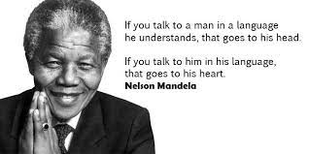

**MODERN LANGUAGES: SPANISH/FRENCH/MANDARIN: HIGHER**

**Rationale**

Language is at the core of thinking. Learners reflect, communicate and develop ideas through language. The Higher Course provides learners with the opportunity to develop skills in listening and talking, reading and writing, which are essential for learning, work and life; to use different media effectively for learning and communication; and to develop understanding of how language works, and use language to communicate ideas and information.

Learners encounter a wide range of different types of texts in different media while they study topics such as family and friends, lifestyles, media, citizenship, education, jobs, work and CV, holiday, countries, cultural events, literature, film and television

[](https://www.google.com/url?sa=i&rct=j&q=&esrc=s&frm=1&source=images&cd=&cad=rja&uact=8&ved=0ahUKEwjSotvJ06bKAhUGThQKHcWADiIQjRwIBw&url=https://thimble.webmaker.org/project/156784/remix&psig=AFQjCNFthE7AF9pnz7J9AzPCE082me9aYQ&ust=1452769850059099)**Course Outline**

[](http://www.google.com/url?sa=i&rct=j&q=&esrc=s&frm=1&source=images&cd=&cad=rja&uact=8&ved=0ahUKEwiXvtO41KbKAhUFNxQKHQvHDR8QjRwIBw&url=http://www.forbes.com/sites/chriswright/2014/12/09/how-sovereign-wealth-funds-bought-spain/&psig=AFQjCNF6Ibkupa1m9nCciQmiOfPxsoWvwQ&ust=1452770020436214)**Mandatory Units**

**Understanding Language (Higher)** 9 SCQF credit points

**Using Language (Higher)** 9 SCQF credit points

Course assessment 6 SCQF credit points

This Course includes six SCQF credit points to allow additional time for preparation for

Course assessment. The Course assessment covers the added value of the Course.

**Course Assessment**

**Modern Languages: Understanding Language (Higher)**

Learners will be required to provide evidence of their reading and listening skills in the modern language, using detailed language in one or more of the contexts of society, learning, employability, and culture.

**Modern Languages: Using Language (Higher)**

Learners will be required to provide evidence of their talking and writing skills in the modern language, using detailed language in one or more of the contexts of society, learning, employability, and culture.

Reading + translation 30 marks

Writing 20 marks (scaled to 30 marks)

[](http://www.google.com/url?sa=i&rct=j&q=&esrc=s&frm=1&source=images&cd=&cad=rja&uact=8&ved=0ahUKEwjx15zz1KbKAhVHRBQKHSa-BS0QjRwIBw&url=http://3dprint.com/109668/3d-printing-future-of-china/&bvm=bv.111396085,d.d2s&psig=AFQjCNF75IgAOaDcmqcVqjTlrjmaS_a6sg&ust=1452770136323524)Listening 20 marks (scaled to 30 marks)

Talking assessment 30 marks

**Conditions of Award**

To gain the award of the Course, the learner must pass all of the mandatory units and the external exam.

Higher courses are graded on A-D basis

Units Assessments are Pass / Fail one Reading

one Listening

one Writing

one Talking

**Recommended Entry**

Entry to this Course is at the discretion of the school. However, learners would normally be expected to have attained the skills, knowledge and understanding required by the following or by equivalent qualifications and/or experience:

National 5 Modern Languages Course or relevant component Units

**Progression**

♦ Advanced Higher Modern Languages or any relevant component Units

♦ Higher Modern Languages in another modern language

♦ Modern Languages for Work Purposes Units (SCQF levels 6 or 7)

♦ further study or training

♦ employment

**Purpose**

The aim of this course is to offer progressive development of competence in the four skill areas of listening, speaking, reading and writing, within a widening range of contexts and language purposes.

**Careers which value students with a language background include:**

* Law
* Tourism
* Business
* Civil Service
* Hospitality
* Medicine
* Journalism
* Translation
* Teaching

**MODERN LANGUAGES: ADVANCED HIGHER**

The course is open to students who have successfully completed the Higher course. The course requires extensive literature reading, a study of civilisation of the country, knowledge of current affairs in the country.

**Internal Assessment**

Reading, Listening, Writing, Talking (Talking is assessed by an SQA visiting examiner at the end of the course) (50 marks)

**External Assessment**

Reading & Translation (50 marks), Listening & Writing (30 & 40 marks)

**Portfolio**

The portfolio essay should be **in English** and be between 1,200 and 1,500 words

**Conditions of Award**

To gain the award of the Course, the learner must pass all of the mandatory units and the external exam.

Advanced Higher courses are graded on A-D basis

Units Assessments are Pass / Fail one Reading

one Listening

one Writing

one Speaking

**Progression**

* Higher education courses at appropriate levels, including HNC or HND or degree courses offered by foreign language agencies at appropriate levels
* Employment, possibly making use of foreign language competence.



**Careers which value students with a language background include:**

* Law
* Tourism
* Business
* Civil Service
* Hospitality
* Medicine
* Journalism
* Translation
* Teaching

**MODERN LANGUAGES: SPANISH, FRENCH/GERMAN/ MANDARIN**

**LANGUAGES FOR WORK PURPOSES - Level 3/ Level 4 / Level 5/Level 6**

**Purpose**

The aim of these units is to offer progressive development of competence in the four skills; listening, speaking, reading and writing. Candidates will be able to focus on either oral or written communication depending on their level. These units reflect on skills required for employability.

**Recommended Entry**

[](http://www.google.com/url?sa=i&rct=j&q=&esrc=s&frm=1&source=images&cd=&cad=rja&uact=8&ved=0ahUKEwjx15zz1KbKAhVHRBQKHSa-BS0QjRwIBw&url=http://3dprint.com/109668/3d-printing-future-of-china/&bvm=bv.111396085,d.d2s&psig=AFQjCNF75IgAOaDcmqcVqjTlrjmaS_a6sg&ust=1452770136323524)Students will normally be expected to have attained:

* Beginner for Level 3.
* National 4 for Level 5
* National 5 for Level 6
* Higher for Level 7

**Course Details**

Each unit lasts 40 hours and students will study one or more languages in a practical, real life work situation. This course would be useful for students studying Travel & Tourism. It may be possible to organise appropriate work placements for students following this course. Over the year it is anticipated that students will complete at least 3 Units.

The course includes:

* Talking about the job you do
* [](http://www.google.com/url?sa=i&rct=j&q=&esrc=s&frm=1&source=images&cd=&cad=rja&uact=8&ved=0ahUKEwiXvtO41KbKAhUFNxQKHQvHDR8QjRwIBw&url=http://www.forbes.com/sites/chriswright/2014/12/09/how-sovereign-wealth-funds-bought-spain/&psig=AFQjCNF6Ibkupa1m9nCciQmiOfPxsoWvwQ&ust=1452770020436214)Writing a report about and discussing a job
* Writing an application for a job
* Interview skills
* Making a job presentation

**Internal Assessment**

Level 3 1 Talking assessment

[](https://www.google.com/url?sa=i&rct=j&q=&esrc=s&frm=1&source=images&cd=&cad=rja&uact=8&ved=0ahUKEwjSotvJ06bKAhUGThQKHcWADiIQjRwIBw&url=https://thimble.webmaker.org/project/156784/remix&psig=AFQjCNFthE7AF9pnz7J9AzPCE082me9aYQ&ust=1452769850059099) 1 Listening assessment

Level 4 1 Reading assessment

1 Writing assessment

Level 5 /Level 6 1 Talking assessment

1 Writing assessment

**Progression**

Attainment of the award will allow students to progress as follows;

* Pupils can continue with the upper level in the same language –National 5 and Higher could be offered to suitable candidates.
* Pupils can start a unit in a different language
* [](https://www.google.com/url?sa=i&rct=j&q=&esrc=s&frm=1&source=images&cd=&cad=rja&uact=8&ved=0ahUKEwj9yfXf1abKAhVC5RoKHfgDBfUQjRwIBw&url=https://commons.wikimedia.org/wiki/File:Flag_map_of_Germany.svg&bvm=bv.111396085,d.d2s&psig=AFQjCNH0UsFS9_41gdgXTlYRDRFOvE12MA&ust=1452770413157521)Employment, making use of foreign language competency

**ART AND DESIGN – POTENTIAL PATHWAYS**

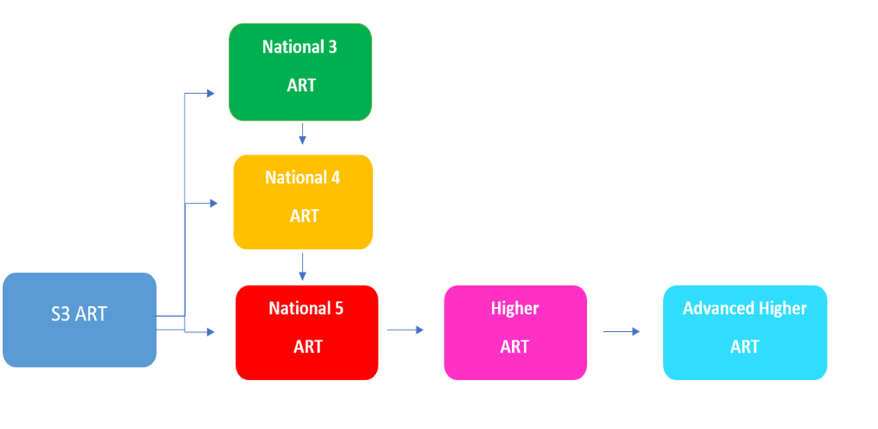



ART & DESIGN: NATIONAL 4

**Recommended Entry**

Students would normally be expected to have undertaken Art & Design in S2 – 3 and be working at National 3 level or above.

**Progression**

Achievement of National 4: Art & Design course might enable progress to:

* National 5 Art & Design, Course.
* National 5 Art & Design Units.
* Higher Art & Design, Course.
* Higher Art & Design, Units.
* Scottish Group Award in a related area at an appropriate level.
* Employment in areas of industries such as design, creative industries or visual arts disciplines.
* This course, or its component units, may form part of one or more Scottish Group Awards.

**Pupils studying Art and Design National 4 will follow the same practical journey as the National 5 course –** *information can be found below***. However, the standard of practical work is expected to be of a lower standard and the National 4 course does not involve a written exam. Instead pupils will be asked to write two essays one design based and the other Expressive.**

**ART & DESIGN: NATIONAL 5**

**Recommended Entry**

* Students would normally be expected to have undertaken Art & Design in S2 - 3.
* A pass at National 4 is desirable but not essential.
* Those wishing to return to the subject after a break of any time are required to submit short drawing test pieces for assessment of potential.

**Components**

**Expressive Activity – Practical Portfolio – External Assessment**

**Design Activity – Practical Portfolio – External Assessment**

**Question Paper – Written Examination – External Assessment**

**Course Structure for N5**

|  |  |  |  |  |
| --- | --- | --- | --- | --- |
| **COMPONENTS** | **ASSESSMENT ARRANGEMENTS** | | **MARKS**  **AVAILABLE** | **PERCENTAGE FOR EACH COMPONENT** |
| **Expressive** | **Portfolio** | **External** | **100** | **40** |
| **Design** | **Portfolio** | **External** | **100** | **40** |
| **Question paper** | **Examination** | **External** | **50** | **20** |
|  | | **TOTAL** | **250** | **100** |

**Expressive Activity – Practical Portfolio**

|  |  |
| --- | --- |
| **Expressive Portfolio** encompasses ***four*** parts | **Marks** |
| **Investigation and Research**  a) A given theme could be growth for example.  b) A genre of choicecould beportraiture, landscape or still life for example. | **40** Marks are available for showing your creative process.  Working through the Investigation/ Development/ Final solution using different mediums and techniques.  **50** Marks are available for demonstrating your expressive skills. |
| **Development**  One idea is selected for development. |
| **Final Solution** |
| **Evaluation**  An Evaluation shall be written after the completion of the portfolio using an SQA template. | **10** Marksare available for justifying using personal opinions the effectiveness of: the creative process, design decisions made throughout the portfolio and visual qualities referring to my theme/ stimulus. |

**Design Activity - Practical Portfolio**

|  |  |
| --- | --- |
| The **Portfolio** encompasses ***five*** parts: | **Marks** |
| **Design brief**  The design area of choice may be graphics or product design for example.  The design brief will require laying out requirements and constraints for your design activity. | **40** Marks are available for showing your design process. |
| **Investigation**  Investigation and researchof the design problem will be done visually- collecting images, market research and existing designs for market research. |
| **Development**  Using research ideas will be developed. The most successful idea will be chosen to develop and explore techniques and materials, making improvements and reflecting on the design brief. | **50** Marks are available for showing your design skills. |
| **Design Solution**  Design solution may be created as a finished concept in 2D or 3D. |
| **Evaluation**  An Evaluation shall be written after the completion of the portfolio using an SQA template. | **10** Marks are available for justifying using personal opinions the effectiveness of: the design process, design decisions made throughout the portfolio and the aesthetic and the functional qualities of the portfolio, visual qualities referring to the design brief requirements. |

**Question Paper – written exam**

|  |  |  |
| --- | --- | --- |
| **FOUR COMPONENTS** | **MARKS** |  |
| **Art Studies**  a) The question paper encompasses an essay involving **two** artists that were studied previously. | **10** |
| b). Social and cultural impact on an artist and their work. | **5** |
| Blind question – analysing a painting that you may not have seen before | **10** |
| **Design studies**  a) The question paper encompasses an essay involving **two** designers that were studied previously. | **10** |
| b) Social and cultural impact on a designer and their designs. | **5** |
| Blind question – analysing a design that you may not have seen before. | **10** |
| **Total** | **50** |

**Expressive Activity – Practical Portfolio**

The expressive Activity encompasses *four* parts:

1. **Investigation**
2. **Development**
3. **Final Piece**
4. **Evaluation**

* Pupils shall be given a **theme**, for example *growth*
* They will choose a **genre** to work from, for example *landscape*
* They will work their way through the **Investigation/ Development/ Final piece** working in different mediums and using different techniques
* An **Evaluation** shall be written after the completion of the portfolio

**Design Activity - Practical Portfolio**

The Design Activity encompasses *five* parts:

1. **Design brief**
2. **Investigation and Research**
3. **Development**
4. **Design Solution**
5. **Evaluation**

* Pupils shall be given a choice of **design area** to work in, for example *Graphics/ Product Design/ Jewellery*
* Pupils shall be given a **theme**, for example *journeys*
* Pupils will write a **design brief** laying out the requirement and constraints of their design activity
* Pupils will **investigate** and **research** their design problem visually - collecting images, market research, existing designs
* Using their **research,** the pupils will develop their ideas
* Pupils choose their most **successful idea** and begin **developing** it – exploring techniques and materials, making improvements and reflecting on the **Design Brief**
* Pupils will create their finished concept in 2D or 3D
* An **Evaluation** shall be written after the completion of the portfolio

**Question Paper – written exam**

There are *two* parts to the question paper

* **Art Studies**
* **Design studies**

The question paper encompasses artworks and designs which the pupils have previously studied and others which are completely new to them.

**Progression**

Achievement of National 4: Art & Design course might enable progress to:

* National 5 Art & Design, Course.
* National 5 Art & Design Units.
* Higher Art & Design, Course.
* Higher Art & Design, Units.
* Scottish Group Award in a related area at an appropriate level.
* Employment in areas of industries such as design, creative industries or visual arts disciplines.

This course, or its component units, may form part of one or more Scottish Group Awards.

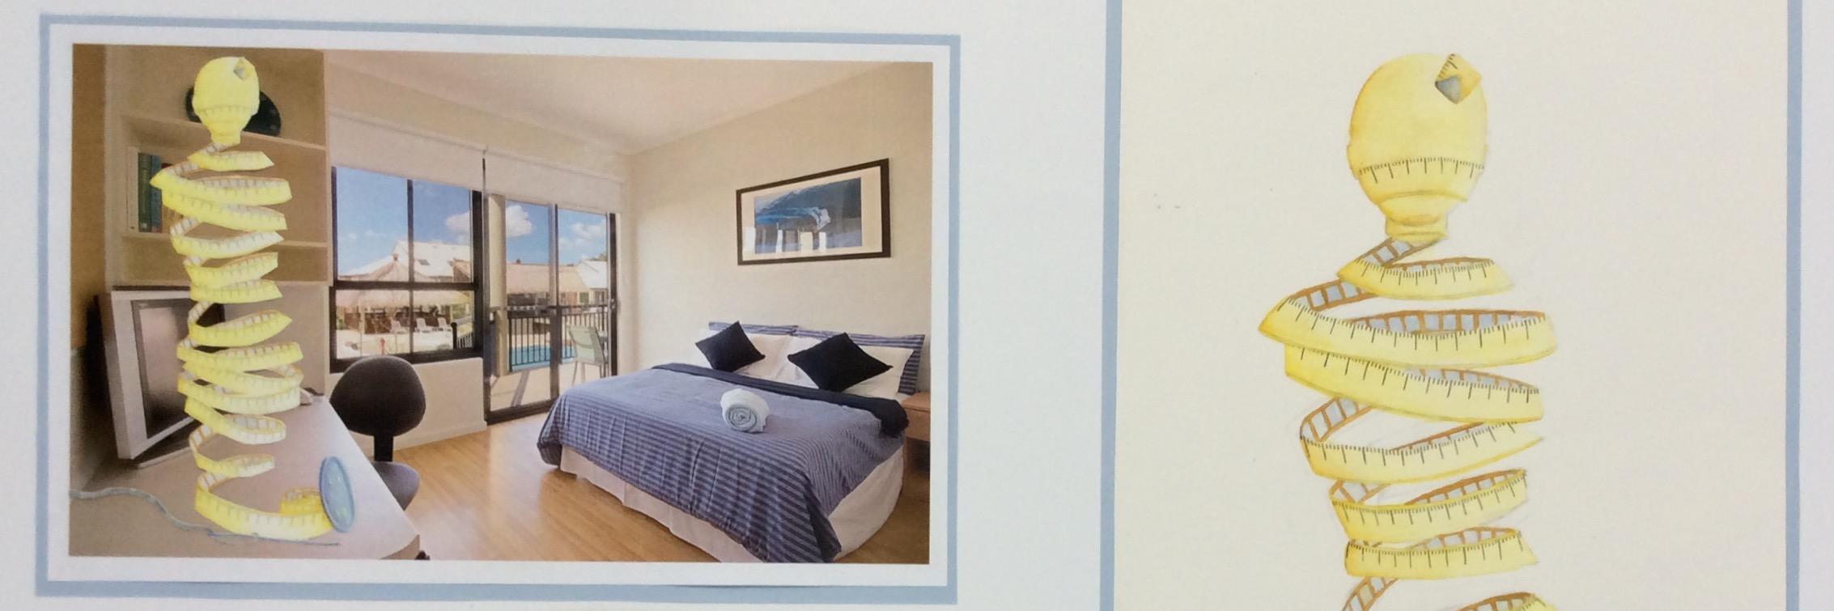

ART & DESIGN: HIGHER

**Recommended Entry**

Students would normally be expected to have undertaken Art & Design in S2 – 3. Previous National 5 study with a ‘C’ pass or above in S4 or S5 is also desirable. Those wishing to return to the subject after a break of any time are required to submit short drawing test pieces for assessment of potential.

**Components**

**Expressive Activity – Practical Portfolio – External Assessment**

**Design Activity – Practical Portfolio – External Assessment**

**Question Paper – Written Examination – External Assessment**

**Pupils studying Art and Design Higher will follow the same practical journey as the National 5 course –** *information can be found above***. However, practical portfolios are expected to be of a higher and more accomplished quality and the written exam is more rigorous.**

|  |  |  |  |  |
| --- | --- | --- | --- | --- |
| **COMPONENTS** | **ASSESSMENT ARRANGEMENTS** | | **MARKS**  **AVAILABLE** | **PERCENTAGE FOR EACH COMPONENT** |
| **Expressive** | **Portfolio** | **External** | **100** | **38.5** |
| **Design** | **Portfolio** | **External** | **100** | **38.5** |
| **Question paper** | **Examination** | **External** | **60** | **33** |
| **TOTAL** | | | **260** | **100** |

**Question Paper – written exam**

|  |  |  |
| --- | --- | --- |
| **SIX COMPONENTS** | **MARKS** |  |
| **Art Studies**  The question paper encompasses an essay involving **one** artists that has been studied previously. Social and cultural impact on an artist and their work. | 10 |
| Blind question – analysing a painting that you may not have seen before | 10 |
| Blind question – analysing a painting that you may not have seen before | 10 |
| **Design studies**  The question paper encompasses an essay involving **one** designer that was studied previously. Social and cultural impact on a designer and their designs. | 10 |
| Blind question – analysing a design that you may not have seen before | 10 |
| Blind question – analysing a design that you may not have seen before. | 10 |
| **Total** | 60 |

**Progression**

Students who achieve Higher Art & Design at ‘A or ‘B’ pass may progress to study at Advanced Higher level, and ‘C’ Passes at our discretion.

**ART AND DESIGN: ADVANCED HIGHER**

The course takes the form of an enquiry similar to Higher, which should produce evidence of work in **two** of the three following areas; Expressive; Design; Art and Design Studies. One of the subjects chosen is major and the other minor. Students will be required to display their work regularly for peer review purposes.

The study is undertaken largely independently, with pupils directing the focus of their study and organising their time accordingly. *Students opting for this course choice are expected to sign up for the school’s Adult Learning Life Drawing Class and to participate in regular public displays of work.*

**Recommended Entry**

Higher - band 4 and above

**ART AND DESIGN: PORTFOLIO COURSE**



This course is available for students in S6 who wish to go into further education to study Art. Students will be shown how to build up a relevant portfolio including drawing, painting, observation, expression and the correct use of a sketch book. Students will be required to display their work regularly for peer review purposes.

*Students opting for this course choice are expected to sign up for the school’s Adult Learning Life Drawing Class and to participate in regular public displays of work.*

**Recommended Entry**

Higher - band 4 and above

DRAMA – POTENTIAL PATHWAYS

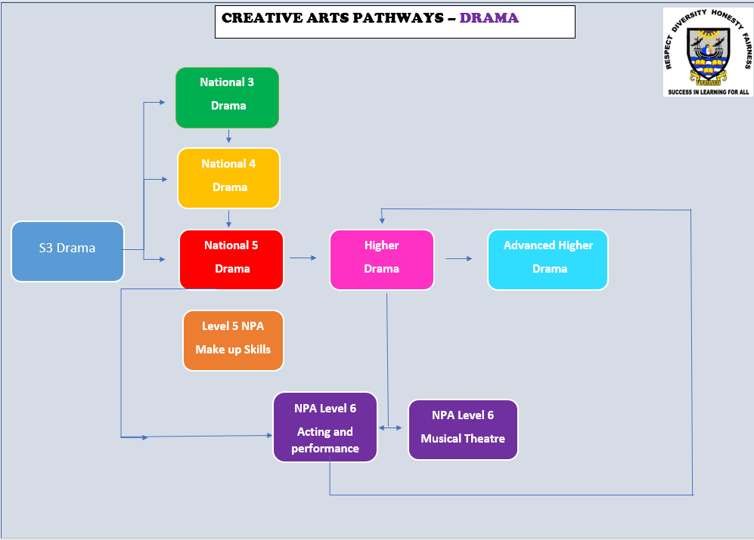



**DRAMA: NATIONAL 4**

**Mandatory Units:**

* Drama Skills - Students will work together or individually to devise, present and evaluate a piece of drama based on a stimulus.
* Production Skills - Students will explore and use theatre production to enhance performances including but not restricted to lighting, costume, Hair/Make-up, sound and props design.

**Added Value Unit:**

Performance - Using the previously learnt skills, students will present a full performance themselves, taking full control of all acting or theatre production roles. Students will also complete an AVU booklet.

**Course Assessment**

Two *Unit Assessments*, (Drama Skills Production Skills) of class project work, plus an “Added Value” *Performance* based on these units will be examined.

ALL ASSESSMENT WILL TAKE PLACE AT SCHOOL LEVEL - THERE IS NO EXTERNAL EXAMINATION AT National 4.

All units are necessary for a student to obtain the Course Qualification for National 4 Drama. If a student completes both Mandatory Units and does not complete the Added Value Unit, they only receive Unit Qualifications for the completed units.

**Recommended Entry**

Entry to this Course is at the discretion of the centre. However, learners would normally be expected to have attained the skills, knowledge and understanding required by the following or by equivalent qualifications and/or experience:

National 3/4 Design and Manufacture Course or relevant component Units

In terms of prior learning and experience, relevant experiences and outcomes may also provide an appropriate basis for doing this Course.

Skills in literacy and numeracy are desirable.

## Progression

Achievement of National 4: Drama course might enable progress to:

* National 5 Drama Course.
* National 5 Drama Units.
* 2-year Higher Drama Course.
* Higher Drama Units.
* NPA in Acting and Performance
* Employment in areas of industries such as design, creative industries or arts disciplines.



**DRAMA: National 5**

**Purpose**

The aim of this Course is to provide a range of learning experiences that will develop important skills and areas of specific drama knowledge. The Course seeks to provide opportunities for candidates to:

* explore relationships, social attitudes and issues;
* explore and use language, movement and theatre as a means of expression and communication;
* acquire a range of theatre production skills;
* develop devising skills and contribute to a presentation;
* increase interest in and knowledge of theatrical performance.

.

**Mandatory Units:**

***Unit 1: Drama Skills***

Developing ideas for drama and contributing to the drama process. Pupils will be assessed on performing, folio work and evaluation.

***Unit 2: Theatre Production Skills***

Analysing a range of production skills (Acting, Lighting, Sound, Set, Props, Costume, Hair/Make-up) and applying that range of production skills to their own ideas and concepts. Pupils will be assessed on performing, folio work and evaluation.

In each unit pupils are given the opportunity to present their work to an invited audience, to help build confidence and organisational skills.

***Unit 3: Performance*** *(Course Assessment)*

Using the previously learnt skills, students will present a full performance themselves taking full control of all acting or theatre production roles.

The will present to an external examiner using their chosen role. They will write a short 400 word essay to show how they prepared for their role.

They will take part in a booklet style written exam during the exam diet in May.

**Course Assessment**

The Course assessment will comprise of one question paper lasting 1.5 hours and worth a total of 60 marks and a practical examination of acting worth 60 marks.

* Question Paper 1 is worth 40%
* Practical examination is worth 60%

# Recommended Entry

At the discretion of the department, however, pupils would normally be expected to have attained the skills, knowledge and understanding from:

National 3 Drama Course or relevant component units

**Progression**

Students who achieve National 5 Drama may progress to study at Higher level in negotiation with the department, or an NPA in Acting or Musical Theatre.

**DRAMA: HIGHER**

**Purpose**

The aim of this Course is to provide a range of learning experiences that will build on important skills and areas of specific drama knowledge. The Course seeks to provide opportunities for candidates to:

* explore relationships, social attitudes and issues;
* explore and use language, movement and theatre as a means of expression and communication;
* acquire a range of theatre production skills;
* develop devising skills and contribute to a presentation;
* develop textual analyse skills
* build on the ability to direct and perform theatre productions
* increase interest in and knowledge of theatrical performance.

**The Course:**

**During Higher Drama pupils will learn about the following:**

* Directing Skills and will be given the chance to direct a small piece of theatre
* Theatre Production Skills (lighting, sound, props, costume, hair/makeup, set)
* Acting and Performance skills
* Textual and Performance Analysis (regular theatre visits will take place)
* Students will learn about stage craft and the skills required to put on a small scale production.

**Course Assessment**

The Course assessment will comprise of one question paper lasting 2.5 hours and worth a total of 50 marks and a practical examination of acting worth 60 marks.

* Question Paper 1 is worth 40%
* Practical examination is worth 60%

Pupils can select what production role they would like to be assessment on for their performance, this can be acting, directing or design. The written exam will take place during the exam diet in May/June. This will be extended writing tasks based on a text they have studied and a performance they have seen, alongside a section of question and answers written from the perspective of an actor, director or designer.

**Recommended Entry**

At the discretion of the department, however, pupils would normally be expected to have attained the skills, knowledge and understanding from:

National 5 Drama Course or relevant component units

**Progression**

Successful completion of the course may lead to:

* Advanced Higher in Drama
* NPA in Acting and Performance or Musical Theatre
* NC or HNC at College
* Further study of Theatre Studies; combined degree or entry to general Arts Courses at University
* Entry to Drama College (e.g. RCS)
* Employment in Performing Arts.

**DRAMA: ADVANCED HIGHER**

**Purpose**

The purpose of this course is to provide a range of learning experiences, which will develop important skills and areas of specific drama knowledge. This course will also promote the candidates’ knowledge and understanding of theatre. Advanced Higher Drama focuses on the skills of acting, directing and devising in a variety of dramatic contexts. The candidates will have the opportunity to:

* Build on their understanding of key theatre practitioners
* Devise and Direct their own piece of drama
* Learn about the areas of theatre production, acting and directing at an advanced level
* Build on their drama practise and develop their knowledge of the subject
* Build on leadership and management skills by planning and organising a mini Drama Festival

**Recommended Entry**

Students will have been expected to have attained one of the following:

* Higher Drama pass at a C or above
* Other appropriate prior experience of drama.

**Course Structure**

The course has three mandatory units as follows:

***Unit 1 : Drama Skills***

Candidates will devise & direct their own drama and present the end product to an invited audience. They will plan and organise a small Drama Festival to show case their work as a class.

***Unit 2: Drama Production Skills***

Candidates will explore a chosen classic text from the perspective of an actor, a member of the theatre production team or of a director in preparation for a production. They will explore the work of key theatre practitioners and learn about the art of creating theatre in their style.

***Unit 3: Performance***

Candidates will perform two contrasting characters as an actor (one with a partner and one monologue), direct a 35 minute workshop as a director or design set and two other production areas as a designer.

**Course Assessment**

Pupils can select what production role they would like to be assessment on for their performance, this can be acting, directing or design. The Course assessment will also require candidates to write a 3000 word dissertation on a drama topic of their choice. This will be guided throughout the year by workshops and tutorials. They will also write a project assignment under assessment conditions based on a production they have studied, this question will be set by SQA.

* Dissertation is worth 30% (submitted in May for marking)
* Practical examination is worth 50%
* Project Assignment is worth 20%

**Progression**

Successful completion of the course may lead to:

* Further study of Theatre Studies; combined degree or entry to general Arts Courses at University
* Entry to Drama College
* Employment in Performing Arts.

See web links on Drama Department site for further details of courses.



**BEAUTY**

|  |
| --- |
| **MAKE UP AND BEAUTY– NPA Level 5/6** |
| **Introduction** |
| This course enables learners to:   * Learn about the make-up industry and working as a professional make-up artist * Understand current make-up trends and the use of social media to promote your make-up business * Use prosthetics and special effects make-up * Understand bridal make-up and working as a bridal make-up artist * Understand the work of a face painter and experiment with different makeup to create mythical and fantasy characters. |
| **Course Structure** |
| The course consists of three units:   * Unit 1: Bridal Make-up (Skincare and safety, working in the industry) * Unit 2: Contemporary make-up. (Special effects, face painting) * Unit 3: Corrective make-up and current trends. |
| **Assessment** |
| * All units are internally assessed * No examination * You will keep a portfolio with all your work. |
| **Entry Requirements** |
| * A keen interest in learning about the skills of working as a professional make-up artist. |
| **Progression** |
| * College (Edinburgh college offer a makeup course) * Employment (part-time and full-time jobs working in a salon, in the theatre, on photoshoots etc) * Working as an entrepreneur. You will develop skills to market yourself as a make-up artist. |
| **Useful Websites** |
| [NPA Make-Up Skills - SQA](https://www.sqa.org.uk/sqa/63844.html)  [Makeup Artistry HND | Edinburgh College](https://www.edinburghcollege.ac.uk/courses/browse/makeup-artistry-hnd-cr1makeb22)  [Fashion Makeup HNC at Edinburgh College | The Complete University Guide](https://www.thecompleteuniversityguide.co.uk/courses/details/fashion-makeup-hnc/57988142) |

**NPA Musical Theatre Level 6**

**Purpose**

The aim of this Course is to provide a range of learning experiences that will develop important skills and areas of specific acting and musical theatre knowledge. The Course seeks to provide opportunities for candidates to:

* Develop a range of skills associated with the triple discipline of Musical Theatre practice
* Develop a range of appropriate skills in voice, movement and acting
* Develop specific skills for presentation at audition
* Apply combined practical skills in audition format
* Develop self-presentation skills
* Develop self-evaluation skills, enabling professional development
* Develop professional attitudes

.

**Mandatory Units:**

***Acting through song-***

1***.***Research and interpret the text of contrasting songs

2 Create and portray a character in the rehearsal process and performance of contrasting songs

3 Evaluate character development and final performance

***Optional Units – Pupils have a choice of 2***

***Opt1: Solo Singing Skills***

1.Demonstrate singing techniques for solo theatre performance

2 Rehearse and perform solo songs suitable for theatre performance

3 Evaluate the rehearsal and performance process

***Opt2:Group Singing Skills***

1.Demonstrate singing techniques for group theatre performance

2 Rehearse and perform group songs suitable for theatre performance

3 Evaluate the rehearsal and performance process

***Opt3:Group Dance Performance***

***1.***Prepare a performance of a group dance Practical assignment

2 Participate in the staging and performance of a group dance Practical assignment

3 Evaluate the process and the performance

***Opt4:Preparation for Audition.***

1,Identify the types of work available within a chosen sector of the performing arts industry

2. Prepare for an audition Written and/or oral evidence

3 Rehearse for and perform an audition Performance

4 Evaluate own performance at an audition

**Course Assessment**

* The assessment strategy for this NPA aims for a balanced approach to assessment through a mix of practical application and coursework.
* The practical based assessments are also chosen through two optional units as well as one mandatory unit.

# Recommended Entry

At the discretion of the department, however, pupils would normally be expected to have attained the skills, knowledge and understanding from:

National 3/4 Drama Course or National 3/4 Music Course

**Progression**

* Students who have achieved SCQF level 5 (Intermediate 2 Drama or Music or Standard Grade Drama or Music) and who wish to progress further.
* Students who have achieved SCQF level 6 (Higher Drama, Music or Dance) and who wish to extend their practical skills and knowledge of musical theatre.
* Students who seek an alternative progressive pathway to Advanced Higher Drama/Music/Dance Units and Courses.
* Students auditioning for drama/music/dance programmes in further or higher education — the Units Preparation for Audition and Acting through Song will help students planning to audition for Musical Theatre of Performing Arts Courses.
* Students preparing for professional theatre auditions — the Unit Preparation for Audition along with any of the other optional Units will help prepare students who are planning to enter the professional theatre/musical theatre or performing arts industry.

MUSIC – POTENTIAL PATHWAYS

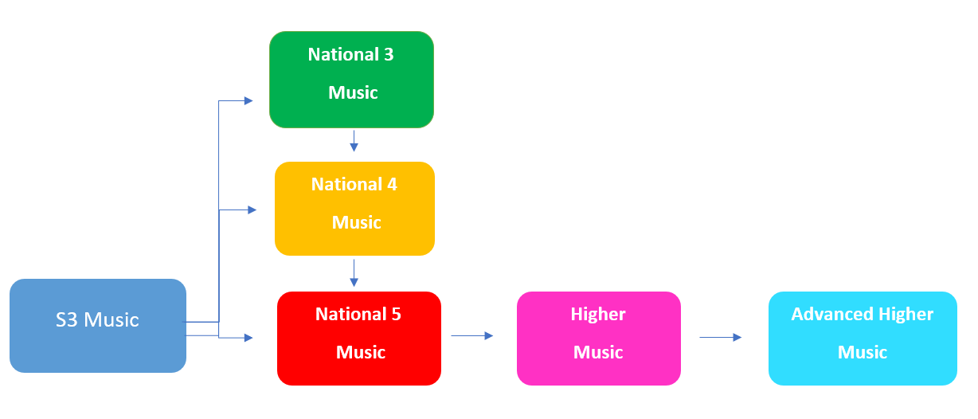

**MUSIC: NATIONAL 4**

**Purpose**

The aim of the course is to provide a range of learning experiences and knowledge to develop important skills and areas of specific music knowledge. The course provides opportunities for candidates to:

* participate in group and individual performances
* develop their practical skills through focusing on two instruments of your choice
* develop their understanding of music literacy
* learn about different styles of music
* explore different ways of composing music

.

This course provides learners with opportunities to continue to acquire and develop the attributes and capabilities of the four capacities of Curriculum for Excellence as well as skills for learning, life and work.

**Mandatory Units** Performing Skills

Understanding Music

Composing Skills

**Music: Performing Skills**

This unit allows you to:

* Develop performance skills in a wide range of styles, in solo and in group situations, on either two instruments or one instrument and voice to a standard of Grade 2 or above (or an equivalent).
* Create and play a complete programme of music of 8 minutes.
* Broaden your musical experiences and skills.
* Participate in group and solo performances, playing music of your choice.

**Music: Understanding Music**

This unit allows you to:

* Listen to a variety of music and develop an awareness of a range of different musical styles and concepts.
* Undertake a personal research project based on a style of music of your choice.
* Gain a broader understanding of reading musical notation and musical literacy (identifying a range of music signs and symbols).

**Music: Composing Skills**

This unit allows you to:

* Create music in practical musical activities.
* Compose music, showing originality, creativity, planning and good use of compositional techniques.
* Arrange and improvise on musical ideas.
* Build on previous work to achieve a higher level of skill.

**Added Value Unit**

* Performance on both instruments/voice showing challenge and application.

**Course Assessment**

The course is assessed through a combination of internal unit assessments by the class teacher (externally verified by the SQA). A full National 4 qualification can only be awarded if the AVU is completed. Pupils will be able to display their own musical skills to different audiences using a range of presentation methods. They will also contribute as part of an audience for other students’ performances.

**Recommended Entry**

Students would normally be expected to have attained:

*(Exceptional circumstances would also be considered)*

National 3 Music Course award

The Units making up a National 3 Music award

Be playing at Grade 1 level or above (or equivalent) on at least one instrument.

*National 4 students are given priority for receiving free instrumental tuition in school and performing in school ensembles and concerts.*

**Progression**

Students who achieve National 4 Music would progress to:

* National 5
* Further study, employment or training.

[](https://www.google.co.uk/url?sa=i&rct=j&q=&esrc=s&source=images&cd=&ved=2ahUKEwjhhMuN15bmAhVOOBoKHZoTCTIQjRx6BAgBEAQ&url=http://pamis.org.uk/news/tag/music/&psig=AOvVaw1iyKCP_qaK5EQFg14mzSEz&ust=1575366270570933)

**MUSIC: NATIONAL 5**

**Purpose**

The aim of the course is to provide a range of learning experiences and knowledge to develop important skills and areas of specific music knowledge. The course provides opportunities for candidates to:

* participate in group and individual performances
* develop their practical skills through focusing on two instruments of your choice
* develop their understanding of music literacy
* learn about different styles of music
* explore different ways of composing music

.

This course provides learners with opportunities to continue to acquire and develop the attributes and capabilities of the four capacities of Curriculum for Excellence as well as skills for learning, life and work.

**Mandatory Units** Performing Skills

Understanding Music

Composing Skills

**Music: Performing Skills**

This unit allows you to:

* Develop performance skills in a wide range of styles, in solo and in group situations, on either two instruments or one instrument and voice to a standard of Grade 3 or above (or an equivalent).
* Create and play a complete programme of music of 8 minutes.
* Broaden your musical experiences and skills.
* Participate in group and solo performances, playing music of your choice.

**Music: Understanding Music**

This unit allows you to:

* Listen to a variety of music and develop an awareness of a range of different musical styles and concepts.
* Gain a broader understanding of reading musical notation and musical literacy (identifying a range of music signs and symbols).

**Music: Composing Skills**

This unit allows you to:

* Create one piece of music which lasts between 1-2:30 minutes.
* Compose music, showing originality, creativity, planning and good use of compositional techniques.
* Build on previous work to achieve a higher level of skill.

**Course Assessment**

The course is assessed through a combination of internal unit assessments by the class teacher (externally verified by the SQA) and external examinations by the SQA. External assessments are in the shape of a Performance exam (50%), an Understanding Music exam (35%) and a Composing Skills Assignment (15%).

**Recommended Entry**

Students would normally be expected to have attained:

*(Exceptional circumstances would also be considered)*

National 4 Music Course award

The Units making up a National 4 Music award.

*National 5 students are given priority for receiving free instrumental tuition in school and performing in school ensembles and concerts.*

**Progression**

Students who achieve National 5 Music would progress to:

* Higher Music
* Free Standing Unit at level 6 or 7 in Performing
* Further study, employment or training.

**[](https://www.google.co.uk/url?sa=i&rct=j&q=&esrc=s&source=images&cd=&cad=rja&uact=8&ved=2ahUKEwi7wbPW2JbmAhUjxoUKHWwgA18QjRx6BAgBEAQ&url=/url?sa%3Di%26rct%3Dj%26q%3D%26esrc%3Ds%26source%3Dimages%26cd%3D%26ved%3D2ahUKEwiA6pSU15bmAhUHdxoKHfjLCXcQjRx6BAgBEAQ%26url%3Dhttps://www.thedj.co.uk/music/%26psig%3DAOvVaw1iyKCP_qaK5EQFg14mzSEz%26ust%3D1575366270570933&psig=AOvVaw1iyKCP_qaK5EQFg14mzSEz&ust=1575366270570933)**

**MUSIC: HIGHER**

**Purpose**

The aim of the course is to provide a range of learning experiences and knowledge to develop important skills and areas of specific music knowledge. It also allows you to develop the skills and knowledge required if you wish to proceed to further study and/or follow a career in music. The Course provides opportunities for candidates to:

* participate in group and individual performances
* develop their practical skills through focusing on two instruments of your choice
* develop their understanding of music literacy
* learn about different styles of music
* explore different ways of composing music

.

This course provides learners with opportunities to continue to acquire and develop the attributes and capabilities of the four capacities of Curriculum for Excellence as well as skills for learning, life and work.

**Mandatory Units** Performing Skills

Understanding Music

Composing Skills

**Music: Performing Skills**

This unit allows you to:

* Develop performance skills in a wide range of styles, in solo or group situations, on **one** of the following combinations: one instrument/voice and accompanying; one instrument and voice or two instruments of your choice at the equivalent of Grade 4 level or above
* Create and perform a programme of 12 minutes of music of your choice
* Broaden your musical experience and skills.

**Music: Understanding Music**

This unit allows you to:

* Consolidate and extend your conceptual understanding of music
* Broaden and deepen your listening skills
* Demonstrate enhanced ability to relate sound to printed music.

**Music: Composing Skills**

This unit allows you to:

* Compose one piece of music which lasts between 1-3:30 minutes with evidence of originality, planning and good use of compositional techniques such as the deployment of selected concepts; arranging and improvising may be included where appropriate
* Broaden and deepen your creative skills

**Course Assessment**

The course is assessed through a combination of internal unit assessments by the class teacher (externally verified by the SQA) and external examinations by the SQA. External assessments are in the shape of a Performance exam (50%), an Understanding Music exam (35%) and a Composing Skills Assignment (15%).

**Recommended Entry**

Students would normally be expected to have attained either:

*(exceptional circumstances would also be considered)*

National 5 Music Course award

Demonstrate playing ability on at least one instrument/voice at Grade 4 level or above

**Progression**

Successful completion of this course may lead to:

* Advanced Higher in Music
* Free Standing Unit at level 7 in Performing
* Further study, employment or training.

[](https://www.google.co.uk/url?sa=i&rct=j&q=&esrc=s&source=images&cd=&ved=2ahUKEwj9osHm2pbmAhVQUhoKHeauAnoQjRx6BAgBEAQ&url=https://www.azutura.com/en/vintage-music-background-wallpaper-wall-mural&psig=AOvVaw2xa6MnEhWDKcrk_b9zvGwm&ust=1575367332426334)

**MUSIC: ADVANCED HIGHER**

**Purpose**

The course provides you with the opportunity to develop musical versatility and particular areas of interest. You can gain understanding of music as a powerful medium of communication with a strong influence throughout the modern world. Flexibility within the overall structure allows you to select a stimulating course, well matched to your individual interests and needs. Emphasis is placed on the study of music through practical activities which will expose you to a variety of cultures

**Mandatory Units** Performing Skills

Understanding and Analysing Music

Composing Skills

**Music: Performing Skills**

This unit allows you to:

* Develop performance skills in a wide range of styles, in solo or group situations, on **one** of the following combinations: one instrument/voice and accompanying; one instrument and voice or two instruments at the equivalent of Grade 5 level or above
* Create and perform a programme of 18 minutes of music of your choice
* Build on previous work to achieve a higher level of skill
* Broaden your musical experience and skills

**Music: Understanding Music**

This unit will offer opportunities to:

* Extend your listening skills through a more in-depth approach
* Identify appropriate musical concepts and comment on their development with perception

**Music: Composing and Analysing Skills**

This unit will offer opportunities to:

* Compose/arrange a piece of music which lasts between 1-4:30 minutes with evidence of originality, planning and good use of compositional techniques such as the deployment of selected concepts; arranging and improvising may be included where appropriate
* To extend their creative skills through a more in-depth approach
* Explore and analyse one piece of music of your choice, through completing a research assignment

**Course Assessment**

The course is assessed through a combination of internal unit assessments by the class teacher (externally verified by the SQA) and external examinations by the SQA. External assessments are in the shape of a Performance exam (50%), an Understanding Music exam (35%) and a Composing Skills Assignment (15%).

**Recommended Entry**

Students would normally be expected to have attained either:

*(exceptional circumstances would also be considered)*

Higher Music Course award

Demonstrate playing ability on at least one instrument/voice at Grade 5 level or above

**Progression**

Successful completion of this course may lead to:

Further study, employment or training.

<https://www.ucas.com/undergraduate/subject-guide-list/music>

<http://www.edinburghcollege.ac.uk/Courses/Music%20and%20Sound%20Production>

[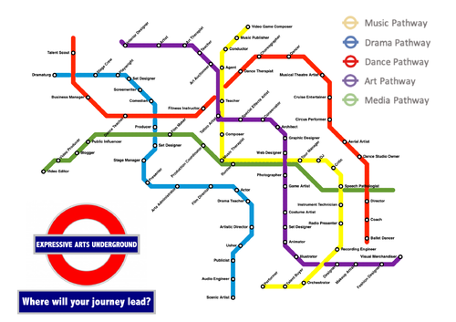](https://www.google.co.uk/url?sa=i&rct=j&q=&esrc=s&source=images&cd=&ved=2ahUKEwiLqdCoz5bmAhXPxoUKHcVXBlAQjRx6BAgBEAQ&url=https://www.tes.com/teaching-resource/expressive-arts-aole-careers-poster-12175739&psig=AOvVaw1Ud7EdUkRxpI36t0Jj9H29&ust=1575364255138123)

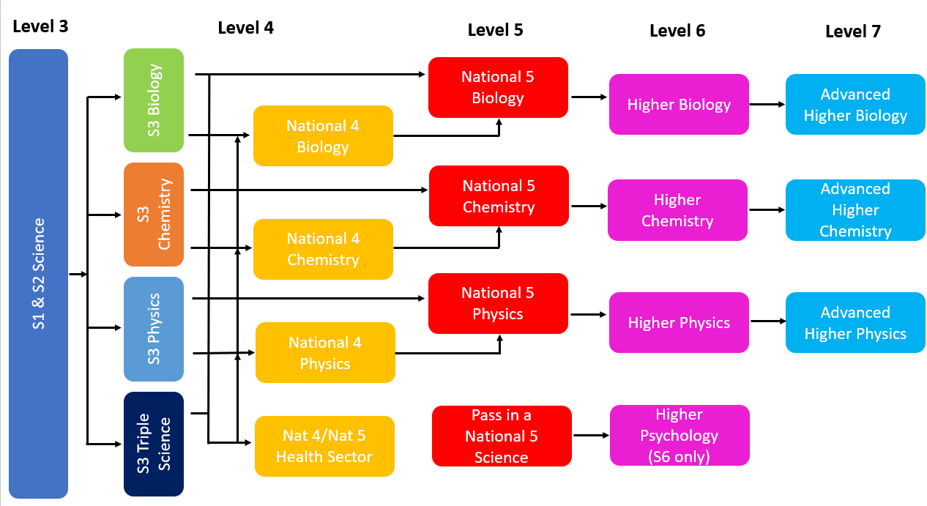**SCIENCE – POTENTIAL PATHWAYS**

**BIOLOGY**



**Why study Biology?**

How does my body work? Why do I get ill and how does my body fight off disease? What is cancer and could we find a cure one day? What is DNA and how does it influence what I am like? Why are plants so important, and why could we not survive if they die out? What impact are we having on the living world – good or bad?

If these questions sound interesting then Biology is the subject for you. Biology is the study of life and biologists try to understand all living things - from microscopic cells up to complex organisms - and how they interact with each other. It’s about better understanding both ourselves and the world we live in. Biology also helps us to tackle some of the problems facing us in the 21st century, whether it be managing the outbreak of disease or helping to conserve endangered animals.

**BIOLOGY: NATIONAL 4 and NATIONAL 5**

**What you’ll study**

Both courses are split into three units – Life on Earth, Cell Biology and Multicellular Organisms – but the content and demands each course are different.

The topics you would cover include:

* Biodiversity and how plants and animals depend on each other
* Impact of humans on the environment
* Inner workings of cells, including the role of DNA and how cells make energy to keep us alive
* Key role plants play in the world, including their amazing ability to make sugar from water and air
* How the heart, lungs and brain work
* Genetic information and predicting what children may inherit from their parents

**What should I have done before?**

For National 4, there are no specific entry requirements, but basic literacy and numeracy skills are required.

If you have done National 4 Biology in S4, you **may** be able to move on to National 5 Biology. However, it is a significant jump in the level of demand and is not for everyone.

If you have passed National 5 in another science (preferably with a grade B or better), then you should be able to pick up National 5 Biology.

**National 4 or National 5?**

The pace of the National 4 is a little easier as it has less content than the National 5 course.

Both courses need good literacy skills – there are lots of new biological words that must be learned and written tasks that must be completed to a specified standard.

You’ll need basic numeracy skills to do well at National 4, e.g. carrying out calculations and reading numbers from graphs.

National 5 is a much more demanding course – there is more content and vocabulary, and topics are studied to a greater depth. You’ll need good numeracy skills to tackle more complex calculations, and you will be expected to analyse data and graphs.

**Assessment in National 4**

You have to:

* Pass short written tests for each unit
* Write up at least one experiment report, to the required standard, showing that you can plan, carry out and make conclusions from an experiment.
* Complete an Added Value unit – this involves more in-depth research on a topic in Biology. It is usually 300-500 and can be presented in a number of different ways. However, it **must** be done to the required standard, and so requires good literacy skills.

There is **no external exam** for National 4 Biology – all the assessment is done in school. However, the SQA check samples of work, so assessment tasks **must** be done to the required standard.

**Assessment in National 5**

There are no formal SQA tests at the end of each unit, but you will have ‘in-house’ assessments to check on your progress.

(In some circumstances, you may do separate Level 5 Unit assessments if you’re not able to complete the whole course – this will allow you to pick up some Unit Awards. If this is the case, you’ll also need at least one experiment report, fully written up to a required standard, showing that you can plan, carry out and report on a biology investigation.)

You will do an Assignment. Although you do this in school, it counts towards 20% of your final exam grade. The Assignment is a long report – about 800-1000 words – on a biology topic which you have researched for yourself. It involves a report on a compulsory experiment, gathering, analysing and presenting data, and coming to well-argued conclusions. This part of the course has been removed in recent years due to the pandemic and its impact, but we expect it to return.

There is a final exam paper, set and marked by the SQA.

**What might happen next?**If you’re successful at National 4, you may move on to National 5 Biology. However, it can be a big step up – so you might want to consider doing another science (Physics or Chemistry) at National 4 instead.

If you’re successful at National 5 and get a grade B or better in the final exam, you can look forward to studying Higher Biology in S5 or S6. Or you may choose to pick up Chemistry or Physics at National 5.

**And in the future…?**

Regardless of what you intend to do in the future, studying a Science develops skills valued by employers, colleges and universities, such as the ability to communicate effectively, solve problems, work to deadlines, analyse information and numerical data and work with others.

Biology can also be useful for many career pathways, including medical careers (such as nursing, physiotherapy and medicine) as well as a variety of biological degrees including sports science, botany and animal behaviour. Studying Biology could also lead to job opportunities in organisations such as botanic gardens or zoos, or working in a laboratory.

**BIOLOGY: HIGHER**

**What you’ll study**

The Higher Biology course is made up of three units – DNA and the Genome, Metabolism and Survival, and Sustainability and Interdependence. The topics you’ll cover include:

* Structure of DNA, how it is arranged in the genome and gene expression evolution and how evidence for this has been obtained
* Role of enzymes in metabolic pathways, including respiration
* Adaptations in organisms for maintaining metabolism
* Manipulating metabolism in the lab, including DNA technology
* Food production and photosynthesis
* Understanding relationships between organisms, including symbiosis and social behaviour
* Measuring biodiversity and considering why it is under threat

**What should I have done before?**

You should have completed National 5 Biology and have achieved – or be expecting – at least a grade C. (Note that most candidates who get a grade C at National 5 take 2 years to complete Higher Biology). It is sometime possible to ‘crash’ Higher Biology in S6. To do this you will need to have done very well in your Higher science(s) in S5, and demonstrate willingness to put in the extra time to make up the required knowledge.

**Assessment in Higher Biology**  
There are no formal SQA tests at the end of each unit, but you will have ‘in-house’ assessments to check on your progress.

(In some circumstances, you may do separate Level 6 Unit assessments if you’re not able to complete the whole course – this will allow you to pick up some Unit Awards. If this is the case, you’ll also need at least one experiment report, fully written up to a required standard, showing that you can plan, carry out and report on a biology investigation).

You will do an Assignment, similar to that in National 5 – but in more depth. Although you do this in school, it counts towards your final exam grade. The Assignment is a long report on a biology topic which you have researched for yourself. It involves reports on experiments, gathering, analysing and presenting data, and coming to well-argued conclusions. Again, this part of the course has been removed in recent years due to the pandemic and its impact, but we expect it to return.

There is a final exam paper, set and marked by the SQA.

**What might happen next?**

A grade B or better in Higher Biology can lead to Advanced Higher Biology in S6. Or you may choose to pick up another science subject at Higher.

**And in the future?**

Higher or Advanced Higher Biology can lead on to a wide variety of Biology degrees, including zoology, parasitology, neuroscience, physiology and sports science, microbiology pharmacology, veterinary medicine or biosciences, as well as courses with a health focus, such as medicine, nursing, and physiotherapy.

Regardless of what you intend to do in the future, studying Biology develops skills valued by employers, colleges and universities, such as the ability to communicate effectively, solve problems, work to deadlines, analyse information and numerical data and work with others.

**BIOLOGY: ADVANCED HIGHER**

**What you’ll study**

The Advanced Higher Biology course is made up of three units – Cells and Proteins, Organisms and Evolution and Investigative Biology. In addition, you’ll independently carry out an in-depth experimental project. The topics you’ll cover include:

* Protein structure, their interactions with membranes and their role in cell division
* Lab techniques used to study proteins
* Evolution, variation and the importance of sexual reproduction
* Parasites, how they are spread and the host immune response
* Ecological field work for measuring variation and classifying organisms
* How scientists design experiments and how they share their findings with the scientific community and the wider world
* Critical evaluation of biological research

**What should I have done before?**

Higher Biology, with at least a grade B. Whilst Chemistry is not essential, it can be beneficial for studying Advanced Higher Biology.

**Assessment in Higher Biology**  
There are no formal SQA tests at the end of each unit, but you will have ‘in-house’ assessments to check on your progress.

You will carry out extended research and practical work into a physics topic – your ‘project’. Your report on this project (about 4500 words) will be marked by the SQA and contributes to your final exam award. The project takes time and dedication – you need to commit to working on it in your study periods, as class time is likely to be limited. As with National 5 and Higher, this part of the course has been removed in recent years due to the pandemic and its impact, but we expect it to return.

There is a final exam paper, set and marked by the SQA.

**What next?**

Higher or Advanced Higher Biology can lead on to a wide variety of Biology degrees, including zoology, parasitology, neuroscience, physiology and sports science, microbiology pharmacology, veterinary medicine or biosciences, as well as courses with a health focus, such as medicine, nursing, and physiotherapy.

Regardless of what you intend to do in the future, studying Biology develops skills valued by employers, colleges and universities, such as the ability to communicate effectively, solve problems, work to deadlines, analyse information and numerical data and work with others.

**CHEMISTRY**

**Why study Chemistry?**

Chemistry is at the heart of all things. It can explain why carrots are orange, why eggs change when they are cooked, why iron rusts – and why stainless steel does not. It explains the reactions that surround us – from our bodies making the proteins that allow is to grow and repair, to the battery in your mobile phone or the fuel in the plane taking you on holiday. Without an understanding of Chemistry and chemical reactions, the world would be a very different place.

Chemistry helps us to make sense of these reactions – and predict how other things will react. It is at the heart of synthesis of new materials, from medicines to plastics and beyond.

Chemistry looks at how the tiny atoms that make up everything join together and how this changes how the things make from them behave, and how we can make use of this.

Studying Chemistry will allow you to find some answers to these questions, and perhaps inspire you to ask more.

**CHEMISTRY: NATIONAL 4 and NATIONAL 5**

**What you’ll study**

Both courses have the same three unit titles – Chemical Changes and Structure, Nature’s Chemistry and Chemistry in Society– but the actual content and complexity differs.

The topics you would cover include:

* Rates of reaction
* How atoms combine, and how this affects their behaviour
* Acids and alkalis
* Carbon chemistry – fuels and consumer products
* The properties and uses of materials – for example, metals, plastics, smart materials
* Analytical chemistry

**What should I have done before?**

For National 4, there are no specific entry requirements – though see the information in the next section about literacy and numeracy skills.

If you have studied National 4 Chemistry in S4, you **may** be able to move on to National 5 Chemistry. However, it is a significant jump in standard, and is not for everyone. We would like you to be doing National 5 Maths as well.

If you have passed National 5 in another science (preferably with a grade B or better), then you should be able to pick up National 5 Chemistry. Remember that you should have done – or be planning to do – National 5 Maths.

**National 4 or National 5?**

The National 4 course has less content than National 5. It’s still a busy course with a lot to get through, but the pace will be a little easier than National 5.

You’ll need basic numeracy skills to do well at National 4 – particularly arithmetic skills, writing simple formulae and drawing accurate charts and graphs.

National 5 is a more demanding course – more content, with more complex concepts. You’ll need good numeracy skills to handle the ‘maths’ side of chemistry. Ideally, you’ll be doing National 5 Maths as well.

Both courses need good literacy skills – there are written tasks that must be completed to a specified standard.

**Assessment in National 4**

You’ll have short written tests for each of the three units. You have to pass each of these tests.

You’ll need at least one experiment report, fully written up to a required standard, showing that you can plan, carry out and report on a chemistry investigation.

You’ll do an Added Value unit. The form of this can change, but it usually takes the form of longer (about 300-500 words) on a chemistry topic that you have researched. Again, this **must** be done to the required standard, and so requires good literacy skills.

There is no external exam for National 4 Chemistry – all the assessment is done in school. However, the SQA check samples of work – so assessment tasks **must** be done to the required standard.

**Assessment in National 5**

There are no formal SQA tests at the end of each unit, but you will have ‘in-house’ assessments to check on your progress.

(In some circumstances, you may do separate Level 5 Unit assessments if you’re not able to complete the whole course – this will allow you to pick up some Unit Awards. If this is the case, you’ll also need at least one experiment report, fully written up to a required standard, showing that you can plan, carry out and report on a chemistry investigation.)

You will do an Assignment. Although you do this in school, it counts towards 20% of your final exam grade. The Assignment is a long report – about 800-1000 words – on a chemistry topic which you have researched for yourself. It involves a report on a compulsory experiment, gathering, analysing and presenting data, and coming to well-argued conclusions. This part of the course has been removed in recent years due to the pandemic and its impact, but we expect it to return.

There is a final exam paper, set and marked by the SQA.

**What might happen next?**

If you’re successful at National 4, you may move on to National 5 in S5 or S6. It can be a big step up – so you might want to consider doing another science (Physics, Biology or Environmental Science) instead. Remember – to do National 5 Chemistry, you ideally need to be doing National 5 Maths as well.

If you’re successful at National 5 and get a grade B or better in the final exam, you can look forward to doing Higher Chemistry in S5 or S6. (We’d like you to be doing Higher Maths, but there can be some flexibility on this if you did well in National 5 Maths). You could combine Higher Chemistry with picking up another science at National 5 level.

**And in the future…?**

Chemistry qualifications – like all science qualifications - are very well regarded. However far you go in your chemistry career at school, it could lead to a career in hi-tech industries, pharmacy or medicine, industry, environmental science, forensics and many more.

Many employers value the skills you develop in Chemistry. Chemistry students often go on to careers in in a variety of different fields, and find the skills they have learned very useful.

**CHEMISTRY: HIGHER**

**What you’ll study**The Higher Chemistry course is made up of four units – Chemical Changes and Structure, Nature’s Chemistry and Chemistry in Society and Researching Chemistry. The topics you’ll cover include:

* Controlling the rate: learning more about how molecules can react
* Periodicity: how patterns exist in the Periodic Table which help explain Chemistry
* Bonding and properties, with a focus on intramolecular bonding and how it affects properties like viscosity, solubility and boiling point
* Fats and oils, with an emphasis on the Chemistry of cooking, food and perfumes.
* Free radical chemistry, with an emphasis on skincare and the reactions of antioxidants.
* Equilibrium
* Thermodynamics

Throughout the course there is an emphasis on numerical calculations and also on applying your knowledge in unfamiliar situations. There are opportunities for research and for learning practical skills.

**What should I have done before?**You should have completed National 5 Chemistry and have got – or be expecting – a grade B or better. You should have completed, and been successful in, National 5 Maths. Ideally, you should be taking Higher Maths, but there can be some flexibility here if you did very well at National 5 Maths. It is sometime possible to ‘crash’ Higher Chemistry in S6. To do this takes real dedication and excellent mathematical skills. You will need to have done very well in your Higher science(s) in S5, and have achieved at least a grade B in Higher Maths.

If you come in with a grade C, it is very likely that you will need to take the course over 2 years.

**Assessment in Higher Chemistry**  
There are no formal SQA tests at the end of each unit, but you will have ‘in-house’ assessments to check on your progress.

(In some circumstances, you may do separate Level 6 Unit assessments if you’re not able to complete the whole course – this will allow you to pick up some Unit Awards. If this is the case, you’ll also need at least one experiment report, fully written up to a required standard, showing that you can plan, carry out and report on a chemistry investigation.)

You will do an Assignment, similar to that in National 5 – but in more depth. Although you do this in school, it counts towards your final exam grade. The Assignment is a long report on a chemistry topic which you have researched for yourself. It involves reports on experiments, gathering, analysing and presenting data, and coming to well-argued conclusions. As with National 5, this part of the course has been removed in recent years due to the pandemic and its impact, but we expect it to return.

There is a final exam paper, set and marked by the SQA.

**What might happen next?**A grade B or better in Higher Chemistry can lead on to Advanced Higher Chemistry in S6 – as long as you have the maths skills required.

**And in the future?**Higher or Advanced Higher Chemistry can lead on to Medicine or Chemical Engineering degrees. Chemistry graduates are always in demand. Chemistry is rightly seen as a challenging course, requiring good ability and good work habits. The rewards are high as even without going into a career which uses the knowledge and skills you have learned directly; your Chemistry qualification is evidence that you can work hard and learn difficult theory.

**CHEMISTRY: ADVANCED HIGHER**

**What you’ll study**

The Advanced Higher Chemistry course is made up of two units – Inorganic & Physical Chemistry, and Organic Chemistry and Instrumental Analysis. In addition, you’ll carry out a detailed experimental project. The topics you’ll cover include:

* Electromagnetic radiation and atomic spectra
* Atomic orbitals, electronic configurations and the Periodic Table
* Transition metals, colours, ligands and complexes.
* Equilibrium; strong and weak acids, buffers and indicators
* Reaction feasibility
* Molecular orbitals
* Stereochemistry
* Synthesis
* Experimental and analytical techniques

**What should I have done before?**

Higher Chemistry, with at least a grade B. Higher Maths with at least a grade B.

**Assessment in Advanced Higher Chemistry**  
There are no formal SQA tests at the end of each unit, but you will have ‘in-house’ assessments to check on your progress.

You will carry out extended research and practical work into a physics topic – your ‘project’. Your report on this project (about 4500 words) will be marked by the SQA and contributes to your final exam award. The project takes time and dedication – you need to commit to working on it in your study periods, as class time is likely to be limited. Again, as with National 5 and Higher, this part of the course has been removed in recent years due to the pandemic and its impact, but we expect it to return.

There is a final exam paper, set and marked by the SQA.

**What next?**Advanced Higher Chemistry can lead on to Chemistry or Engineering degrees. Examples of further and higher education programmes that learners doing the Course might progress to include medicine, law, dentistry, veterinary medicine, engineering, environmental or health sciences.

Advanced Higher Courses provide good preparation for learners progressing to further and higher education as learners doing Advanced Higher Courses must be able to work with more independence and less supervision. This eases their transition to further/higher education.

Advanced Higher Courses may also allow ‘advanced standing’ or partial credit towards the first year of study of a degree programme.

**PHYSICS**

**Why study Physics?**

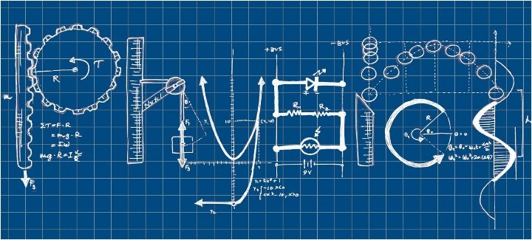It’s human nature to wonder why. Why does the Sun seem to move across the sky? Why is the sky blue? How do signals actually get to my phone? Why are there so many stars? Why do hot things hurt? Is there life on other planets? What actually is a rainbow?

Physics is how we try to explain the world – and the universe – around us. Physics looks for patterns and rules, to help us understand what’s going on and predict what’s going to happen next.

Physics goes from the very small – the particles that make up atoms – to the very large - the galaxies that make up our universe. And pretty much all points in between.

If you’ve ever wondered why – and you want to know the answer – then Physics could be the right choice for you.

**PHYSICS: NATIONAL 4 and NATIONAL 5**

**What you’ll study**

In both National 4 and National 5, you’ll study a wide range of topics – Dynamics, Space, Electricity, Energy, Waves, Radiation - but the actual content and complexity differs.

The topics you would cover include:

* building and analysing electrical circuits
* researching and using the electromagnetic spectrum
* understanding radioactivity
* heat and gases
* measuring and analysing movement – speeds, accelerations and forces
* space exploration and the nature of the universe

**What should I have done before?**

For National 4, there are no specific entry requirements – though see the information in the next section about literacy and numeracy skills.

If you have done National 4 Physics in S4, you **may** be able to move on to National 5 Physics in S5 or S6. However, it is a significant jump in standard, and is not for everyone. We would expect you to be doing National 5 Maths as well.

If you have passed National 5 in another science (preferably with a grade B or better), then you should be able to pick up National 5 Physics. Remember that you should have done – or be planning to do – National 5 Maths.

**National 4 or National 5?**

The National 4 course has less content than National 5. It’s still a busy course with a lot to get through, but the pace will be a little easier than National 5.

You’ll need basic numeracy skills to do well at National 4 – particularly arithmetic skills, handling simple formulas and drawing accurate charts and graphs.

National 5 is a more demanding course – more content, with more complex concepts. You’ll need good numeracy skills to handle the ‘maths’ side of physics. Ideally, you’ll be doing National 5 Maths as well, or have done it already.

Both courses need good literacy skills – there are written tasks that must be completed to a specified standard.

**Assessment in National 4**

You’ll have short written tests for each of the three units. You have to pass each of these tests.

You’ll need at least one experiment report, fully written up to a required standard, showing that you can plan, carry out and report on a physics investigation.

You’ll do an Added Value unit. The form of this can change, but it usually takes the form of longer (about 300-500 words) on a physics topic that you have researched. Again, this **must** be done to the required standard, and so requires good literacy skills.

There is no external exam for National 4 Physics – all the assessment is done in school. However, the SQA check samples of work – so assessment tasks **must** be done to the required standard.

**Assessment in National 5**

There are no formal SQA tests at the end of each unit, but you will have ‘in-house’ assessments to check on your progress.

(In some circumstances, you may do separate Level 5 Unit assessments if you’re not able to complete the whole course – this will allow you to pick up some Unit Awards. If this is the case, you’ll also need at least one experiment report, fully written up to a required standard, showing that you can plan, carry out and report on a physics investigation.)

You will do an Assignment. Although you do this in school, it counts towards 20% of your final exam grade. The Assignment is a long report – about 800-1000 words – on a physics topic which you have researched for yourself. It involves a report on a compulsory experiment, gathering, analysing and presenting data, and coming to well-argued conclusions. This part of the course has been removed in recent years due to the pandemic and its impact, but we expect it to return. This part of the course has been removed in recent years due to the pandemic and its impact, but we expect it to return.

There is a final exam paper, set and marked by the SQA.

**What might happen next?**

If you’re successful at National 4, you may move on to National 5 in S5 or S6. It can be a big step up – so you might want to consider doing another science (Biology or Chemistry) instead. Remember – to do National 5 Physics, you ideally need to be doing National 5 Maths as well.

If you’re successful at National 5 and get a grade B or better in the final exam, you can look forward to doing Higher Physics in S5 or S6. (We’d like you to be doing Higher Maths, but there can be some flexibility on this if you did well in National 5 Maths.) You could combine Higher Physics with picking up another science at National 5 level.

**And in the future…?**

Physics qualifications – like all science qualifications – are very well regarded. However far you go in your physics career at school, it could lead to a career in hi-tech industries, communications industries, architecture, engineering – or even teaching. You might also consider apprenticeships, in industries such as construction, electrical engineering, IT, and renewable energy technology.

**PHYSICS: HIGHER**

**What you’ll study**

The Higher Physics course is made up of three units – Our Dynamic Universe, Particles and Waves, and Electricity. The topics you’ll cover include:

* dynamics – the physics of moving objects
* the expanding universe – evidence and implications
* the Standard Model – our best explanation for what everything is made of
* nuclear physics
* an introduction to quantum physics
* the behaviour of light
* electrical and electronic concepts and circuits

**What should I have done before?**

You should have completed National 5 Physics and have got – or be expecting – a grade B or better. You should have completed, and achieved an A or B in, National 5 Maths. Ideally, you should be taking Higher Maths, but there can be some flexibility here if you did very well at National 5 Maths.

If you come in with a grade C in National 5 Physics, it is very likely that you will need to take the course over 2 years.

It is sometime possible to ‘crash’ Higher Physics in S6. To do this takes real dedication and excellent mathematical skills. You will need to have done very well in your Higher science(s) in S5, and have achieved at least a grade B in Higher Maths.

**Assessment in Higher Physics**  
There are no formal SQA tests at the end of each unit, but you will have ‘in-house’ assessments to check on your progress.

(In some circumstances, you may do separate Level 6 Unit assessments if you’re not able to complete the whole course – this will allow you to pick up some Unit Awards. If this is the case, you’ll also need at least one experiment report, fully written up to a required standard, showing that you can plan, carry out and report on a physics investigation.)

You will do an Assignment, similar to that in National 5 – but in more depth. Although you do this in school, it counts towards your final exam grade. The Assignment is a long report on a physics topic which you have researched for yourself. It involves reports on experiments, gathering, analysing and presenting data, and coming to well-argued conclusions. As with National 5 Physics, this part of the course has been removed in recent years due to the pandemic and its impact, but we expect it to return.

There is a final exam paper, set and marked by the SQA.

**What might happen next?**

A grade B or better in Higher Physics can lead on to Advanced Higher Physics in S6 – as long as you have the maths skills required. Ideally, you’ll be doing Advanced Higher Maths as well – but a good grade at Higher may be enough.

**And in the future?**

Higher Physics can lead on to physics or engineering degrees. Physics and engineering graduates are always in demand. Previous Leith Academy physics students have gone on to careers in mechanical and civil engineering, bomb disposal, astrophysics research – jobs that can take you all over the world as well as pay you handsomely.

If university isn’t for you, then physics qualifications can set you up very well for technical apprenticeships in industries such as construction, defence and renewable energy technology.

**PHYSICS: ADVANCED HIGHER**

**What you’ll study**

The Advanced Higher Physics course is made up of three units – Rotational Motion & Astrophysics, Quanta & Waves and Electromagnetism. In addition, you’ll carry out a detailed experimental project. The topics you’ll cover include:

* rotational dynamics – the physics of spinning objects
* gravity and General Relativity
* stellar physics – the birth, life and death of stars
* quantum theory
* simple harmonic motion
* properties of light
* electric and magnetic fields

**What should I have done before?**

Higher Physics, with at least a grade B. Higher Maths with at least a grade B. Ideally, you should be doing Advanced Higher Maths in S6 as well.

**Assessment in Advanced Higher Physics**  
There are no formal SQA tests at the end of each unit, but you will have ‘in-house’ assessments to check on your progress.

You will carry out extended research and practical work into a physics topic – your ‘project’. Your report on this project (about 4500 words) will be marked by the SQA and contributes to your final exam award. The project takes time and dedication – you need to commit to working on it in your study periods, as class time is likely to be limited. This part of the course has been removed in recent years due to the pandemic and its impact, but we expect it to return.

There is a final exam paper, set and marked by the SQA.

**What next?**

Advanced Higher Physics can lead on to physics or engineering degrees. Physics and engineering graduates are always in demand. Previous Leith Academy physics students have gone on to careers in mechanical and civil engineering, bomb disposal, astrophysics research – jobs that can take you all over the world as well as pay you handsomely.

If university isn’t for you, then physics qualifications can set you up very well for technical apprenticeships in industries such as construction, defence and renewable energy technology.

**PSYCHOLOGY**

**Why study Psychology?**

Psychology is the study of behaviour and many people are interested in how we think and why we behave in the way we do.

The Higher Psychology course is essentially an introduction to studying the subject at University. You will learn about different viewpoints in the history of the subject and about important experiments and investigations that have been carried out. You will develop your skills of evaluation and analysis of theories, ideas and studies. As a science-based subject you will study the costs and benefits of different research methods and you will plan, carry out and discuss your own Psychology project.

**Why not to study Psychology?**

Studying Higher Psychology will not sort out your problems or help you deal with someone else’s. Psychology might sound new and different but won’t be easy as you have to be good at using information and writing essays. Higher Psychology does not cover hypnosis, schizophrenia or mind control. It won’t turn you into Derren Brown. There’s a lot to learn and high-level skills are needed to show your understanding. If in doubt, ask one of the current class about whether it’s easy or not.

**What you’ll study:**

The topics you will cover include:

* Historical Approaches to studying Psychology
* Stress: causes, effects and management of stress
* Research Methods
* Social Influence: conformity and obedience
* Prejudice: explaining and reducing prejudice
* Sleep & Dreams: what happens when we are not awake, and why?

**What should I have done before?**

A good background in science will help you. In the other Science courses you will have planned, carried out and written a conclusion for an experiment. You will do the same in Psychology as your coursework but as it is worth 33% of your grade you’ll need to do this well for a good grade. So National 5 or better in a Science subject would be good.

A good background in English and other subjects that require you to write essays will help you. The summer exam is essentially 4 essays worth 20 marks each. Your literacy and communication skills will be improved to develop critical skills of analysis and evaluation. So National 5 or better in English or a Social Studies subject would be good too.

With a good background needed in Science and in English, it should be obvious why Psychology is only provided as a choice in S6.

**Assessment**

You’ll develop two pieces of written work for two of the topics and complete a short test for a third topic. You have to pass each of these Unit Assessments and the Prelim exam to be presented for the summer examination.

You’ll then need to complete your own Research Investigation report, fully written up to a required standard, showing that you can plan, carry out and report on a Psychology topic. This will be worth 33% of your grade so you must be prepared to work hard on your own to ensure you do well.

There is a final exam paper, set and marked by the SQA - 4 essays worth 20 marks each in 160 minutes.

**And in the future…?**

You might wish to continue with a degree in Psychology or similar subjects but you need to have carefully checked the course requirements beforehand. Some Universities prefer that you have not studied Psychology before as the Higher course is like half of a First Year course; other Universities don’t mind.

For employment you can use Psychology as evidence of your literacy, communication, planning, numeracy, inter-personal and independent learning skills.

**HEALTH SECTOR**

**SKILLS FOR WORK “HEALTH SECTOR”: NATIONAL 4 & NATIONAL 5**



**Why study this new course?**

Do you like Science but find it hard? Would you like to pass without doing any tests? Are you thinking of leaving school after S4? Do you enjoy working on a computer? Are you still unsure about what you might do in the future? Do you want to develop your skills for a job?

If you have answered *“Yes”* to any of these questions then Skills For Work: Health Sector is a course that will help you.

You may have studied a Science subject in S3 but you found it hard and not been that successful in the tests. In Health Sector, there are no tests you need to pass! In other Science subjects at S4 you will need to do a written project called an “Added Value Unit” and writing an extended piece of work might be a challenge, but in the Health Sector course you don’t need to do this to achieve a National 4 award.

**What you’ll study**

You will cover 5 units of work and each one you finish will be on your exam certificate even if you don’t finish them all:

* Working Safely with people and apparatus
* Health Sector equipment
* The Human Body
* Careers in the Health Sector
* Me and my future

You will spend most lessons completing a small piece of research on the computer and putting these together to finish each unit. Sometimes you will be using equipment in a Science lab. Across the year you will build up a folder of work that shows what you know and what you can do. A big part of this course is about you developing those skills that employers want so that you get and keep a job in the future.

**What should I have studied before?**

Science in S1, S2 and S3. It doesn’t matter if you didn’t do Biology in S3, though, that might help. What would help is a willingness to work well to finish each lesson and each unit in the course.

**Assessment in National 4**

There is no final exam at the end of the year. There are no tests that you must pass. There are no experiments to write about or projects to complete. Each lesson’s learning will be printed and kept in your folder as evidence that you are working at National 4 standard. Each unit that you complete will be on your exam certificate showing what you have achieved. You will work at your own pace so if you miss a few lessons then you just pick back up and carry on. You’ll never fall behind the rest of the class as you work through your next unit at your pace.

**What might happen next?**

In S4 you will start the National 4 course and there should be more than enough time for you to finish it. If you are working successfully and there is still enough time you can move on to the National 5 course, which builds and develops on the National 4 units. If you already have a National 4 pass in a Science subject then you can start National 5 in S5. During the course you will take time to think, prepare and review your plans for the future whilst developing the skills you need.

**And in the future…?**

Even though the course might be called *“Health Sector”*, the more important part of the name is *“Skills for Work”*. Some people might want to work in care and nursing, but more pupils in the last few years have gone into building, mechanics, sales and food industries than into health. This is because this course should help you consider and prepare for *any* job that matches your skills and abilities.

ENGLISH, ESOL and MEDIA 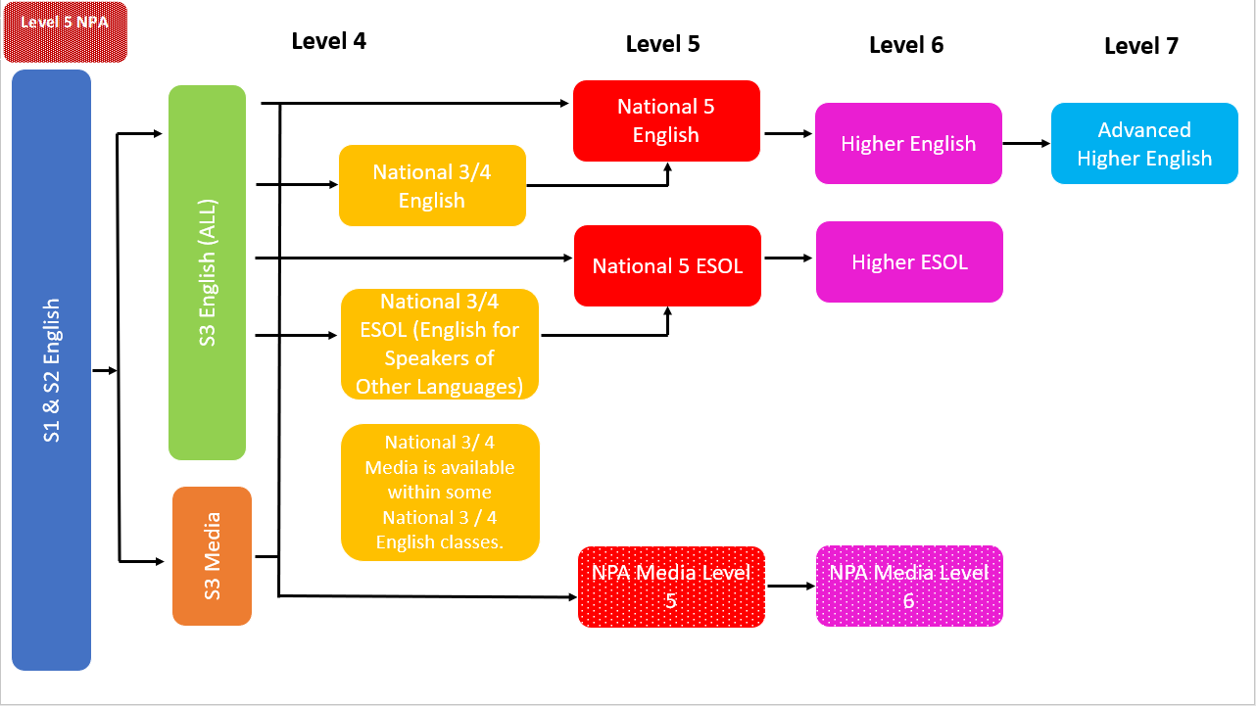 - POTENTIAL PATHWAYS

**ENGLISH: NATIONAL 5**

**Overview**

This course will allow pupils to encounter and engage with a wide range of texts across literature, language, and the media. The course enables pupils to communicate, to think critically, and to be thoughtful and creative. Pupils will be encouraged to reflect on, and to build an understanding of, their own experiences, environment, and culture, and the experiences, environments and cultures of others. Through the study of Scottish writers, pupils will develop an appreciation of Scotland’s own literary heritage.

The materials used throughout the course provide pupils with the resources required to develop skills in analysis of fiction and non-fiction texts.

**Home Learning**

Successful completion of homework assignments is key to success. Pupils who fail to demonstrate the required commitment to the course may be required to move to a more appropriate level of study.

**The Final Exam:**

**Section 1: Reading for Understanding, Analysis and Evaluation (RUAE) – 1 hour in total – out of 30 marks**

* Pupils will read and answer Understanding, Analysis and Evaluation questions on ONE unseen, non-fiction passage.

**Section 2: Critical Reading - 1 hour and 30 mins in total – out of 40 marks**

* **Part One – Scottish Set Text (on Scottish text)**
* Pupils will read an extract and then answer questions. They will also have to show knowledge of the rest of the text(s).
* **Part Two – Critical Essay (on other texts you have studied – NOT SCOTTISH TEXT)**
* Pupils will choose ONE essay question and write ONE essay on a text they have studied during the course.

**The Writing Folio:**

* This is not an exam, but work that is sent away and counts for 30% of the total grade.
* We will send away two essays:
  + One ‘Discursive’ essay – this could be argumentative or persuasive
  + One ‘Creative’ essay – this could be imaginative or personal
* Each piece is graded out of 15 marks by external markers at the SQA.

**Unit Assessment – in class**

* Spoken Language Unit – to be assessed in class by the class teacher – listening and talking on a topic

**Folio Expectations:**

The folio is worth 30% of the overall mark. It is essential that this work is submitted on time and that it meets the SQA criteria. The class teacher will mark two drafts of this work and provide feedback for improvement. It is the pupil’s responsibility to use this feedback and make the required changes.

The folio should:

* Be typed in size 12 font Calibri/Arial/Times New Roman
* Be submitted on the SQA Folio Template, which is available here: <https://www.sqa.org.uk/sqa/47904.html>
* Be submitted on time
* Be no longer than 1000 words

**Success at National 5: How parents can provide support…**

A high level of commitment is required of all pupils. In order to achieve success pupils will be expected to:

* Complete all home learning and meet regular deadlines
* Pass all internal assessments
* Regularly attend classes.
* Work independently.

**Recommended Entry**

Pupils would normally be expected to have attained the skills and knowledge required by the following or equivalent qualifications and/or experience:

* Pass at National 4 English
* CfE Level 4

**Progression**

* Higher English
* related areas of further study, employment or training.

ENGLISH: HIGHER

The Higher English Course provides pupils with the opportunity to develop listening, talking, reading and writing skills that will enable them to understand and use language. Building on literacy skills, pupils will develop understanding of the complexities of language by studying a wide range of texts. The Course also develops high levels of analytical thinking and understanding of the impact of language.

The materials used throughout the course provide pupils with the resources required to develop skills in analysis of fiction and non-fiction texts.

**The Final Exam:**

**Section 1: Reading for Understanding, Analysis and Evaluation (RUAE) – 1 hour 30 mins in total – out of 30 marks**

* Pupils will read and answer Understanding, Analysis and Evaluation questions on TWO unseen, non-fiction passages.

**Section 2: Critical Reading - 1 hour and 30 mins in total – out of 40 marks**

* **Part One – Scottish Set Text (on Scottish text)**
* Pupils will read an extract and then answer questions. They will also have to show knowledge of the rest of the text(s).
* **Part Two – Critical Essay (on other texts you have studied – NOT SCOTTISH TEXT)**
* Pupils will choose ONE essay question and write ONE essay on a text they have studied during the course.

**The Writing Folio:**

* This is not an exam, but work that is sent away and counts for 30% of the total grade.
* We will send away two essays:
  + One ‘Discursive’ essay – this could be argumentative or persuasive
  + One ‘Creative’ essay – this could be imaginative or personal
* Each piece is graded out of 15 marks by an external SQA marker.

**Unit Assessment – in class**

* Spoken Language Unit – to be assessed in class by the class teacher – listening and talking on a topic

**Folio Expectations:**

The folio is worth 30% of the overall mark. It is essential that this work is submitted on time and that it meets the SQA criteria. The class teacher will mark two drafts of this work and provide feedback for improvement. It is the pupil’s responsibility to use this feedback and make the required changes.

The folio should:

* Be typed in size 12 font Calibri/Arial/Times New Roman
* Be submitted on the SQA Folio Template, which is available here: <https://www.sqa.org.uk/sqa/47904.html>
* Be submitted on time
* Be no longer than 1300 words

**Success at Higher: How parents can provide support…**

A high level of commitment is required of all pupils. In order to achieve success pupils will be expected to:

* Complete all home learning & meet regular deadlines
* Pass all internal assessments
* Regularly attend classes.
* Work independently.

**Recommended Entry**

National 5 English C+

**Progression**

* Advanced Higher English
* Degrees in English, Communication Studies, Media Studies, Film Studies, Journalism, Advertising and Public Relations

ENGLISH: ADVANCED HIGHER

Advanced Higher English provides pupils with the opportunity to develop complex language skills which are essential for learning, life and work, and to develop the ability to interpret complex literary forms and to produce sophisticated language.

Advanced Higher English fosters an in-depth appreciation of complex and sophisticated language, and of a wide range of literature and texts in different genres. This will enable pupils to access their own cultural heritage and history, as well as the culture and history of others.

Pupils will have the opportunity to personalise their study; choices enable pupils to encounter a wide range of texts in different genres and to produce sophisticated writing in chosen literary forms.

**Question paper: Literary Study 20 marks**

This question paper assesses pupils’ application of their critical reading skills and their knowledge and understanding of previously-studied literary texts.

The question paper has a total mark allocation of 20 marks. This is 20% of the overall marks for the course assessment.

Pupils apply their understanding, analysis and evaluation skills to previously-studied texts from one of the following genres: poetry, prose fiction, prose non-fiction, or drama. This takes the form of one appropriately structured critical essay.

This question paper requires pupils to make connections and/or comparisons across texts. The required number of texts is specified in each question:

* poetry: three poems
* prose fiction: two novels or three short stories
* prose non-fiction: at least two non-fiction texts
* drama: two plays

**Question paper: Textual Analysis 20 marks**

This question paper assesses pupils’ application of critical reading skills to an unseen literary text. The question paper has a total mark allocation of 20 marks. This is 20% of the overall marks for the course assessment.

Pupils apply their understanding, analysis and evaluation skills to one unseen text. Pupils select one text from the genres of poetry, prose fiction, prose non-fiction or drama and produce a critical analysis which is appropriately structured to meet the demands of the question.

**Recommended Entry**

Higher English: A or B

**Media Studies: NPA IN FILM AND MEDIA**

**Overview.**

The course enables pupils to study film and the media through a range of analytical and practical units.

Two units are mandatory and two are chosen based on pupils’ interests (such as Directing a Single Camera Production, Basic Video Editing units).

The Film and the Film Industry: An Introduction unit introduces pupils to technical, cultural codes and narrative conventions in film through viewing and analysing films and film extracts in a range of film genres.

Pupils will also gain detailed knowledge and understanding of the film industry and current commercial factors that affect film production and distribution, including funding, marketplace developments and the impact of developments in technology on production, content and audience engagement.

This unit will also introduce pupils to the film and media industries and provide an understanding of:

* job roles and functions within the sector and the commercial and cultural factors affecting the film industry.
* technical and/or cultural codes and narrative conventions in film.
* awareness of the industry standards and practice.
* the practical application of digital skills.
* effective resource management.

The Creative Project unit allows pupils to plan, implement and evaluate a media-based project in response to a given brief. The Creative Project gives pupils the opportunity to put into practice knowledge and skills they have developed, and to further develop key skills such as planning, communication, problem solving and time management.

The NPA IN FILM AND MEDIA course is at SCQF level 6.

**Recommended Entry**

* National 4 Media Pass
* National 4/5 English

**Assessment**

The course is all internally assessed:

* Two mandatory units
* Two chosen units

There is also an unseen media text (film) assessment that is completed under controlled conditions, and that is then assessed internally.

All unit work is collated into a course folder that is moderated by the SQA.

**How can parents help?**

Pupils are expected to submit several reports/presentations based on research, analysis and evaluation for a range of texts (films). These will need to be word processed. Pupils will be expected to work on these in lessons and at home.

Pupils will also be expected to work in groups on practical tasks and commit time out of school hours for filming and editing projects.

**Success at NPA FILM AND MEDIA:**

A high level of commitment is required of all pupils and they will be expected to:

* Complete all home learning and meet regular deadlines for submission of work.
* Generate work of a suitable standard and quality.
* Re-draft work as needed.
* Attend all classes.
* Work independently.

**Progression**

On successful completion of this course pupils may choose to progress in any of the following ways:

* Foundation Apprenticeship for Creative and Digital Media
* HND Creative Industries: Television
* HND Creative Industries: Communication and Media
* HND Practical Journalism
* HNC Media Analysis and Production
* HNC Creative Industries: Media and Communication
* HNC/D Communication with Media/Journalism/Advertising and Public Relations
* Degrees in Communication Studies, Media Studies, Film Studies, Journalism, Advertising and Public Relations
* Employment in Media sectors at Entry level such advertising, public relations.

**ESOL (English for Speakers of Other Languages) – National 5**

**Overview:**

The main purpose of the course is for pupils whose first language is not English to develop the skills of reading, writing, listening, and speaking in order to better understand and use English in everyday life, work-related and study-related contexts.

As pupils develop their language skills, they will be able to process information more easily, apply knowledge of language in practical and relevant contexts, and gain confidence to undertake new and more challenging tasks in a variety of situations.

The course offers pupils opportunities to develop and extend a wide range of skills. In particular the course aims to enable pupils to:

* develop reading, writing, listening, and speaking skills in English
* understand detailed written and spoken texts in English in the context of everyday life and familiar contexts of work and study
* produce detailed written English in the context of everyday life and familiar contexts of work and study
* interact with others showing understanding of and using detailed spoken English in the context of everyday life and familiar contexts of work and study
* apply knowledge and understanding of language in spoken and written English

ESOL for everyday life

The pupils develop the four skills of reading, writing, listening, and speaking needed for everyday life in personal, social and transactional contexts. The broad social context is intended to support pupils who need to use English as the language of everyday communication.

ESOL in context

The pupils develop the four skills of reading, writing, listening, and speaking in the familiar contexts of work and study.

**Assessment:**

* Question paper: Reading 35 marks
  + The purpose of this question paper is to allow pupils to demonstrate breadth, challenge and application in the skill of reading in the contexts of everyday life, work and study.
  + Pupils will read three texts in English and respond in English to questions in English.
* Question paper: Writing 30 marks
  + The purpose of this question paper is to allow pupils to demonstrate breadth, challenge and application in the skill of writing.
  + Pupils produce two written texts. They will respond to one task from the context of everyday life and one from the contexts of either work or study. Each task has some limited support for guidance; this will usually take the form of bullet points detailing suggestions appropriate to the topic.
* Question paper: Listening 25 marks
  + The purpose of this question paper is to allow pupils to demonstrate breadth, challenge and application in the skill of listening for information in the contexts of everyday life, work and study
  + Pupils will listen to one monologue and two spoken interactions in English and respond in English to questions in English. The questions for listening assess understanding, application and analysis skills.
* Performance: Speaking and Listening 30 marks
  + The purpose of this performance is to allow pupils to demonstrate breadth, challenge and application in the skills of speaking and listening.
  + Pupils have a conversation in English on a chosen topic and in response to an assessment brief. They ask and respond to questions and initiate and support the interaction throughout, as appropriate.
  + The chosen topic is from one of the contexts of everyday life, work or study.

**Success at National 5: How parents can provide support…**

A high level of commitment is required of all pupils. In order to achieve success pupils will be expected to:

* Complete all home learning and meet regular deadlines
* Pass all internal assessments
* Regularly attend classes.
* Work independently.

**Recommended Entry:**

* This course is for pupils whose first language is not English. Class teachers may recommend ESOL to pupils.
* Pupils should have achieved the relevant ESOL level through prior learning or experience of using English or the National 4 ESOL course or equivalent qualifications.

**Progression:**

* Higher ESOL or Higher National (HN) units in ESOL
* further study, employment or training

**ESOL - Higher**

**Overview:**

The course is for pupils whose first language is not English, to further develop the skills of reading, writing, listening, and speaking. This allows a better understanding and use of English in everyday life, work-related and study-related contexts.

As pupils further develop their language skills, they are able to process information more easily and apply knowledge of language in practical and relevant contexts. They gain confidence to do new and more challenging tasks in a wide variety of situations.

Pupils develop and extend a wide range of skills:

* reading, writing, listening, and speaking skills in English
* understanding detailed and complex written and spoken texts in English in the contexts of everyday life, work and study
* producing detailed and complex written English in the contexts of everyday life and work or study
* developing skills in using different media effectively to support communication in English and independent learning
* interacting with others showing understanding of, and using detailed and complex spoken English in, the contexts of everyday life and work or study
* applying knowledge and understanding of detailed and complex language in spoken and written English

ESOL for everyday life

Pupils develop the four skills of reading, writing, listening, and speaking needed for effective communication in everyday life in personal, social and transactional contexts. The broad social context supports pupils who need to use English as the language of everyday communication.

ESOL in work-related contexts

Pupils develop the four skills of reading, writing, listening, and speaking needed for effective communication in the context of work. There is a particular focus on the development of speaking and writing skills in this context. The broad context of work supports pupils who need to develop their English language skills for employment. They can apply these skills when seeking work and entering employment.

ESOL in study-related contexts

Pupils develop the four skills of reading, writing, listening, and speaking needed for effective communication in the context of study. There is a particular focus on the development of speaking and writing skills in this context. The broad context of study supports pupils who need to develop their academic English skills. They can apply these skills to other subjects or courses they do.

**Assessment:**

* Question paper: listening 25 marks
  + This question paper allows pupils to demonstrate breadth, challenge and application in the skill of listening for information in the contexts of everyday life, work and study.
  + Pupils listen to one monologue and two spoken interactions, each on a different topic, in the broad contexts of everyday life, work and study. Pupils respond to questions in English by using English.
* Question paper: reading 35 marks
  + This question paper allows pupils to demonstrate breadth, challenge and application in the skill of reading in the contexts of everyday life, work and study.
  + Pupils read three texts in English, each on a different topic, in the broad contexts of everyday life, work and study. Pupils respond to questions in English by using English.
* Question paper: writing 30 marks
  + This question paper allows pupils to demonstrate breadth, challenge and application in the skill of writing in the contexts of everyday life and work or study.
  + Pupils produce two written texts. One text must be from the context of everyday life and the other is a choice from the contexts of either work or study.
  + Pupils produce approximately 220–250 words for the everyday life writing task and approximately 250–300 words for the work or study writing task. Each task contains limited guidance.
* Performance: speaking and listening 30 marks
  + This performance allows pupils to demonstrate breadth, challenge and application in the skills of speaking and listening in the contexts of everyday life, work or study.
  + Pupils have a discussion in English on a chosen topic, initiating, responding to questions and supporting the interaction throughout, as appropriate.

**Recommended Entry:**

* This course is for pupils whose first language is not English. Class teachers may recommend ESOL to pupils.
* Pupils should have achieved a C+ pass at National 5 ESOL or a D+ pass at National 5 English.

**Progression:**

* Further study, employment or training
* ESOL is recognised by most Universities as equivalent to Higher English.

**WORK EXPERIENCE**

**Purpose**

This course supports candidates in developing planning, organisational, investigative and interpersonal skills and enhances self-awareness through work experience.

**Recommended Entry**

* Entry is at the discretion of the school.

**Course Details**

**In Work Experience candidates will:**

* Plan and carry out a work experience placement with limited support.
* Carry out allocated tasks during work experience with limited supervision.
* Work co-operatively with others in the analysis, planning and undertaking of work experience
* Review the contribution of the knowledge and skills gained through work experience to their own personal, social and vocational development.

**Health & Safety at Work**

Candidates will have the opportunity of achieving the entry level 1 British Health & Safety at Work award and the Emergency First Aid qualification.

**Assessments**

This course will be assessed internally.

**Progression**

On successful completion of this course pupils may choose to progress to:

* Further Work Experience
* Training / employment

# College Courses Available at Edinburgh College

Please see the Edinburgh College website for full information on School College Partnership courses available in 2023-24:

[For School Pupils | Edinburgh College](https://www.edinburghcollege.ac.uk/courses/for-school-pupils)

* **Almost all courses will take place on Tuesday and Thursday afternoons, periods 5&6 but a few take place on Fridays after school. Please check the online information carefully to ensure you know when and where your chosen course takes place.**
* Further information about college is available from House Heads and Mr Stewart.
* **College applications are all completed online and open on February the 1st 2023.**
* **Students MUST inform their House Head directly if they are applying for a college course. All applications for courses are online.**
* **College is mostly for S5/6 pupils but with the approval of home and your House Head then some S4 pupils can be supported to apply for College too.**

# Foundation Apprenticeships at Edinburgh College

**WHAT IS A FOUNDATION APPRENTICESHIP?**

Foundation Apprenticeships are a work-based learning opportunity for senior-phase secondary school pupils.  Lasting two years, pupils typically begin their Foundation Apprenticeship in S5. Young people spend time out of school at the college or with a local employer and complete the Foundation Apprenticeship alongside their other subjects like National 5s and Highers.

It’s a chance to get valuable work experience and gain an industry-recognised qualification.  It also lets you try out a career while you’re still at school.



There are currently Foundation Apprenticeships in the following courses offered by Edinburgh College:

* Accountancy
* Business Skills (1-year option available for S6 pupils only)
* Creative and Digital Media (with or without Graphic Design)
* Engineering
* Financial Services
* IT: Software Development
* Scientific Technologies (Laboratory Skills)
* Social Services and Healthcare

Information on the Foundation Apprenticeships on offer this coming session can be found here:

[Staying at School | Edinburgh College](https://www.edinburghcollege.ac.uk/information-and-advice/information-for-school-pupils-teachers-and-guardians/staying-at-school)

​

**WHO IS IT FOR?**

Foundation Apprenticeships are open to pupils entering 5th year. You must have the ability to study at SCQF level 6 (Higher equivalent) in a vocational setting, and meet the entry requirements of the course.  Attainment is measured by ongoing assessment in college and in the workplace.

**WHAT QUALIFICATIONS WILL I GAIN?**

On successful completion of the course, you will achieve a Joint Qualification Certificate for the Foundation Apprenticeship in your chosen subject. This is a group Award at SCQF level 6 which

Comprises a National Progression Award (NPA) and a Scottish Vocational Qualification (SVQ)

* Further information about college is available from House Heads and Mr Stewart.
* **College applications are all completed online and open on February 1st 2023.**
* Students MUST inform their House Head directly if they are applying for a college course.

**JET PROGRAMME**

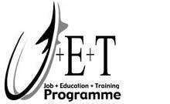

Your school, along with all other Edinburgh High Schools, offers the Job, Education and Training (JET) Programme while you are in S4 to S6.

The experience and skills you will gain on the JET Programme will help you get a job when you leave school, or help you gain entry into College. You will get real work experience and learn about essential and important Employability Skills which ALL employers want.

**How JET Works:**

* For one period per week you’ll attend JET training where you will meet up with your JET co-ordinator and learn important new skills relevant to working life.
* One day per week – every Friday – you will attend a Work Experience Placement, in a real job, with an employer in Edinburgh, where you will put your new skills into practice.
* The rest of the time you will follow your regular timetable and work towards your National 4s and 5s.

**What Kind of Placement Can I Get?**

Your JET Co-ordinator will discuss with you what type of placement may suit you. If you’ve some idea of the type of job you’d like to do when you leave school, JET will match you to a placement which will give you a good idea of what it’s like in the world of work in your chosen sector.

**Work Experience Placement Choices**

JET can offer you a work experience placement in a variety of sectors, for example:

* Hospitality – Hotels, Restaurants, Cafes.
* Retail – Department Stores, Shops, Supermarkets.
* Local Authority – Department or Local Office with The City of Edinburgh Council.
* Childcare – in a Primary School, Nursery or Childcare Centre.
* Hairdressing – Well known Hair and Beauty salons.
* Office Work – for example using computers, telephones and reception duties.
* Libraries – working with books and customers in our city Libraries.
* Automotive Vehicle – you will attend a training session every Friday in a workshop and work towards a City & Guilds qualification. Places are limited to 20 students.

So, remember, when you’re completing your JET Application Form you should state what work experience placement you’re looking for.

**What Happens at Work Experience Placement?**

When you are at your work experience placement each Friday you will be treated in the same way as any other employee. This means:

* You will be expected to work a normal full working day. Depending on what type of work your employer does, you could be expected to start at 8.00 am.
* You will be expected to wear tidy, smart work clothes, or a uniform or overalls provided by the employer - NOT your school uniform.
* You will be expected to have a positive attitude, be courteous and polite and respect the people you will be working with.

**What Are My Chances of Getting a Job at The End of The JET Programme?**

If your attendance, timekeeping, behaviour and attitude at work experience placement have been very good, so are your chances of being offered a job from your JET placement employer. Several students have already secured jobs through the JET programme.

Unfortunately, not all employers are able to offer a job at the end of JET, however, if you’ve done very well, your chances of getting a job from another employer are very good, as you’ll have references from your JET employer and a good CV.

Alternatively, you may wish to go to College fulltime rather than enter employment. Whatever you decide, JET will definitely have helped you to further your career prospects.

**How Do I Get a Place on The JET Programme?**

* Complete the Student Note of Interest and return it to school by the date on the form.
* Come along with your parent/ guardian to the JET Information Evening – school will let you know when this is.
* Complete the JET Application Form and return it to school by the deadline date.
* Attend an Informal Interview with the JET Co-ordinator to discuss your choice of work placement.

**SPEAK TO YOUR HOUSE HEAD FOR FURTHER INFORMATION.**

**Leith Academy S5&S6 Learner Pathways for 2023-24**

**Name ______________________________________ Year____________ House_________________**

***When do you plan to leave school? _____________________ Preferred Route (circle one): College/Uni/Employment/Apprenticeship? Preferred Occupation:________________________________***

**In S5**, you must study **5** **subjects**; you will also have 2 periods of PE, 1 of PSE and some periods of **Wider Achievement** if picking any Nationals. The subjects you choose should ideally be subjects you are currently studying in S4 to allow for progression in your learning but can also be new options.

**In S6,** you must study **5** **subjects if only choosing these at National Levels** **and/or Higher**; you will also have 2 periods of core Study, 1 period of PSE and may have some periods of **Wider Achievement or Volunteering**. Volunteering will mean being timetabled to support a S1-3 class in a subject in which you are competent. If you are pickinga combination of **Advanced Highers and Highers** then **4 or 5** subjects must be chosen; you will also have 2 periods of core Study, 1 of PSE and may have 1 study column (equating to 5 periods) and/or some periods of Volunteering. **If you are picking 3 Advanced Highers then at this stage you may make only 3 choices but are recommended to choose at least 4**.

**Please also note the following:**

* Your estimate grades from your reports for this session should be used to inform your choices.
* It will be possible to offer some other courses in Column B – our ‘travel column’ – during double periods on Tuesdays and Thursdays. These will be run at local schools or colleges. 50% of transport costs only will be paid by the school.
* Info. on courses at Edinburgh College, including Foundation Apprenticeships, is available from House Heads and on the College website: [For School Pupils | Edinburgh College](https://www.edinburghcollege.ac.uk/courses/for-school-pupils)

**If you wish to apply for one of these courses then you must do so online and also inform your House Head.**

* **Requests for additional Advanced Higher courses** should be noted at the end of this form, where you may also note interest in the Job + Education + Training (J.E.T.) programme.
* S6 pupils taking a subject as a re-sit must sign up for the whole course and attend all classes plus complete all homework and assessments.

**On your Learner Pathway sheet, identify both a first choice (with a 1) and a second choice (with a 2) in each column, bearing in mind the total number choices you will be making for next session (5 for all new S5s; 3 or 4 or 5 for new S6s depending on thePathway selected).**

**This form should be completed alongside your Application Form and submitted to your House Head from the 20th of February 2023.**

**Leith Academy S5&S6 Learner Pathways for 2023-24**

***Make 1st and 2nd choices in each column***

|  |  |  |  |  |  |  |  |  |  |  |
| --- | --- | --- | --- | --- | --- | --- | --- | --- | --- | --- |
|  | **Column A** |  | **Column B** |  | **Column C** |  | **Column D** |  | **Column E** |  |
| **Advanced Higher** | English  Spanish  Chemistry |  | LEAPS Transitions  Modern Studies  Art  Physics |  | Mechanics  History |  | Biology  PE  Geography |  | Mandarin  Maths  Drama |  |
|  |  |  |  |  |  |  |  |  |  |  |
| **Highers** | English |  | English |  | English |  | English |  | English |  |
| **&** | Maths |  | Media NPA |  | Maths |  | ESOL |  | Maths |  |
| **Level 6** | Drama/Acting and Performing |  | Maths |  | Geography |  | Biology |  | Applications of Maths |  |
| **NPAs** | History |  | RMPS |  | Psychology (S6 Only) |  | Art |  | Mandarin |  |
|  | Business Management |  | Administration |  | PE |  | Physics |  | Music |  |
|  | Computing |  | Chemistry |  | Modern Studies |  | Languages for Work |  | Biology |  |
|  | Accounting |  | PE |  | SQA Leadership (S6 Only) |  | Business and IT NPA |  | French |  |
|  | Health and Food Technology |  | Spanish |  | Creative Graphics |  | Economics |  | Design and Manufacture |  |
|  | Art |  | Drama/Acting and Performing |  | Business Management |  | Exercise and Fitness |  | Sociology |  |
|  |  |  | Philosophy |  |  |  |  |  |  |  |
|  |  |  | College/Foundation Apprenticeship |  |  |  |  |  |  |  |
|  |  |  |  |  |  |  |  |  |  |  |
| **S6 Only:** | **Study** |  | **Study** |  | **Study** |  | **Study** |  | **Study** |  |
|  | **Column A** |  | **Column B** |  | **Column C** |  | **Column D** |  | **Column E** |  |
| **Nationals**  **& NPAs** | N4/5 English |  | N4/5 English |  | N4/5 English |  | N5 Maths |  | N4/5 English |  |
|  | N5 Maths |  | N5 Maths |  | N5 Chemistry |  | N4/5 Modern Studies |  | N4/5 ESOL |  |
|  | N4 Practical Cookery |  | Applications of Maths N4 |  | N4 Chemistry |  | N4/5 History |  | N5 Maths |  |
|  | N5 Health and Food Technology |  | N5 Computing |  | N5 Biology |  | N4/5 Travel and Tourism |  | Numeracy and Finance NPA |  |
|  | N4/5 Early Learning and Childcare |  | M4/5 History |  | N5 Physics |  | N4/5 Business Management |  | N4 Maths |  |
|  | N4/5 Administration |  | N5 Chemistry |  | Sport and Recreation NPA |  | N4 Biology |  | N4/5 PE |  |
|  | N4/5 Business Management |  | N5 Biology |  | N4/5 PE |  | N5 Biology |  | N5 Football |  |
|  | N4/5 Spanish |  | Jewellery Techniques NPA |  | Level 5 Creative Graphics |  | N4 Health Sector |  | N5 Biology |  |
|  | N4/5 French |  | N4/5 Design and Manufacture |  | N4/5 Music |  | N4/5 Drama |  | N4/5 Drama |  |
|  | N4/5 Geography |  | N5 Practical Cookery |  | Beauty NPA |  | N3/4/5 Italian |  | N4/5 RMPS |  |
|  | N4 Physics |  | N4 Practical Cookery |  | Musical Theatre NPA (S5/6 Only) |  | N4/5 Spanish |  | N5 Sociology |  |
|  | N5 Physics |  | N4/5 Mandarin |  | N4/5 Art |  | N4/5 Practical Woodwork |  | N4/5 Modern Studies |  |
|  | N4/5 Art |  | Level 5 Media NPA |  | N5 Accounting |  |  |  | N3/4 People and Society |  |
|  |  |  | N5 Philosophy |  | N4/5 Administration |  |  |  |  |  |
|  |  |  |  |  |  |  |  |  |  |  |

**Requests (including additional Advanced Higher and J.E.T.):**

**Leith Academy**

**S3 into S4 Learner Pathways for 2023-24**

**Name ______________________________________ House_________________**

***When do you plan to leave school? _______________________ Preferred Route (circle one): College/Uni/Employment/Apprenticeship?***

***Preferred Occupation:________________________________________***

In 2023-34, we will be continuing with a full Senior Phase curriculum; for S4s, this means that National level classes may be composed of pupils from S4, S5 and S6 together.

**In S4, all pupils MUST choose English/ESOL and Maths**; **FOUR MORE SUBJECTS** must also be chosen to add to your core subjects – PE, PSE and RMPS. The other four subjects you choose **should be subjects you are currently studying in S3** **ideally so as to provide progression** but some **new options** are offered from S4 onwards – **these would only be provided for you after discussion with teaching staff, your House Head and parents/carers.**

**Please read the following carefully before making your choices:**

* **All pupils MUST choose English/ESOL and Maths/Applications of Maths for S4**; in addition, pupils should ideally choose **four** of the subjects they **studied in S3,** although other choices are available.
* **In each column**, pupils must make **a first choice (1)** and **a second choice (2)**, which should also ideally be a subject they are studying in S3. **Any new subjects for S4 will only be allocated to pupils following a discussion with the House Head.**
* Pupils currently in **Achieve** will automatically continue with this in S4 in addition to their other 6 subjects.
* Places for **J.E.T.** (Job + Education + Training) will be allocated via an application and after discussion with House Heads.
* Core subjects are compulsory for all (1 period of PSE, 1 period of RMPS and 2 periods of PE).
* If you wish to consider applying for a Schools College Partnership college course as one of your chosen subjects then you must discuss this with your House Head asap

|  |  |  |  |  |  |  |  |  |  |  |  |
| --- | --- | --- | --- | --- | --- | --- | --- | --- | --- | --- | --- |
| Column A |  | Column B |  | Column C |  | Column D |  | Column E |  | Column F |  |
| N4/5 English |  | N4/5 English |  | N4/5 English |  | N5 Maths |  | N4/5 English |  | Maths N5 |  |
| N5 Maths |  | N5 Maths |  | N5 Chemistry |  | N4/5 Modern Studies |  | N4/5 ESOL |  | Maths N4 |  |
| N4 Practical Cookery |  | Applications of Maths N4 |  | N4 Chemistry |  | N4/5 History |  | N5 Maths |  | English N4/5 |  |
| N5 Health and Food Technology |  | N5 Computing |  | N5 Biology |  | N4/5 Travel and Tourism |  | Numeracy and Finance NPA |  | ESOL N4/5 |  |
| N4/5 Early Learning and Childcare |  | M4/5 History |  | N5 Physics |  | N4/5 Business Management |  | N4 Maths |  |  |  |
| N4/5 Administration |  | N5 Chemistry |  | Sport and Recreation NPA |  | N4 Biology |  | N4/5 PE |  |  |  |
| N4/5 Business Management |  | N5 Biology |  | N4/5 PE |  | N5 Biology |  | N5 Football |  |  |  |
| N4/5 Spanish |  | Jewellery Techniques NPA |  | Level 5 Creative Graphics |  | N4 Health Sector |  | N5 Biology |  |  |  |
| N4/5 French |  | N4/5 Design and Manufacture |  | N4/5 Music |  | N4/5 Drama |  | N4/5 Drama |  |  |  |
| N4/5 Geography |  | N5 Practical Cookery |  | Beauty NPA |  | N3/4/5 Italian |  | N4/5 RMPS |  |  |  |
| N4 Physics |  | N4 Practical Cookery |  | N4/5 Art |  | N4/5 Spanish |  | N4/5 Modern Studies |  |  |  |
| N5 Physics |  | N4/5 Mandarin |  | N5 Accounting |  | N4/5 Practical Woodwork |  | N3/4 People and Society |  |  |  |
| N4/5 Art |  | Level 5 Media NPA |  | N4/5 Administration |  |  |  |  |  |  |  |

**Additional Options – place a ✓ in the box next to the courses below if interested for S4: (✓ only if in Achieve for S3)**

|  |  |  |  |  |  |
| --- | --- | --- | --- | --- | --- |
| J.E.T. |  |  |  | Achieve |  |

**This form and your S4 Application should be completed and submitted to your House Head or the Office by 6th March 2023.**

