Work Experience at DWF

My experience at DWF was full of learning, I discovered so much from the 3 days that I attended the Edinburgh office. There are so many more opportunities in the legal industry than just being a lawyer or paralegal. For instance, you can work in marketing and deal with events and the social media sides of things, or in administration and work with the drawing up of contracts and sending of letters.

Hearing about the various roles and the journey which many staff took to get to the positions that they are now in was inspiring. These stories showed me I don’t need to have a clear view on what I want to do when I’m older, whilst it’s good to have an idea, I don’t need a rigid path. I might study something at university or college and end up working in a totally different field from the subject I studied – and that’s exciting.
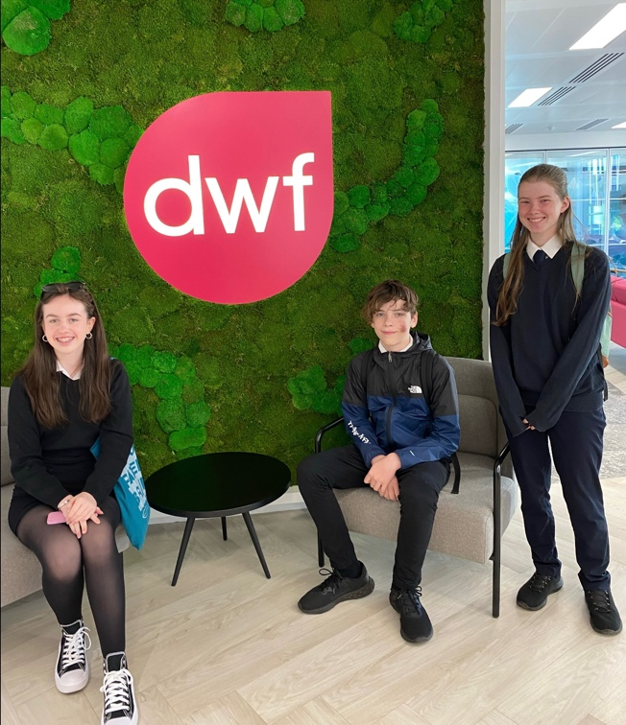

Getting to experience work meetings and weekly check-ins with people from all over the UK was so interesting. I learned about the different offices which DWF have all over the world and how they operate. The DWF Edinburgh office isn’t like any of the offices I’ve been to before, it’s a new and fresh environment that made me feel comfortable; the staff were welcoming, and they made the experience so much more enjoyable.

One of the communication skills which I developed was being able to hold a professional conversation. These conversations might last for a while, and it is very important to be composed and to act professionally. Digital literacy is also very important and so having some sort of computer skills is also really helpful as many tasks are now completed online.

Aislinn McLean

