**LEITH ACADEMY**

**PROSPECTUS**

**2023-24**





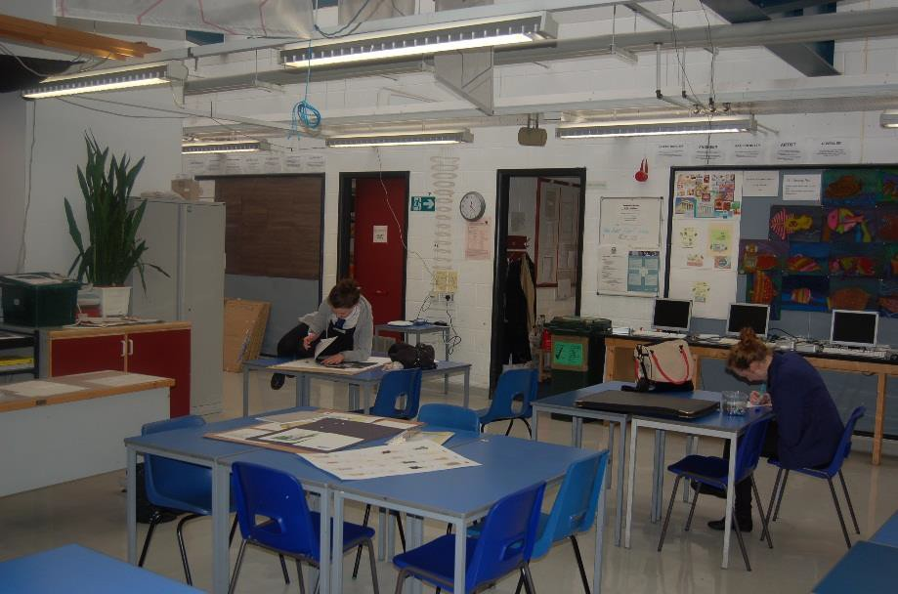

**Leith Academy**

**Information for Parents**



A Foreword from the Executive Director of Communities and Families

Session 2023-24

Dear Parents/Carers,

This brochure contains a range of information about your child’s school which will be of interest to you and your child. It offers an insight into the life and ethos of the school and also offers advice and assistance which you may find helpful in supporting and getting involved in your child’s education.

We are committed to working closely with parents as equal partners in your child's education, in the life of your child's school and in city-wide developments in education.

Parental involvement in the decision making process and in performance monitoring are an integral part of school life. We look forward to developing that partnership with your support.

Throughout this handbook the term ‘parent’ has the meaning attributed in the Standards in Scotland's Schools Act 2000 and the Scottish Schools (Parental Involvement) Act 2006. This includes grandparents, carer or anyone else who has parental responsibility for the child.

I am pleased to introduce this brochure for session 2023-24 and hope that it will provide you with the information you need concerning your child’s school. If you have any queries regarding the contents of the brochure please contact the Head Teacher of your child’s school in the first instance who will be happy to offer any clarification you may need.

Amanda Hatton

Executive Director of Communities and Families

Children and Families Vision

Our vision is for all children and young people in Edinburgh to enjoy their childhood and fulfil their potential.

We believe that children and young people do best when:

* they are able to live safely and happily within their own families with the right kind of support as needed
* they attend first class, inclusive schools and early years settings which meet their needs

We will do all we can to strengthen support for families, schools and communities to meet their children's needs.

Our mission is to place children, young people and families at the heart of our service and provide support when it is needed throughout childhood and the transition to adulthood.

 C:\Users\0598943\AppData\Local\Microsoft\Windows\Temporary Internet Files\Content.Outlook\7JT5VTIV\Black statutory (002).jpg 

**In Edinburgh children and young people are at the heart of our vision for the future.**

As an inclusive community we work with parents, carers and, where appropriate, partner agencies to support all children and young people.

By working together, we help children and young people to develop understanding about relationships, respect, teamwork, honesty, fairness, patience, and compassion. We do this by offering interesting and relevant learning experiences, by providing our staff with the training and resources they need, and by working with the whole community to accept and care for one another.  This isn’t always easy, but we believe it is essential so that our children and young people understand the people they meet and learn how to work together to handle setbacks and difficult situations throughout their lives.

When children and young people experience adverse events or as a response to their additional support need, they let us know by reacting in different ways. This presents difficulties for those around them.  By working together, by understanding the cause and working out solutions, we can find a way to solve or deal with a problem.  If it takes time to get over a problem we will work with a child, young person, and their family to work out the best way forward.  This may involve making adaptations and providing additional support or in exceptional circumstances identifying a change of environment.

We recognise that we all experience difficult times, and that everyone deserves the best possible care and support.  In Edinburgh we support children and young people to learn in different ways according to their needs. As children and young people learn to read, write, and count some require more support than others do. This need for support arises for a variety of reasons learning difficulties, challenges with emotional regulation and social communication issues. We must meet the needs of all our students in a fair, compassionate, and proportionate way.

In considering how to support all children and young people reach their full potential it may not always be possible to arrive at a resolution all parties agree. However, we will to listen to any parent, young person, child or member of staff and work together to resolve difficulties.

We are committed to do all we can to make Edinburgh an inclusive place to live and learn.

Lorna French

Head of Schools and Lifelong Learning and Chief Education Officer, Edinburgh Council

 

**Welcome from the Head Teacher**

Dear Parent

Welcome to the Leith Academy prospectus. This prospectus offers an introduction to our school and a general overview of the education your child will be getting at school.

If you have any questions, or would like any further information on any aspect of this prospectus or the education of your child, please do not hesitate to contact the school.

To make our prospectus easy to use we have divided the information into five different sections:

#### Section One – Practical Information about the School 8

#### Section Two – Parental Involvement in the School 15

#### Section Three – School Curriculum 22

#### Section Four – Support for Pupils 27

#### Section Five – School Improvement 32

We publish this prospectus in the firm belief that parents, the community and the school must work together in the education of your child. Effective co-operation of this sort will only be possible if you, the parents, are totally aware of what the school is trying to do, how it is organised and the opportunities it offers.

Leith Academy has enjoyed a long history of successful learning and teaching. An important part of our work is the creation of a positive learning environment and the development of a “success culture” in which each young person achieves her/his very best. Classroom subjects are offered at different levels and in groups designed to meet the widest possible range of abilities, interests and career prospects.

Formal education is only part of the story since we also share some responsibility for the growth of character and personality in the young people in our care. We realise we are only one of the many influences at work on the young person of today. However, we see it as our duty to provide, through the curriculum, through extra-curricular activities, through the Pupil Support system and through the general atmosphere of the school, an environment likely to encourage the growth of acceptable attitudes and personal qualities.

This prospectus can only tell part of the story. The spirit within the school, its values and ultimate success are less easily put into words. For you to make an assessment of these, recent former pupils and parents are probably your best source of information. Our school moto is Persevere. Our mission statement is ‘Success and Learning for All’. We refer to this regularly with Pupils and Parents.

Our values are:

* Respect
* Diversity
* Honesty
* Fairness

These values contribute to our school ethos every day.

Please read this prospectus and discuss its contents with your daughter or son. It will probably be useful to keep it for the future. An updated version is a permanent feature of our website, the address for which is given later. All the information is accurate at this time but will be subject to change of roll, staff and resources each year.

M Irving BEd (Hons), MEd , SQH

Leith Academy

20 Academy Park, Edinburgh, EH6 8JQ

0131-554 0606

[www.leith.edin.sch.uk](http://www.leith.edin.sch.uk) [admin@leith.edin.sch.uk](mailto:admin@leith.edin.sch.uk)

Name of Headteacher: Name of School: Address:

Telephone Number: Website:

E-mail Address:

Stages of Education provided for: Secondary

Present Roll: Approx 1000 Denominational Status of the School (if any): n/a

Gaelic Medium Education if relevant: n/a

**Organisation of the School Day**

The school day starts at 8.30 am and pupils are expected to arrive punctually for classes. Parents are asked to encourage good time keeping and help the school to ensure that young people develop such habits early in their school lives. A typical current timetable for S1 is as follows:

**MON-THURS 8.30-8.39 8.39-9.36 9.36-10.33 10.48-11.45 11.45–12.42 13.22-14.19 14.19-15.16**

**FRI ONLY 8.30-8.48 8.48-9.45 9.45-10.42 10.57-11.54 11.54-12.51**

|  |  |  |  |  |  |  |  |  |  |
| --- | --- | --- | --- | --- | --- | --- | --- | --- | --- |
|  | TG | 1 | 2 |  | 3 | 4 |  | 5 | 6 |
| MON |  |  |  | B |  |  | L |  |  |
| TUES |  |  |  | R |  |  | U |  |  |
| WED |  |  |  | E |  |  | N |  |  |
| THUR |  |  |  | A |  |  | C |  |  |
| FRID |  |  |  | K |  |  | H |  | |

# **Plan of the School**

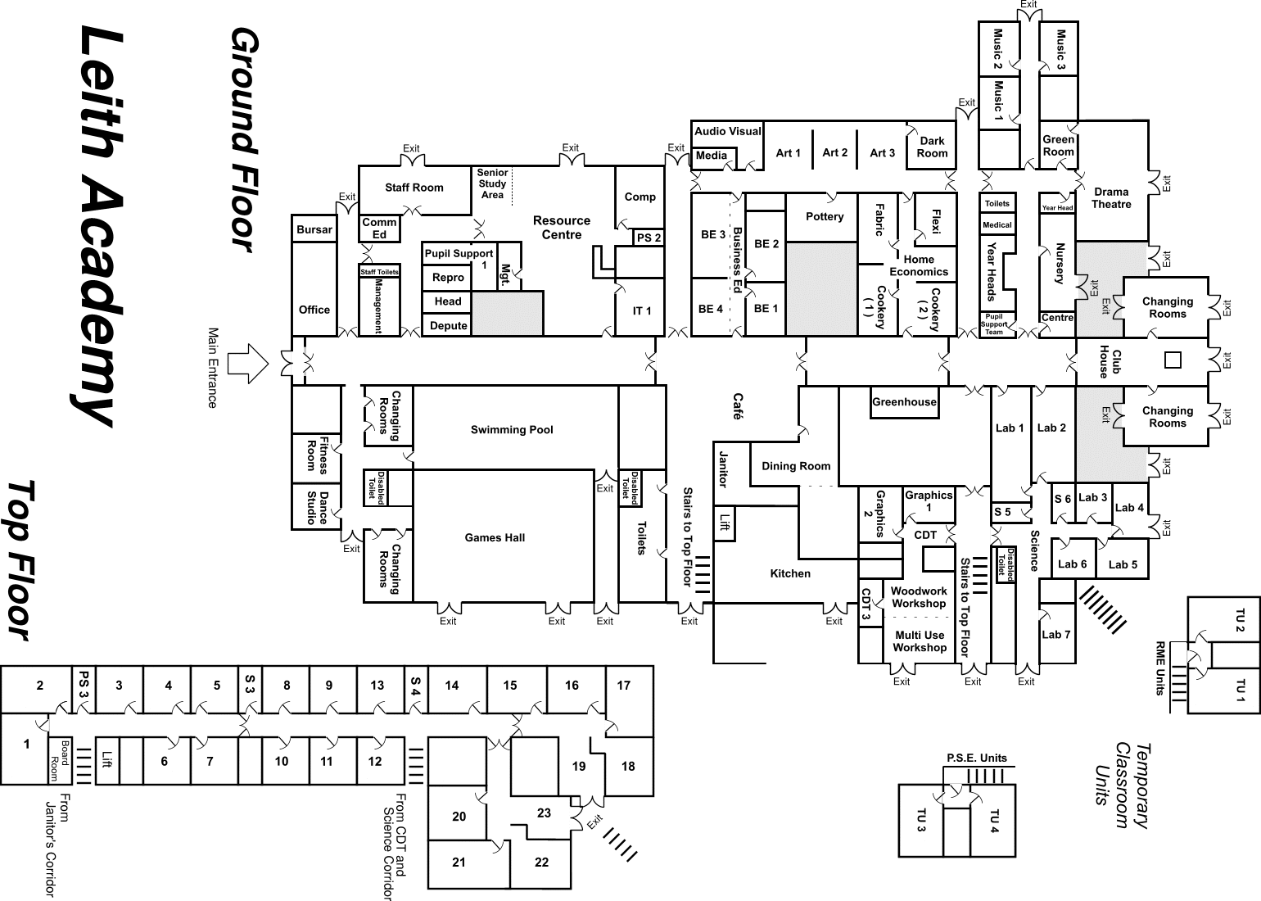

**Agreed Term Dates for Session 2023/24**

#### All Edinburgh Council term dates can be found on the website here [Term dates – The City of Edinburgh Council](https://www.edinburgh.gov.uk/schools/term-dates)

#### Senior Leadership Team

#### Roles and responsibilities 2023/24

Each member shares in the responsibility of creating a positive ethos and learning environment in the school. A team approach is adopted in matters of curriculum, assessment and reporting, and pupil management. Each SMT member links with several faculties/departments in the school on a regular basis. Special areas of responsibilities are as follows:

#### MR M IRVING (HEAD TEACHER)

* Personnel management (teaching staff): recruitment and deployment, support and welfare, references and career development
* Improvement planning and policy development
* Responsibility for all aspects of devolved budget
* Co-ordination of school calendars, handbooks and prospectus
* Responsibility for public relations, marketing and publicity
* Overview of S6
* Overall responsibility for praise/merit systems
* Adviser to Parent Council
* Faculty link for Creative Arts, Modern Languages and Social Subjects

#### MRS A FAIR (DEPUTE HEADTEACHER – PUPIL SUPPORT)

* + Co-ordination of Pupil Support arrangements (including general policy, chair of PSG and PS team meetings, overview of ASL, careers education, EAL and links with external agencies)
  + Designated Member of Staff for Child Protection Procedures
  + Co-ordination of CPD programme (including Professional Review & Development)
  + Co-ordination of key ‘logs’: attendance, exclusions, anti-bullying, racism, drug incidents, violent incidents)
  + Faculty link for Pupil Support and Health & Wellbeing

#### MR B STEWART (DEPUTE HEADTEACHER – COWAN/PORT)

* Timetable construction and Curriculum overview
* Enrolments S4-S6
* Co-ordination of approaches to Learning & Teaching
* Curriculum enterprise (including Developing the Young Workforce, 16+ liaison,
* college links, and Career Ready), UCAS
* Co-ordination of arrangements for educational excursions (including the S6 Benmore residential)
* SMT link with Pupil Council
* Overview and co-ordination of whole-school mentoring approaches
* Co-ordination of Equality, Diversity and Inclusion
* DHT link for Cowan and Port
* Faculty link for English and Science (including over view of Literacy)

#### MS R WATSON (DEPUTE HEADTEACHER – ANDERSON/BARTON)

* + 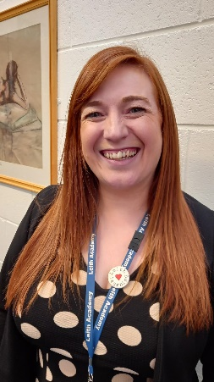Co-ordination of primary-secondary links (including membership of the Cluster Management Group)
  + Enrolments S1-S3 (including overview of hosting arrangements)
  + SQA Co-ordination (including timetabling for prelim exams S4-S6)
  + Student Regent/Induction Manager
  + ICT and multimedia in the curriculum
  + Home/school links (including responsibility for home learning/supported study initiatives)
  + Co-ordination of assessment and reporting systems (including EDICT)
  + Events Co-ordinator: photographs, services, Sponsored Walk, ‘special’ evenings, Evening of Celebration, S1 Benmore residential
  + DHT link for Anderson and Barton
  + Faculty link for Technology & Mathematics (including overview of Numeracy across learning)

#### Shared responsibilities:

Behaviour management (including Duty Officer and exclusions)

#### MRS N FIELDING (BUSINESS MANAGER)

* Overview of school finances
* Redistribution of classes due to staff absence
* Personnel management (SET): recruitment and deployment, support and welfare, references and career development (including Performance Review & Development); maintenance of records for all staff
* SEEMiS Co-ordinator, with responsibility for all ScotXed and CEC returns
* Health and Safety Officer
* Data Protection/Copyright/Freedom of Information
* Overview of property management (building and ground maintenance); liaising with Facilities Management
* Overview of cleaning and catering services; liaising with Facilities Management

# **Section One – Practical Information about the School**

This section deals with the practical aspects of your child’s attendance at our school. It provides details on such things as:

* + travelling to and from school
  + school meals and milk
  + financial assistance with school clothing, transport and school meals
  + school closures in an emergency or unexpectedly for any reason
  + general supervision available for your child in the morning and at lunchtime
  + wet weather details
  + how the school communicates with parents
  + how to complain if you are not happy about something.

## **Communicating with the School**

This section provides you with some background information on our school. It tells you how our school day and school year are made up and how to contact the school if, for example, your child is ill.

## **Registration and enrolment**

The date for registration of new school entrants is on the council’s website [www.edinburgh.gov.uk.](http://www.edinburgh.gov.uk/) Registration for Primary One and First Year Secondary takes place in November each year. Pupils should be registered in only one school for their catchment area. Parents will be provided with information about the school, when they register their child.

Parents who want to send their child to a school other than the catchment school must make a placing request. Please refer to Section Four of this prospectus for more information on placing requests.

Parents of pupils who have moved into the catchment area or, who wish their child to transfer to the school, should contact the school office for information.

## **Attendance and absence**

It is the responsibility of parents of a child of school age to make sure that their child is educated. Absence from school is recorded as authorised, that is approved by the Communities and Families department, or as unauthorised that is unexplained by the parent (truancy).

Please let the school know by phone or email on [Admin@leith.edin.sch.uk](mailto:Admin@leith.edin.sch.uk) if your child is likely to be absent for some time, and email school on his or her return to school, confirming the reason for absence. If there is no explanation from a child’s parents, the absence will be regarded as unauthorised.

The school operates a text messaging system which will alert parents to their child’s lateness to school or absence on a period by period basis.

Please make every effort to avoid family holidays during term time as this will disrupt your child’s education and reduces learning time. I can approve absence from school for a family holiday in certain extreme situations, for example, in traumatic domestic circumstances where the holiday would improve the cohesion and wellbeing of the family. Please discuss your plans with me before the holiday. If I cannot give permission before the holiday, it will be recorded as unauthorised absence. I can authorise a holiday if you can prove that work commitments make a family holiday impossible during school holiday times. Normally, your employer will need to provide evidence of your work commitments. Absence approved by me on this basis is regarded as authorised absence.

Any requests for extended absence over two weeks will be referred to the Senior Education Manager (Inclusion) who will decide if it will be recorded as authorised or unauthorised leave.

Parents from minority ethnic religious communities may request that their children be permitted to be absent from school to celebrate recognised religious events. Absence approved on this basis is regarded as authorised absence. Extended leave can also be granted on request for families returning to their country of origin for cultural or care reasons.

A supportive approach is taken to unexplained absence. However, the Communities and Families Department has legal powers to write to, interview or prosecute parents, or refer pupils to the Reporter to the Children’s Panel, if necessary.

## **School Uniform**

We are very proud of the school uniform and that all of our pupils wear it. It has been a tradition in the school over its long history since 1560. The school appreciates the support of parents in this matter. The following arrangements are currently in place:

* White shirt
* Leith Academy Tie (dark blue)
* Black v-neck jumper/cardigan (plain and without logos)
* Black trousers/skirt (No joggers / leggings without a skirt)
* Black shoes / footwear
* Blue blazer (for prefects in S6) supplied online, details provided to individuals

As we are an inclusive school and a place where we recognise and celebrate diversity of all kinds, including those of us who identify as LGBTQ+, then any pupil is entitled to wear any form of the allowed uniform prescribed above if they choose. Ties are currently available from the School office;

* it reflects the proud tradition and history of the school, which started in 1560
* it gives the school a unique and special image
* it creates a ‘team spirit’ and identity within the school
* it provides pupils with a strong sense of belonging and commitment to the school
* it offers a good preparation for working life
* it reduces inequalities amongst pupils, which can lead to isolation and bullying
* it reduces the potential for theft
* it helps identify intruders and improves security
* it provides a relatively cheap means of clothing youngsters
* it offers visitors to the school a very positive image

Pupils are expected to present a neat and tidy appearance. Any visible tops worn under shirts/sweatshirts should be black or white. For PE, all pupils should have a complete change of clothing - shorts, appropriate sports top and shoes with non-marking soles, for indoor use, swimming costume, etc. When teams represent the school they should be smartly turned out in the school strip. All pupils must bring a school bag large enough to carry books, folders, iPad and PE Kit.

The following are not appropriatein school:

* items causing health/safety risks (e.g. ‘shiny’ clothing, metal chains, earrings, large belts, chunky bracelets/necklaces)
* items posing a security risk (e.g. baseball caps, hoods up)
* footwear which may damage flooring
* clothing with words or pictures which could cause offence to others
* football colours (worn as shirts, scarves, etc.)
* clothing that is so tight, short or revealing that it could give offence to others
* clothing which advertises the use of alcohol, tobacco or drugs
* clothing which is inappropriate for a place of work/study
* loose and baggy clothing which would be a hazard in CDT and Science areas

In general, pupils wearing clothes which do not comply with health and safety guidelines cannot participate in lessons and may be sent home to change. The co-operation of parents in maintaining standards is necessary and welcomed.

Please help us by ensuring that pupils do not bring valuable or expensive items of clothing to school. If you have any queries regarding the school’s dress code, please contact the school office.

## **Footwear and Clothing Grants**

## Grants for footwear and clothing for children are available to parents on the Council website.

Information on free school meals and clothing grants is available here <https://www.edinburgh.gov.uk/food-clothing/free-school-meals-school-clothing-grants> Applications for free school meals and clothing grants can be made by contacting Edinburgh Council.

## **School Meals**

We are a cashless School. All payments must be made through Parent Pay. Menus offer healthy and meal options while reflecting the Scottish Government food and drink legal requirements for school lunches. Special diets and allergies are usually accommodated subject to consultation with parent/guardian and catering services.

Meal prices are reviewed annually. Please contact the School to be advised of the current price.

## **Free School Meals**

Some families may be eligible for free school meals. Application forms are available from the school office or online from the Council. The forms have to be completed by the parent along with supporting documentation as detailed on the application form. An application is required for every school session.

Please note the school operates a ‘cashless cafeteria system’. All pupils and staff are issued with their own personalised pin number and use this to purchase food. Parents can add money to accounts through ParentPay. Those entitled to free meals will find their accounts credited automatically each day. This has reduced queuing and the need for pupils to carry much cash with them to school. (It also introduces them to the use of new technology.) A Breakfast Club also operates in the morning between 7.45 and 8.15am. A healthy breakfast, including cereal, tea and toast, is provided free of charge to pupils who make use of this facility.

## **Travel to and from School**

Parents are requested, when dropping off/collecting children from school that they do not park on the yellow box at the entrance to the school grounds or on the double yellow lines at the main school entrance.

All children can travel on bus and tram for free with a young Scot card. There are some exceptions to this, e.g. for health and/or safety reasons or if the child has been placed in a non-district school by the Communities and Families Department. Transport assistance is not provided on the basis of income.

## **General Supervision**

Before school begins supervision is very limited, therefore pupils should not arrive at school until as near to the school start time as possible. Senior management are on duty at break times and there is a rota of staff and prefects on lunchtime supervision (Monday-Thursday).

## **School security**

The safety and security of pupils and staff when attending or working in a school is very important to us. We use a number of security measures including signing in at reception, badges and escorts (where appropriate) while visitors are within the school building. Normally, anyone calling at a school for any reason will be asked to report to the school office. The school staff then can make the necessary arrangements for the visit.

## **Unexpected Closures**

In the event of an emergency, such as a power cut or severe weather, that prevents schools from opening in the morning or results in an early closure, a range of communications channels are used to let parents know. Text messages are sent to parents on these occasions where that is possible and updates are placed on the school website <https://leithacademy.uk/> and through our Twitter channel @leithacademy .

In addition, announcements will be made on Radio Forth (Forth 1 and Forth 2) and via the Council's corporate Twitter account [www.twitter.com/Edinburgh_CC](http://www.twitter.com/Edinburgh_CC) and Facebook page [www.facebook.com/edinburghcouncil.](http://www.facebook.com/edinburghcouncil) If many schools are affected, or the situation is likely to be prolonged, then the Council's website [www.edinburgh.gov.uk](http://www.edinburgh.gov.uk/) will also be used.

## **A policy for mobile phones and other devices**

The school recognises and welcomes the fact that many, if not most, of the pupils have access to a mobile phone: it makes them safer in the community and affords parents more peace of mind; it can be used for educational purposes.

Our device use policy, created by our Pupils can be found on our website here <https://leithacademy.uk/parents/gdpr-policy/>

We all recognise the beneficial applications of mobile phones and other devices and encourage the use of our school iPads to research answers/materials. Others accept that the pupil may use the calculator which many phones have. The camera may be used to record examples of work, as can the video (both these things are encouraged in CfE.) Smart phones may have Apps such as English and foreign language dictionaries/translators or maps which are of use in classrooms of today.

The school, however, reflects society, and in society there is an etiquette for the use of mobile phones and other such devices in places where groups of people are gathered together for a single purpose, whether it be in the cinema or a public meeting. In classes, a group is gathered under the leadership of a teacher for the purpose of learning and teaching. Indeed, the teacher may direct the pupils to use their mobile device for a purpose such as one mentioned above.

However in such circumstances it is inappropriate to make or receive phone calls, message other people, access the internet for purposes other than those directed by the lesson.

For these reasons pupils should only use their phones (or other devices) when directed to or allowed by the teacher. When so directed, they should not use their phones in an inappropriate way (see above,) and they should put them away when directed.

At all times in the classroom, pupils’ phones should be on silent.

We would ask parents to support the school by not texting or phoning pupils during lesson times. Parents can get in touch with their children in an emergency by telephoning the school.

In our society it is not acceptable to take photographs of other people, make videos involving them, or record them on audio without their express permission. Indeed, doing so may involve an individual in breaking the law. It is therefore unacceptable to do these things in school. It may be that pupils will wish to record a performance in an Expressive Arts subject or record speaking in a foreign language: this can only be done if every participant is in agreement and the resultant images or recordings can be shared with everyone in the group.

If pupils do not comply with these guidelines, they may be referred to the Curriculum Leader (minor, one-off) their House Head (more regular or repeated misuse) or the Duty Officer (serious misuse or persistently within a lesson.) At this point a parent may be contacted and in some cases asked to come in to the school to discuss the best way forward.

In connection with the above, however, it should be noted that the Council no longer reimburses parents for the loss or damage to pupils’ property/belongings. The school is not insured for such events and will be highly unlikely to make any compensation payments (unless proven to be negligent). Therefore it is most important that pupils take every precaution in looking after their belongings, particularly in areas such as PE changing rooms. Staff will secure valuables, but pupils are responsible for asking for help. Expensive items such as mobile ’phones and iPods are often the target for theft nowadays and pupils bring them into school at their own risk.

Given the situation described above, it is recommended that families check their current insurance policy and extend it if necessary to cover loss/damage to items in school. This may prove a relatively inexpensive approach.

## **Equality**

We at Leith Academy have values of Diversity and Respect. We work within and equity and equality framework. This outlines the duties which the Council is required to undertake to tackle discrimination, prevent harassment and ensure our work promotes equality. The Council is committed to eliminating discrimination on the grounds of race, gender, disability, sexual orientation, religion/belief, age, marriage or civil partnership, transgender status or pregnancy/maternity. Our website has our last updated policy here <https://leithacademy.uk/parents/equalities-policy/> .

## **English as an Additional Language**

The Communities and Families Department provides a support service of teachers of English as an additional language. The teachers visit schools to work with those bilingual pupils who require assistance in developing English language skills.

## **Complaints, Comments and Suggestions Procedure**

We all hope that you will be completely satisfied about your child's education and we encourage feedback on our services from parents and pupils. We are, therefore, interested in feedback of all kinds, whether it be compliments, suggestions or complaints.

If you want to register a comment of any type about our school you can do this by writing, e-mailing, telephoning or making an appointment to see someone. All feedback is welcome and keeps us in touch.

If, in particular, you have a complaint about the school, please let us know. It is better that these things are shared openly and resolved fairly, rather than being allowed to damage the relationship between the family and the school. There will be no negative consequences arising from making a complaint and we will deal with the issue as confidentially as possible.

There are some things which you should take note of in relation to making a complaint:

* + Please make any complaints initially to the Headteacher. This makes sure that the school knows what is going on and has an opportunity to respond and resolve the issue.
  + We will try to respond as quickly as possible, but often issues are complex and we need time to investigate.
  + If you are still unhappy with the service or with our response then you will have the right to take the matter further and contact Advice and Conciliation Dept at the Council.
  + If you are still unhappy after the further investigation and reply you can take the matter up with the Scottish Public Services Ombudsman, our reply will include the contact details.

## **Health and Safety**

Within the general policy laid down by The City of Edinburgh Council, the Communities and Families Department has prepared and has continuing development of, safety policy statements for all areas of its responsibility in accordance with the [Health and Safety at Work Act 1974.](http://www.hse.gov.uk/legislation/hswa.pdf) School staff are fully instructed in their responsibilities in this respect, and safety regulations apply to all aspects of school life, both on and off the premises. It is expected that pupils will behave responsibly and comply with all safety requirements. The support of parents/carers in promoting good practice in health and safety matters is of great importance to the school.

## **Medicine administration**

Parents who wish the school to administer medication (prescribed or non-prescribed) should contact the School Support Assistant (Welfare) to discuss details and complete necessary paperwork. It should be noted that, in the case of prescribed medicine, the medication must be supplied in the dispensing container with the original pharmacy label attached stating the pupil’s name, date of birth, name of medication, time/frequency and route of administration. The statement ‘As Directed’ is not acceptable. Medication that is not supplied to school in the dispensing container with the original dispensing label will not be accepted.

# **Section Two – Parental Involvement in the School**

Parental involvement is very important as we know it helps children do better in school.

This section contains information about how parents can be involved in supporting learning at home as part of a home – school partnership.

You can also find out more about the ethos of our school, what our values are and our aspirations for our pupils including how we celebrate pupil success, and links we have with partner organisations and the wider local, national and international community.

Lastly, it includes information on our Parent Council, how to contact them and how parents can get involved in the life and work of the school.

An important part of our work is the creation of a positive learning environment and the development of a success culture in which each individual achieves her/his very best.

The school operates a system of merits/demerits whereby staff can recognise and reward pupils’ achievement, commitment and effort. In addition, merit certificates are issued twice a year and we have an annual Evening of Celebration (in June), again to recognise and reward achievement, commitment and effort.

## **Values**

We are committed to supporting the development of the whole pupil and as a result, wish to encourage their development in spiritual, moral, social and cultural terms.

Leith Academy staff, parents and pupils value:

* + - * Respect
      * Diversity
      * Honesty
      * Fairness

## **Promoting Positive Relationships / Behaviour**

We wish to encourage a partnership with you to ensure the best possible standards of pupil behaviour. The discipline structure is intended to provide a suitable framework for teachers and pupils to live and work together happily. This has to take place in a controlled atmosphere to allow learning and teaching to take place and to enable pupils to feel safe and secure. Pupils are expected to behave in a polite and considerate manner and to follow our Values and Codes of Behaviour, displayed clearly around the school.

Depending on the seriousness of any event and if a pupil fails to respond positively to warnings, s/he may be moved from her/his class. If a pattern of misbehaviour develops or if staff are very concerned about a pupil, the parents will be contacted and a joint solution determined. Only in the most serious of offences will exclusion from school be considered.

The effectiveness of this system and hence the effectiveness of education depends on the co-operation of all concerned - pupils, staff and parents.

## **Anti-Bullying Policy**

This issue is addressed regularly in PSE and in our assemblies for all year groups. A Buddy system has been set up to pair pupils who may be vulnerable with senior pupils who can offer them advice and support. We believe that the most successful solutions to bullying are those which involve all parties in open and honest discussions, in order to develop a successful outcome.

Our policy can be found here <https://leithacademy.uk/parents/equalities-policy/> .

## **Communication with Parents**

We welcome parental involvement as research has shown that when parents are involved children do better in school.

Please ensure your contact details such as phone and email are up to date and accurate.

Every effort is made to maintain close contact and relations with parents of our pupils and keep everyone informed about the variety of events and activities which take place. This ensures that everyone is aware of the opportunities available and can take advantage of them.

Information will be sent out to parents via text messaging and email. In addition to this, information is often given from the School to Parents. This is done by email / text / website / twitter. A bulletin is produced three times a week and read to all pupils by Key Adults, this is also emailed to Parents. There is also a copy placed on the noticeboard at the front of the school. Head’s News is sent out digitally at the end of each week. Assemblies are held regularly for each House group where important issues are raised and then followed up in the Key Adult.

Our main points:

Website - <https://leithacademy.uk/>

Twitter - @leithacademy

Email – [Admin@leith.edin.sch.uk](mailto:Admin@leith.edin.sch.uk)

Parents are always welcome to discuss their children’s welfare or progress with the appropriate member of staff. Please email or phone the school to make an appointment first, as this will ensure that a mutually convenient time can be arranged to meet. Arranging an appointment in advance allows the school to ensure that the relevant members of staff can be available for consultation and that issues are given proper consideration prior to discussion.

## **Parent Council**

Parent Councils are the formal representative body for parents/carers with children attending school in Scotland. Parent Councils are different in each school to enable them to meet the needs of parents/carers locally. Parents are welcomed to be:

* + involved with their child’s education and learning;
  + be active participants in the life of the school; and
  + express their views on school education generally and work in partnership with their children's schools.

All parents/carers are automatically members of the Parent Forum at their child’s school. As a member of the Parent Forum all parents can expect to –

* + receive information about the school and its activities;
  + hear about what partnership with parents means in our school;
  + be invited to be involved in ways and times that suit you;
  + identify issues you want the Parent Council, to work on with the school;
  + be asked your opinion by the Parent Council on issues relating to the school and the education it provides;
  + work in partnership with staff; and
  + enjoy taking part in the life of the school in whatever way possible.

The Parent Forum decides how their representatives on the Parent Council are chosen and how the Parent Council operates. Parents/carers are encouraged to volunteer or put themselves forward to be chosen as representatives of the Parent Council if they wish. The main aims of the Parent Council are:

* + to support the school in its work with pupils
  + to represent the views of parents
  + to promote contact between the school, parents, pupils, providers of nursery education and the community
  + to report to the Parent Forum
  + to be involved in the appointment of senior promoted staff.
  + to raise funds for the school for the benefit of pupils (in some schools the PTA/PA fulfils this role).

The current Leith Academy Parent Council office bearers are:

* Richard Fogg and Helen Clifford (Co-Chair)
* Xanthe Bird (Treasurer)
* Vicky Allan and Hilary Brown (Clerks)

The Parent Council website can be accessed via the school website here <https://leithacademy.uk/parent-council/> and there is a Parent Council noticeboard at the main entrance to the school.

For more information on parental involvement or to find out about parents as partners in their children’s learning, please contact the school or visit the Parentzone website at [www.parentzonescotland.gov.uk.](http://www.parentzonescotland.gov.uk/)

The Scottish Parent Teacher Council is the national organisation for PTAs and PAs in Scotland, Parent Councils can join too, and it runs an independent helpline service for all parents.

The National Parent Forum of Scotland has been set up to give Parent Councils and parents an opportunity to discuss and raise educational issues of mutual interest or concerns at a national level.

## **Pupil Council**

The Pupil Council comprises pupils from S1-S6 and across all four Houses. The Council acts as a voice for all pupils in school and, through the use of ‘Have Your Say’ cards, all pupils can contribute to issues on school matters. The Pupil Council is also closely affiliated with other committees which also run in the school (e.g. Eco) and, through these groups, pupils have had the opportunity to attend outside events with Planning Aid Scotland as well as establishing community links with the Leith Youth Forum and the Scottish Youth Parliament. The Pupil Council also sends representatives to Parent Council meetings. Through being an active member of the Pupil Council, pupils are provided with a basis for active learning of important life skills, such as speaking and listening skills, teamwork, problem-solving, moral reasoning skills as well as building on their self-esteem and self- confidence.

# **Section Three – School Curriculum**

Our Curriculum Rationale can be found on our website here [Curriculum Rationale - (leithacademy.uk)](https://leithacademy.uk/parents/curriculum-rationale/)

# **Section Four – Support for pupils**

# This section gives information about how pupils’ additional support needs will be identified and addressed and the types of specialist services provided within our school.

## **Getting It Right for Every Child**

Taking care of our children's well-being and making sure they are alright - even before they are born

* helps us ensure the most positive outcomes for them later in life. It gives them the potential to grow up ready to succeed and play their part in society. Our school adopts the Getting It Right for Every Child in Edinburgh approach to give the right help to children, young people and families, when they need it from a joined up multi agency team.

Getting It Right for Every Child aims to improve outcomes for all children and young people. It promotes a shared approach that:

* + *builds solutions with and around children and families*
  + *enables children to get the help they need when they need it*
  + *supports a positive shift in culture, systems and practice*
  + *involves working together to make things better*

Getting It Right for Every Child is the foundation for work with all children and young people, including adult services where parents are involved. It builds on universal health and education services, and is embedded in the developing early years and youth frameworks. Developments in the universal services of health and education, such as Better Health Better Care and Curriculum for Excellence, are identifying what needs to be done in those particular areas to improve outcomes for children.

## **Protecting Children and Young People**

We place a high priority on the well-being and safety of our pupils. To this end we have in place a personal safety programme to give pupils knowledge and life skills to keep them safe from all form of abuse. Where we have concerns that a child about the possible abuse of pupils we are required to follow Child Protection Procedures which set out the specific duties and responsibilities towards the child and their parents/carers.

## **Additional Support Needs**

As with all local authority schools in Scotland, this school operates under the terms of the Additional Support for Learning Act (2009) and its accompanying Code of Practice, <https://www.legislation.gov.uk/asp/2009/7/pdfs/asp_20090007_en.pdf>

We work with other agencies and professionals – for example, Social Work Services, Educational Psychology Service, National Health Service and you, the parent, to make decisions with regards to the best possible education to meet the needs of your child within the resources available.

Parents, carers and children with additional support needs can also seek independent advice and support through contacting the school.

## **Pastoral Support**

There are four House Heads who are each responsible for the care and welfare of pupils from S1-S6. They provide a single point of contact for parents about any matter and will be responsible for siblings, thereby developing a relationship based on sound knowledge of individual needs, abilities and background and of family background. The Support for Learning Leader will be responsible for co-ordinating arrangements and support for pupils with Additional Support Needs.

For Session 2023-24, the House Heads/SfL Leader are:

#### Mr Daniel Fox – Anderson Mrs Laura Lindsay – Barton

**Ms Jenna Hamill– Cowan Mr Blair Connor – Port**

**Ms Ali Taylor – Support for Learning Leader**



**Aims and Objectives**

All our specialised services have been brought together into one departmental structure. The functions of Guidance, Support for Learning and Alternative Education have been integrated into the Pupil Support Department. Its aims are as follows:

* + to provide a single point of contact for each pupil, (the House Head) so that staff, parents and pupils know whom to approach for practical assistance in helping pupils succeed at school, with specialised provision co-ordinated by the ASL Manager
  + to provide a broad range of support services to pupils experiencing difficulty with any aspect of school life: personal, social or academic
  + to provide team management of all the specialised provision in the school covering: Pastoral Care, Support for Learning, Additional Needs, Disability and Social Inclusion
  + to support pupils at times of transition and choice e.g. from primary to secondary, S2-S3 and S4-S5-S6 course choices, planning for careers and accessing post-school education
  + to provide a programme of Personal and Social Education for S1-S3 and Personal Development for S4-S6
  + to advise subject departments on strategies for meeting the learning needs of all pupils to ensure achievement for all
  + to work with staff, members of other agencies, primary teachers, parents and pupils to identify and address learning difficulties
  + to liaise with parents, staff and members of other agencies to review pupils’ progress and ensure effective additional support for pupils who require it
  + to develop a programme of pastoral care involving all staff in the school. This will involve ii meeting regularly with a small group of pupils, getting to know them and assisting them in monitoring their attendance and progress.

## **Support for Learning**

This service assists subject departments in developing strategies which will enable the full range of pupils to access the curriculum.

## **Additional Educational Needs Provision**

Provision of in-class support, either from a Pupil Support Assistant or a teacher to enable an individual pupil or group to access the curriculum. This extends to EAL (English as an Additional Language) pupils for whom there is some in-class support as well as the opportunity of additional short-term language classes.

## **Disability Provision**

Services to pupils experiencing physical difficulties aimed at allowing them to access the curriculum and the facilities of the school.

## **Inclusive Education Provision**

These are services that are targeted at young people experiencing difficulties in meeting the day-to- day demands of school. ‘The Centre’ provides support to pupils whose behaviour can present as a barrier to learning and there are developing curriculum support strategies, with SfL staff working with faculties/departments to provide support to pupils who are experiencing difficulties in coping with aspects of the school curriculum. We also have our Learning Hub and Nurture base which also work with young people who may be finding school distressful. These areas are provided on a referral basis.

## **Secondary Resource Provision**

Within the City of Edinburgh Council’s framework for the integration of services to children with Additional Support Needs Leith Academy has been designated as one of four mainstream secondary schools which provide enhanced provision for pupils on the autistic spectrum and those with moderate learning difficulties. The teaching staff have undergone training, Pupil Support teachers have built up specialist knowledge and we now have experience in assisting this group of pupils to make a success of their time at Leith Academy. In order to facilitate referrals to this specialised provision, applications are dealt with through the Communities and Families Department’s Professional Advisory Group (PAG). This allows an appropriate level of priority to be given to pupils requiring this specialist support. The Secondary Resource Provision utilises the classroom adjacent to the Resource Centre, although pupils will spend the majority of their time in mainstream classes with appropriate support. The Secondary Resource Provision aims to:

* + create an ‘Asperger friendly’ environment
  + liaise closely with parents and outside agencies
  + provide opportunities for development of social skills
  + be proactive in minimising the sources of stress to avoid outbursts and bullying
  + hold regular reviews to monitor progress and plan for future needs

## **Key Adult Groups**

Every pupil currently in years S1 to S6 is a member of a Key Adult Group. This is a group of pupils who meet daily with their Key Adult. The member of staff, the Key Adult, stays with the group as the pupils move up through the school. This means that all pupils have a member of staff who gets to know them as individuals and who can engage with them in meaningful discussion of personal progress, school ethos and school organisation. The tutor works with the pupil to:

* + monitor absences and punctuality
  + review progress and set targets
  + discuss assembly topics
  + support dress code and school behaviour rules
  + communicate news items from the school bulletin
  + distribute relevant information for pupils and parents
  + reinforce the praise merit system
  + ensure the 'equipped for success' policy is followed
  + build awareness of whole school events such as supported study, revision schools, after school clubs, sports and artistic opportunities

By getting to know pupils and building up a positive working relationship with them the Key Adult can support the school’s aims, alert subject staff and Pupil Support staff to any concerns and can have a positive influence on pupils' attitudes and standards, helping us to improve our school ethos.

# **Section Five – School Improvement**

The section gives you an overview of the main achievements of the school within the last 12 months and performance information relating to literacy, numeracy and health and wellbeing.

## **Raising Attainment – Success in Learning for All**

Monitoring performance and using the resulting information to secure improvement is an important part of the work of headteachers, school staff and officers within Communities and Families.

## **Standards and Quality Report**

Every year each school publishes a Standards and Quality report which highlights the school’s major achievements. Information relating to improvements in performance highlights attainment trends.

Wider achievement is recognised and celebrated across the school with successes registered in the wider achievement and vocational options offered: JET, Achieve, SQA Leadership, Health Sector, Travel & Tourism, Vocational Languages, Work Experience, etc. Our 16+ initiatives contribute to sustaining young people in Positive Destinations. Achievement, commitment and effort across a wide range of activities are recognised at our annual Evening of Celebration.

## **School Improvement Plan**

The most recent plan can be found on the school’s website here [School Improvement Plan - (leithacademy.uk)](https://leithacademy.uk/parents/sqip-2018/).The four priorities for the session are outlined, reflecting the National Improvement Framework are:

* Improvement in children and young people’s attainment, particularly in literacy and numeracy
* Closing the attainment gap between the most and least disadvantaged children and young people
* Improvement in children and young people’s health and wellbeing
* Improvement in employability skills and sustained, positive school leaver destinations for all young people

Parents have a role to play with especial reference to the third priority in that their views on the school’s provision are sought on a biennial basis. This feedback is followed up with the Parent Council.

**GDPR**

Our website contains Leith Academy/City of Edinburgh Council Policy on GDPR which can be found here <https://leithacademy.uk/parents/gdpr-policy/> .