**Handwriting**

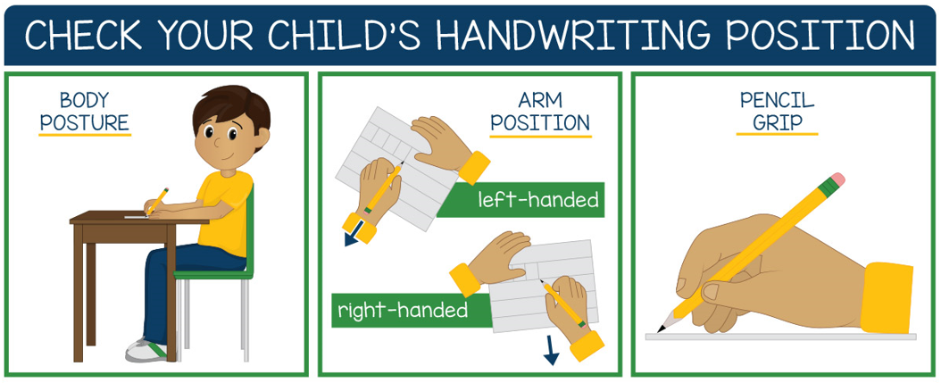

**Letter formation rhymes - from Read Write Inc Programme**

