**LEITH ACADEMY - Vape and Smoke Free School Guidance**

Through the adoption of a vape and smoke free school guidance, **LEITH ACADEMY** is committed to providing a healthy and safe studying and working environment for students and school staff on its premises and contributing to raising a vaping and tobacco product free generation. This guidance is based on best available evidence which is summarised on Appendix 1 and follows a World Health Organisation framework.

**Objectives**

School staff are dedicated to creating a vape and smoke free school environment and aim to:

• protect the health and wellbeing of our students, and school staff by banning the use vape and tobacco products.

• encourage vaping and tobacco users to quit and offer appropriate support.

• de-normalise vaping and tobacco use, thereby contributing to raising a vaping and tobacco product free generation.

**Definitions**

Tobacco products: this guidance refers to tobacco products including those that are traditionally smoked, snuffed, and ingested as well as other oral forms of tobacco.

Vaping products (or e-cigarettes): are battery-operated devices that people use to inhale an aerosol, which typically contains nicotine (though not always), flavourings, and other chemicals. While these devices might be a useful quitting aid for people who smoke, Public Health Scotland advises that e-cigarettes are not suitable products for children or non-smokers.

**Who does the guidance apply to?**

The ban on using vape and tobacco products applies to everyone present on the school premises: pupils, school staff, parents while visiting and all other visitors, regardless of the purpose of their visit and at all times.

**What areas are covered by the guidance?**

The vaping and tobacco product free school guidance applies to all **LEITH ACADEMY** facilities, properties, and vehicles, regardless of location.

Vaping and tobacco use is prohibited in any indoor areas, including, but not limited to, offices, classrooms, meeting rooms, service rooms, bathrooms, hallways, staircases, and sports and leisure venues. The use of vaping and tobacco products is banned in all outdoor **LEITH ACADEMY** properties, including, but not limited to, playgrounds, paths, fields, parking areas, and sports and leisure areas

This guidance also applies to all school events organised outside the school property. LEITH ACADEMY discourages the use of vaping and tobacco products outside the school gate or in immediate proximity to school properties.

**Curriculum**

Schools should use Curriculum for Excellence experiences and outcomes for planning learning in this area of the curriculum. CEC Progression Pathways/ PSE Toolkit can support this work and have been updated with new information and resources to support teaching about vaping. As always, learner voice should shape the learning to ensure it is appropriate for the context of the school.

**Implementation**

All staff are expected, and supported, to contribute to the implementation of this guidance. As such school buildings and grounds should be monitored throughout the day.

If a student is seen smoking or vaping, staff should either challenge them and / or report through the school’s usual processes, e.g. Wellbeing Concern, Seemis referral, etc.

Appropriate responses / reasonable measures will be applied to students including:

* Discussing the issue
* Confiscating the item
* Contacting home
* Restorative approaches – discussions, supports and consequences may include i.e. peer support from older pupils, parental meeting, family support, sign posting e.g. [Quit Your Way Scotland | NHS inform](https://www.nhsinform.scot/care-support-and-rights/nhs-services/helplines/quit-your-way-scotland/), [Vaping addiction soon takes hold | NHS inform](https://www.nhsinform.scot/campaigns/vaping/), Vaping Fact Sheet (Appendix 2), not being allowed to use toilets during class time, only able to use specific toilets, school counsellor, referral to school nurse etc.

If anyone is caught supplying tobacco & vapes to other pupils, the school will report this to the School Link Officer.

Further implementation guidance can be found in Appendix 3.

**Cessation support**

**LEITH ACADEMY** is committed to supporting all vaping and tobacco users who want to quit. Please contact School Nurses who will provide advice and information to support a successful quit attempt. Otherwise, anyone who is willing to quit smoking or vaping can directly contact the national Quit Your Way Scotland service by phoning 0800 84 84 84 or [chatting online with an adviser](https://www.nhsinform.scot/campaigns/vaping/). Alternatively, local GPs can also provide support. There is advice available for how parents can talk to their child about vaping from [Parent Club](https://www.parentclub.scot/articles/information-and-facts-about-vaping). Additional advice can be found at [Vaping addiction soon takes hold | NHS inform](https://www.nhsinform.scot/campaigns/vaping/) and at [Fast Forward -](https://www.fastforward.org.uk/)

**Monitoring and evaluation**

**LEITH ACADEMY** will monitor and evaluate the effectiveness of the guidance through:

• monitoring smoking and vaping hotspots across school premises on a regular basis.

• addressing all reported notifications on guidance violations; and

• conducting a regular online survey every 2 years among students and school staff, for example, using the CEC Wellbeing surveys.

This guidance shall come into effect on 14 AUGUST 2024

Next review is planned for ANNUAL

Signature of Head Teacher: M. Irving

**Appendix 1:**

**Background and evidence base**

This guidance uses the World Health Organisation Tobacco Free Schools Framework. According to their report, tobacco claims over 8 million lives annually; a staggering 1.3 million of these deaths are non-smokers succumbing to illnesses attributed to second-hand smoke, and 51 000 of these victims are children. The main concern of tobacco use and exposure to second-hand smoke in youth is the harmful effects of nicotine on adolescents’ brain development.

In addition, children are more vulnerable to different forms of marketing and peer pressure and are easily influenced by their role models. This situation emphasises the need for more effective and comprehensive measures to prevent children and young people from starting tobacco and nicotine use.

As children spend one third of their waking hours at school, it is imperative to offer them clean air and protect their information environment from the misleading and manipulative tactics of the tobacco industry.

This guidance and actions are in line with the Scottish Tobacco Free 2034 Generation target, as well as recent national measures to further protect children and young people from the unknown risks associated with the unlicensed use of vapes.

**Appendix 2**

**Vaping Fact Sheet (NHS Inform)** [**Vaping addiction soon takes hold | NHS inform**](https://www.nhsinform.scot/campaigns/vaping/)

**Vapes are not for children or non-smokers. In Scotland, it’s illegal to sell vapes or e-cigarettes to anyone under 18, or to buy them for someone who’s under 18.**

There has been an increase in young people saying they’ve used a vape at least once in their lifetime.

Research on smoking has shown that nicotine is highly addictive. Someone who uses vapes may become addicted to nicotine and find it difficult to stop using it. The nicotine contained in many vapes is highly addictive. It can stop young people from concentrating on the activities they enjoy.

You can become addicted to nicotine within days of starting to use it, even if you only vape occasionally.

**Effects of nicotine**

Most of what is known about the effects of nicotine comes from research into smoking.

**Nicotine addiction**

Research on smoking has shown that nicotine addiction can affect your mental health. It can make you tired, stressed and anxious. It can also affect your concentration and impact your ability to learn and study.

Nicotine addiction can lead to long-lasting changes in cognition (thinking), attention and memory. It can also lead to mood disorders like depression and anxiety.

While the long term health effects are still being researched, organisations like [Cancer Research UK](https://www.cancerresearchuk.org/about-cancer/causes-of-cancer/smoking-and-cancer/is-vaping-harmful), the [British Heart Foundation](https://www.bhf.org.uk/informationsupport/heart-matters-magazine/news/e-cigarettes), the [Royal College of Paediatrics and Child Health](https://www.rcpch.ac.uk/resources/policy-briefing-vaping-young-people)and the [Royal College of Physicians](https://www.rcplondon.ac.uk/guidelines-policy/royal-college-physicians-response-government-s-consultation-youth-vaping) all believe it’s unsafe for children and young people to vape. Vapes are not for children.

**Nicotine withdrawal**

When a person is dependent on (or addicted to) nicotine and stops using it, their body and brain have to get used to not having nicotine. This can result in temporary symptoms of nicotine withdrawal.

Nicotine withdrawal symptoms include:

* irritability
* restlessness
* feeling [anxious](https://nhsinformstaging.azurewebsites.net/illnesses-and-conditions/mental-health/anxiety/) or [depressed](https://nhsinformstaging.azurewebsites.net/illnesses-and-conditions/mental-health/depression/)
* [trouble sleeping](https://nhsinformstaging.azurewebsites.net/mind-to-mind/sleeping-better/how-to-improve-your-sleep/)
* problems concentrating
* craving nicotine
* headaches

Please remember you can always speak to a supportive adult at home, in the community or in school, for example your teacher, Pupil Support Lead or School Nurse.

**Appendix 3: Action plan for implementation**

**Action Plan**

The school should:

* designate responsibility for the policy to the appropriate school improvement group.
* determine a date for a policy launch; and
* develop a plan to launch and monitor implementation of the policy.

Copies of the guidance should be made available to pupils, school staff, parents/carers and partners.

Schools may choose to involve their pupils in developing their own versions of the guidance.

The smoke and vape free guidance can be accessed via the **LEITH ACADEMY** website [Home - (leithacademy.uk)](https://leithacademy.uk/) and should be included with other health and wellbeing information.

‘This is a no smoking/vaping school’ signs should be placed at all entrances to **LEITH ACADEMY** buildings and grounds as appropriate to indicate that this is a tobacco and vape free area, and on all school vehicles.

[**Information and facts about vaping | Parent Club**](https://www.parentclub.scot/articles/information-and-facts-about-vaping)

The designated group may wish to develop a proportionate response according to their local context:

* Engage with pupils / focus groups/survey to gain their views on taking the guidance forwards and discuss key issues pertinent to the school, including shaping the curriculum to meet learner needs.
* Create a pupil group to be involved in the launch and implementation of the guidance.
* Capture parent / staff voice.
* Create an action plan and launch.
* Consider a parent event to plan a coordinated approach to protect against harm from vaping.
* Consider contacting local Trading Standards Officers to discuss their support during launch.
* Consider linking this work to your whole school approach to [UNCRC](https://www.unicef.org.uk/what-we-do/un-convention-child-rights/).
* Ensure teaching /PSE staff are confident in the subject and signpost to HWB progression planners/PSE Toolkit on this subject.
* IDL approach e.g. Art, English, Science, PE,

See Sample Action Plan below.

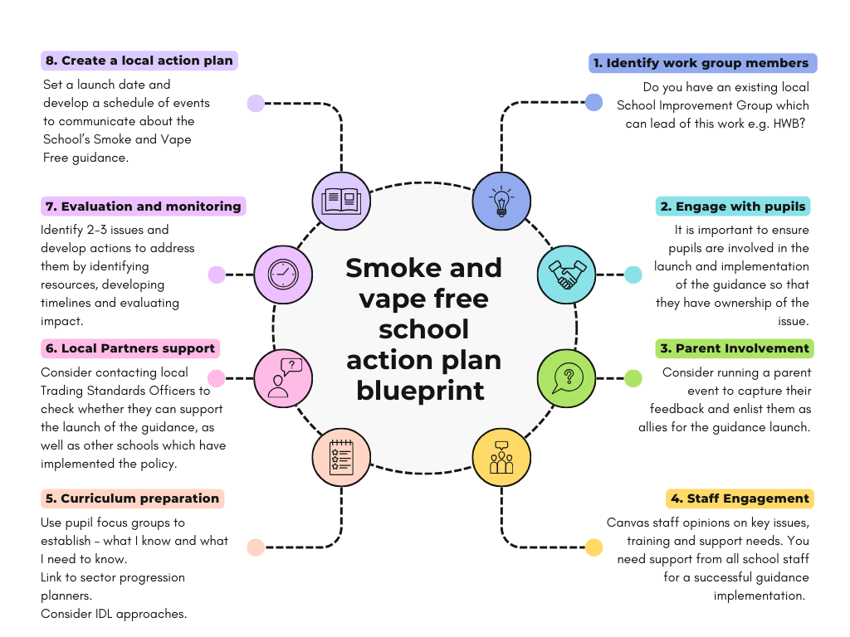

Smoke and Vape Free Schools Action Planner Template

|  |  |  |  |  |  |  |  |
| --- | --- | --- | --- | --- | --- | --- | --- |
| Focus area | Activity | Implementation | | | | | Notes |
| Resources needed | Delivered by | | Where | When |
| Pupils |  |  | |  |  |  |  |
|  |  | |  |  |  |  |
| Parents |  |  | |  |  |  |  |
|  |  | |  |  |  |  |
| Staff |  |  | |  |  |  |  |
|  |  | |  |  |  |  |
| External Partners |  |  | |  |  |  |  |
|  |  | |  |  |  |  |
| Curriculum development |  |  | |  |  |  |  |
|  |  | |  |  |  |  |
| Evaluation and monitoring |  |  | |  |  |  |  |
|  |  | |  |  |  |  |