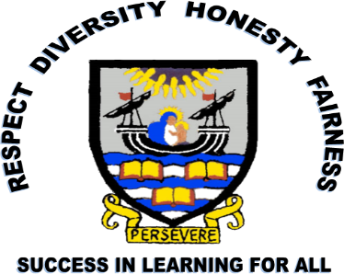

LEITH
ACADEMY

S3
HANDBOOK
&
LEARNER PATHWAYS

2026/27
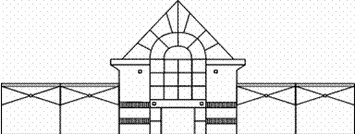


Leith Academy

S3 Handbook & Learner Pathways

Session 2026/27

CONTENTS
Introduction
Subjects
English & Media
Maths
Modern Languages:
French
Mandarin
Spanish
Italian/German
Science:
Biology
Chemistry
Physics
Triple Science
Social Subjects:
Geography
History
Modern Studies
Sociology
RMPS
YPI
Business & Computing Technologies:
World of Business
World of Computing
Design Technology:
Design Technology
Practical Skills
Expressive Arts:
Art
Photography
Drama: Theatre Tech
Drama
Music
Musical Theatre
Music Technology
Health, Food and Practical Cookery
Physical Education & Electives
Prince’s Trust Achieve Programme
Subject Pathways & Learner Pathway
Introduction

Welcome to the S2 into S3 Handbook. This is a short guide to the content of the courses we offer to our S3 pupils as they complete the final year of the Broad General Education and prepare themselves for the Senior Phase, when they will complete their National Qualifications.

The Handbook is divided into sections based on the subject areas offered in S3 and provides details of the specific courses within these, from which pupils’ S3 timetables will be constructed. There are several compulsory subjects in S3 and these are as follows:

- English – 4 periods a week
- Maths – 4 periods a week
- Modern Languages (continuing the main language studied in S1 and S2) – 3 periods a week
- Core Physical Education – 2 periods a week
- Core Religious, Moral and Philosophical Studies – 1 period a week
- Core Personal Social Education – 1 period a week; delivered by House Heads

In addition to this, pupils must choose one subject from the following subject areas, indicated in Columns A to D on the Learner Pathway (see page 12):

- Science
- Technology
- Social Subjects
- Expressive Arts

Students must also make selections from our “Choice” Columns E&F; these Columns on the Learner Pathway sheet include a range of subjects from all subject areas. All subjects from Column A to E are delivered 3 periods a week; Column F will be delivered 2 periods a week.

The following pages will hopefully help students be supported to pick the best subjects for them. Should you need any further help or support then you should contact your House Head in the first instance:
Anderson – Mr Fox: Daniel.Fox@leith.edin.sch.uk
Barton – Miss Lindsay: Laura.1.Lindsay@leith.edin.sch.uk
& Mrs Simpson: kelly.simpson@leith.edin.sch.uk
Cowan – Miss Hamill: Jenna.3.Hamill@leith.edin.sch.uk
Port – Mr Connor: Blair.Connor@leith.edin.sch.uk
You can also contact Ben Stewart, Depute Head, who has an overview of course choice:
Mr Stewart: Benjamin.Stewart@leith.edin.sch.uk
English
Pupils will develop the four key skills of Reading, Writing, Listening and Talking in S3 English. They will study texts from a range of genres including prose, drama, poetry and film. The course will develop their skills of understanding, analysis and evaluation, which will prepare them for their National 4 or National 5 English or ESOL in S4. Engaging in a variety of writing opportunities will allow pupils to be creative and to develop their research and note-taking skills.
Media
Pupils will explore a range of media texts from a range of genres, such as film, TV, print media etc. They will develop their skills in analysing and creating different forms of media. This course will help prepare pupils for the NPA Media course in the Senior Phase and will also develop skills used in N5 and Higher English.
Maths

In S3 Maths, you will continue to develop problem solving skills in the areas of numeracy, algebra and geometry. Throughout the year, you will sit assessments at the level you are working at to assess these skills. We will also make decisions about the pathway into S4 - whether this is a Mathematics or Applications of Mathematics pathway.

A short summary of each subject is below:
📘 Mathematics (SQA)
- About abstract maths: algebra, trigonometry, calculus, equations.
- Focuses on theory and problem-solving.
- Useful if you want to go into science, engineering, computing, or other STEM areas.

📗 Applications of Mathematics (SQA)
- About practical maths: money, statistics, measurement, everyday problem-solving.
- Focuses on real-life situations like budgeting, interpreting data, or planning.
- Useful for workplace skills and daily life, not just academic study.
Modern Languages

French /Mandarin/Spanish/Italian/German
The study of languages with a focus on:
- Self: personality, nationality, age, family, leisure activities, daily routine, numbers, clothes
- Learning: school routine, subjects, opinions
- Culture: where people live, holiday activities, festivals
- Employability: part-time jobs, places of work, tasks at work

Science

Biology
The study of living things - how they work and interact.
Topics you will study in S3 Biology:

- Planet Earth​
- Food Science​
- Cells, Cloning & Cancer​

- Inheritance​
- Sports Science

Chemistry
The study of chemicals - how they react and what they can be used for.
Topics you will study in S3 Chemistry:

- Atoms and bonding​
- Lab Skills​
- Metals​
- Cosmetic Chemistry​
- Fuels and Hydrocarbons​
- Acids and Formula

Physics
The study of trying to understand how the universe works.
Topics you will study in S3 Physics:

- Practical Physics​
- Space & Waves​
- Electricity and Electronics​
- Forces and Motion

Triple Science
We know some pupils have a desire to study all three Science subjects throughout S3. Therefore, we offer a special Triple Science Pathway. By selecting this option, pupils can cover the content of all three S3 Science subjects, taught by specialist teachers, but in the same lesson time as two subject choices. As there is less time spent in each subject, you need to discuss and agree with your S2 Science teacher(s) that you will be able to cope with the accelerated pace of the lessons and that your current attainment in Science supports a decision to study three Sciences in S3. This pathway is suitable for pupils who really enjoy all areas of Science and would like to keep their options open about which Science subjects to select in the Senior phase.

Social Subjects
Geography
Physical Geography
- We learn about how the natural processes of our planet work.
- In S3, we study Weather and Rivers.
Human Geography
- We study how and where people live and the consequences of this.
- In S3, we study Population Issues and study how cities are changing.
Global Issues
- These are issues that affect the whole world – often in the news and discussed in world politics.
- In S3, we study Climate Change and Globalization.
History
The Industrial Revolution
- The Industrial Revolution brought the United Kingdom into an era of technology and productivity. It created wealth for many but social problems and poverty for others.
Nevertheless, it is impossible to deny that the years after 1750 were a time of great achievement in terms of Agriculture, Industry, Transport and Communications, and Health and Housing. We will examine these areas.
- We also examine the topic of Crime and Punishment in Victorian Britain.

Civil Rights in the USA
- Early immigration to the USA.
- Attitudes toward these new immigrants.
- Jim Crow Laws that segregated USA.
- The actions of the KKK.

Modern Studies
- Political Issues – Recently in Scotland, 16-year-olds were allowed to vote in a referendum. It is important to know how to participate in politics and why you should participate. This unit will look at these issues in the context of Scotland.
- Social Issues – We also study the inequalities which exist in Scotland and the UK. What is the difference between rich and poor in Scotland and why is there such a big difference?
- International Issues – In this unit you will look at international terrorism and later in the year you will look at world issues like child soldiers, HIV in Africa, civil war and poverty.

Sociology - Culture and Identity
Candidates develop a basic knowledge and understanding of how to use sociological concepts to explain culture and identity. They investigate and explain the relationship between culture and identity and develop skills in collecting, using and communicating information from a range of sources. They also develop an awareness of diversity.

YPI
Pupils studying Geography, History, Modern Studies and RMPS will also participate in the Youth Philanthropy Initiative programme. This is a real-life experience researching social issues which impact our local area and the finding out about the charities which try to tackle these problems. The unit culminates in a year group final when one group will be awarded £3000 to give to the charity they represented.

Religious, Moral and Philosophical Studies
- World Religion: We will study the practice and beliefs of the world’s fastest growing religion - Islam.
- Moral Issues: We cover topics of debate and question if they are right or wrong.
- Philosophy: We will try to answer some of life's difficult questions.
Business and Computing Technologies

World of Business
We know that many pupils are keen to study a number of areas within Business and want to understand better what is involved within each specialism so we are now offering a combined World of Business course, where pupils will have the opportunity to find out what is involved within each subject as they prepare themselves for the Senior Phase.

World of Business will include the following:

Accounting
- Studying the role of the Financial and Management Accountant.
- Preparing the Income Statements of small businesses to identify profit or loss.
- Identifying how much a business is worth by preparing the Statement of Financial Position.
- Understanding the crucial role of cash management in the success of a business by preparing Cash Budgets.

Administration & IT
- Developing ICT skills in a professional business context using Microsoft Office software.

Business Management
- Understanding how businesses are set up and run.
- The importance of business within the UK economy.
- Developing your entrepreneurial spirit.

Economics
- Economics is about choice and its impact on individuals, businesses and the government.
- You will gain an awareness of current economic problems and consider options in solving those problems.
- This will appeal to learners with an enquiring, logical and analytical mind, and to those with an interest in how economies operate.

World of Computing
- It is not about learning ICT skills.
- It is the study of how computers work, how to program them and how they shape and change our human environment.
- You will learn about coding, game design and cyber security.

Design Technology

Design Technology
This course offers learners a taster project for each of the courses that we offer in the senior school: Creative Thinking, Design Engineer Construct, Practical Woodwork and Jewellery. A large part of this course is classroom-based.
- Creative Thinking: learners are encouraged to thinking differently, break rules, fail, collaborate and create, and progress to presenting creative, innovative solutions and ideas. Connected to careers in Graphic Design, Marketing, Advertising and Interior Design.
- Design Engineer Construct: pupils learn about the built environment and infrastructure design. This is a unique pathway into Architecture, Engineering, and other careers in this field.
- Practical Woodwork: manufacturing products in wood. Connected to careers in Practical Skills like Joinery, Construction and Carpentry.
- Jewellery Techniques: manufacturing products in aluminium, copper and brass; developing a variety of skills used in manufacturing jewellery.
- Final Design Project: designing a product with an emphasis on creativity and developing sketching skills. Manufacturing using a variety of materials (wood, metal and plastic).

Practical Skills
This course is based fully in the workshop, offering a taster of the courses in the senior school: Practical Woodwork and Jewellery Techniques.
- Practical Woodwork: manufacturing products in wood, with an emphasis on accuracy and developing a variety of woodwork skills and reading drawings.
- Jewellery Techniques: manufacturing products in aluminium, developing a variety of skills used in small metal working and manufacturing jewellery.
- Pupils progress by monitoring health and safety in the workshop when using tools and machines.

Expressive Arts

Art
- Students are offered more room to develop individually tailored work within class projects throughout the course. This encourages confidence and creativity. We ensure students take ownership of their work, preparing them for the N4/5 next year.
- Students will learn about a variety of designers and will design and make their own pieces - for example, headgear for heroes or villains.
- Pupils will do figure drawing features in the projects, learning how to draw people in proportion in an expressive way builds confidence.
- Students will work with a wider range of material including watercolours. They will be taught new painting techniques on stretched paper for example.
- Students will learn how to create landscapes in perspective using one- and two-point perspective.
- Digital skills are taught - for example, creating architecture using the app Minecraft to design an arts centre situated at Duddingston Loch.

Photography
- Pupils will have the chance to learn or develop photography skills throughout the year and will have the opportunity to use a wide range of photography equipment and photo editing software.
- Over the year, pupils will build a photography portfolio, including photography in a variety of styles: portraits, built environment, landscape, still life.
- There will be opportunities to practise these skills in and out of school.

Drama
Pupils will learn about a variety of acting and design production roles throughout S3 Drama.
• You will be given lots of performance opportunities, which will help you build your confidence with this whether you are an actor on stage or a designer backstage.
• In Drama, you will learn about the actor’s voice and movement, stylized movement and stage combat, how to build a character and how to work with scripts.
• You will also learn about Design Production Areas, Sets, Lighting, Props, Make-up & Hair, Costume and Sound Design.
• You will be assessed through your practical work and through some theory work, which will help those pupils who want to go onto N4/5 Drama.

Drama: Theatre Tech
This new course will give those who love drama but aren’t confident on the stage the chance to really develop their skills. The course will consist of in-depth units in:
- Lighting
- Sound
- Stage Management
There will be opportunities for pupils studying Theatre Tech to shadow older pupils and eventually take on lead roles in their preferred areas for school shows, drama productions and music concerts.

Musical Theatre
This course is perfect for pupils who are interested in musical theatre, and who enjoy acting and singing. The course will allow pupils to develop their singing skills and acting skills through learning and performing musical theatre songs. There will be 2 main points of focus throughout the year:
- Group singing skills
- Solo singing and acting through song
There will be opportunities to involve dance if pupils are keen to do this, but you do not need to be a dancer to take this course. There will be multiple performance opportunities throughout the year.

Music
Music in S3 is split into 3 different units:
- Performing Skills: pupils will continue to develop skills on 2 chosen instruments. This will include a mix of solo and group performing opportunities.
- Understanding Music: you will learn about a large variety of different music styles and discuss musical features of these. This will include styles such as Jazz, Blues, World music and Scottish music. You will also develop your knowledge of Music Theory.
- Composing Skills: you will learn about different methods of writing your own music and will have the opportunity to create your own music in a variety of different styles throughout the year. This might include, creating Electronic music on GarageBand, or doing a Blues improvisation on your own instrument.

Music Technology
Music Technology in S3 is split into 3 different units
- Music Technology Skills: learning how to use specialist music technology equipment, software and apps, whilst also learning basic recording, mixing and mastering skills.
- Music Technology in Context: creating projects such as short film/computer game soundtracks, audiobooks, podcasts and composing electronic music.
- Understanding 20th and 21st Century Music: developing listening skills whilst learning about prominent styles of music from the 20th and 21st centuries.

Health, Food and Practical Cookery
- Pupils develop cooking skills to prepare them for National 4/5 Hospitality: Practical Cookery.
- Pupils develop knowledge of nutritional values and how these affect our health.
- Pupils gain knowledge of the organisation and planning required to work in hospitality.

PE/Football
- Pupils develop physical skills, techniques, fitness and tactics in a variety of activities.
- Pupils develop teamwork skills, leadership skills and communication skills when working with others.
- Pupils develop digital learning and analytical skills as well as planning approaches to improve performance.
- Both courses prepare pupils for National PE, Football and Sport and Recreation.

PE Electives

More Than Sport
This course will aim to develop positive self-esteem, increased confidence and improved health awareness through the medium of aesthetic activities such as dance, netball and cheerleading. Pupils will lead whole school events such as Active Girls’ Day and Mental Health Awareness Day as well as engagement throughout the year with our Fit for Girls initiative.

Rugby: Developing Performers
This course is an introduction to strength and conditioning, coaching and leading Primary rugby events. Although done through the medium of rugby, a lot of the skills learned can be transferred into other activities. You do not need prior rugby experience for this course.

Young Sports Leaders
This course is an introduction to our leadership pathway. It provides pupils with the opportunity to develop leadership, communication and organisational skills. The course will incorporate a variety of activities such as netball, basketball, football, athletics and swimming. Pupils will lead sporting events with Primary schools such as Primary Sports Days.

Prince’s Trust Achieve Programme
The Prince’s Trust Achieve programme supports pupils to develop the skills and confidence they need to reach their goals through relevant, engaging and informal learning. The course is flexible and supports young people to develop transferable skills that can help them to improve attainment and personal and social skills that can be applied in school and their wider lives. Through engaging in units such as Teamwork Skills, Career Planning, Community Project, and Undertaking an Enterprise Project, among others, learners will have the opportunity to achieve a Scottish Personal Development and Employability Certificate at Levels 3, 4, or 5.

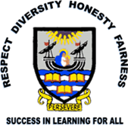
Leith Academy S2>S3 Learner Pathway 2026-27
Name: _________________________________________ Class: ______________ House: _________________________

A  Sciences |  | B  Social Subjects |  | C  Technologies |  | D  Expressive Arts |  | E  Free Choice  3 Periods per Week |  | F  Free Choice  2 Periods per Week |  | G | H | I | J
Physics |  | World of Business |  | World of Business |  | Art |  | Chemistry |  | German |  | English | Maths | Spanish | PE/RME/PSE
 |  |  |  |  |  |  |  | French |  | Italian
Chemistry |  | History |  | World of Computing |  | Drama |  | World of Business |  | Languages for Life and Work
 |  |  |  |  |  |  |  | Art |  | Photography
Biology |  | Geography |  | Design Technology |  | Music |  | Mandarin |  | Theatre Tech
 |  |  |  |  |  |  |  | Drama |  | Musical Theatre
Triple Science* |  | Modern Studies |  | Practical Skills |  | PE |  | PE |  | Rugby: Developing Performers |  | Please note that no course can be guaranteed - this will depend on numbers and staffing.
 |  |  |  |  |  |  |  | Geography |  | More Than Sport
 |  | RMPS |  | Health, Food and Practical Cookery |  | Football |  | Modern Studies |  | Young Sports Leaders
 |  |  |  |  |  |  |  | History |  | Scots Language and Culture
 |  | Achieve* |  |  |  | Health, Food and Practical Cookery |  | Music Technology |  | Creative Writing & Poetry
 |  |  |  |  |  |  |  | Media |  | Screen Writing
 |  |  |  |  |  |  |  | Music |  | Sociology – Culture and Identity
 |  |  |  |  |  |  |  | Triple Science*

- Pupils will follow one subject from each of Columns A – F but they should make a first and second choice in each of these columns in case we cannot provide their first choice. Pupils should do this by placing numbers 1 and 2 in the boxes alongside their subject choices.
- ACHIEVE* may only be selected in Column B after this has been agreed, prior to coursing, with the House Head and Achieve teaching staff.
- Pupils selecting Triple Science* must select this in both Columns A and E. This will involve studying all three Sciences in a contracted time. Pupils must have spoken to and agreed their suitability for this option with their Science teacher before selecting.

Pupil’s Signature: ___________________________________ Parent/Carer’s Signature: ________________________________________ Date: __________
Please hand in or email your completed Learner Pathway to your House Head by 19th January 2026.
Subject Pathways
Business & Digital Pathways

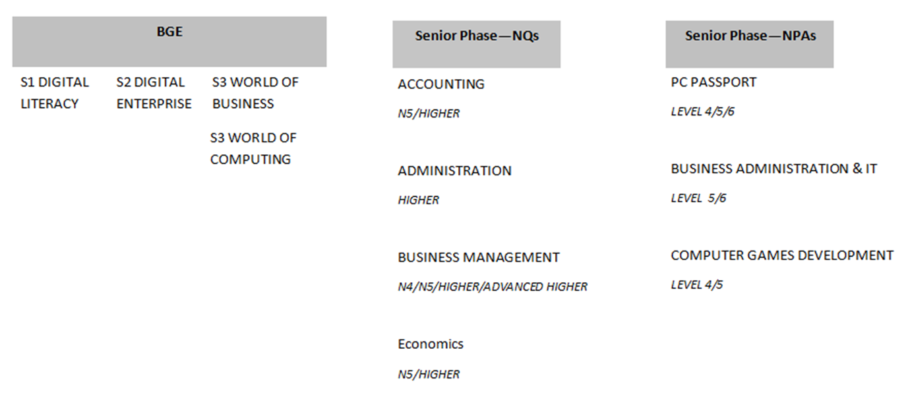

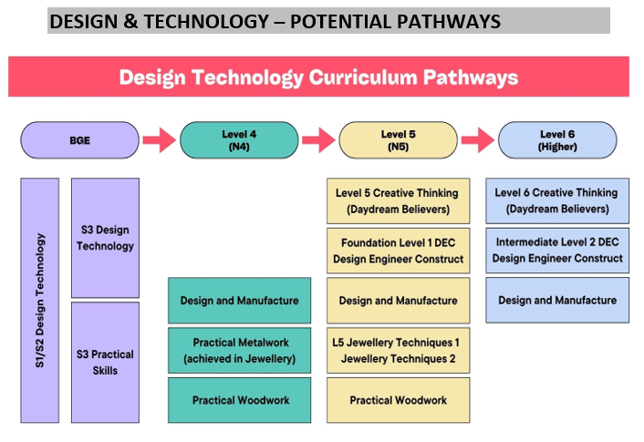
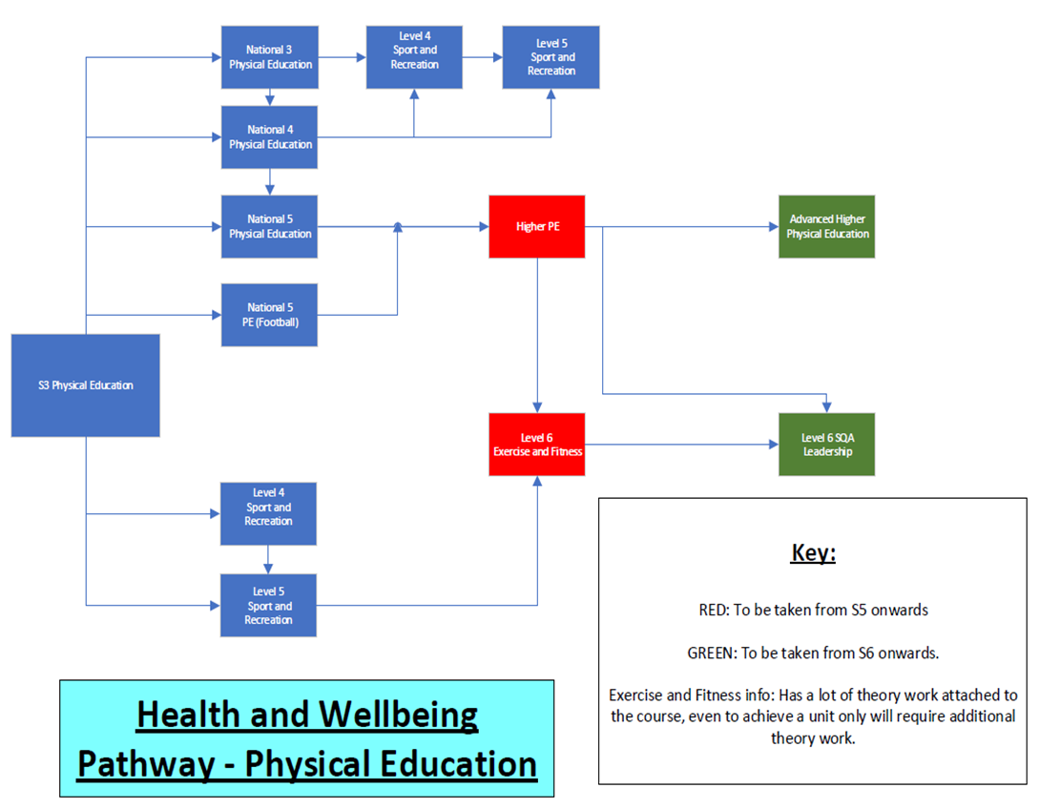

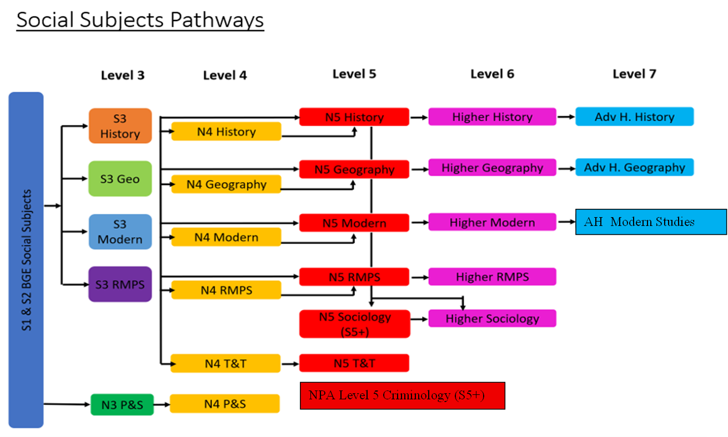
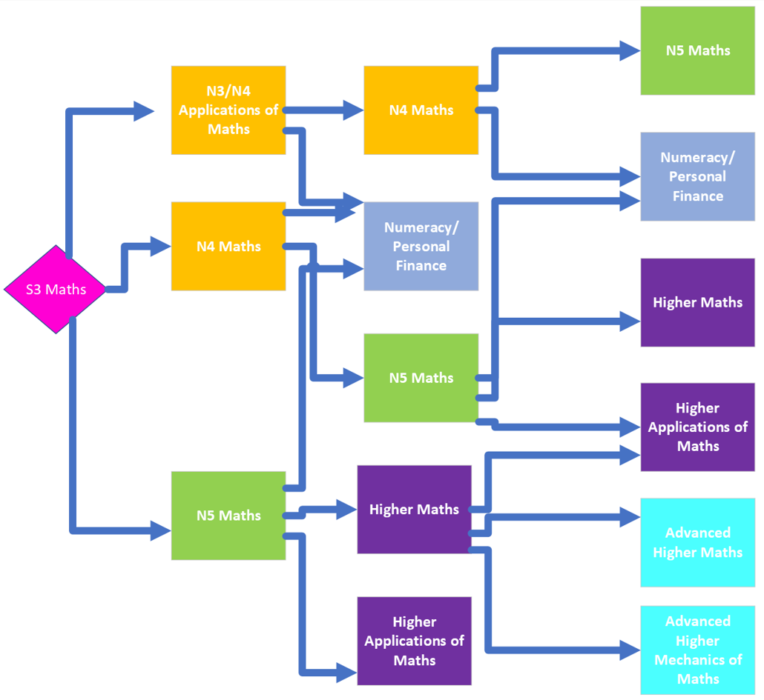
Mathematics Pathways
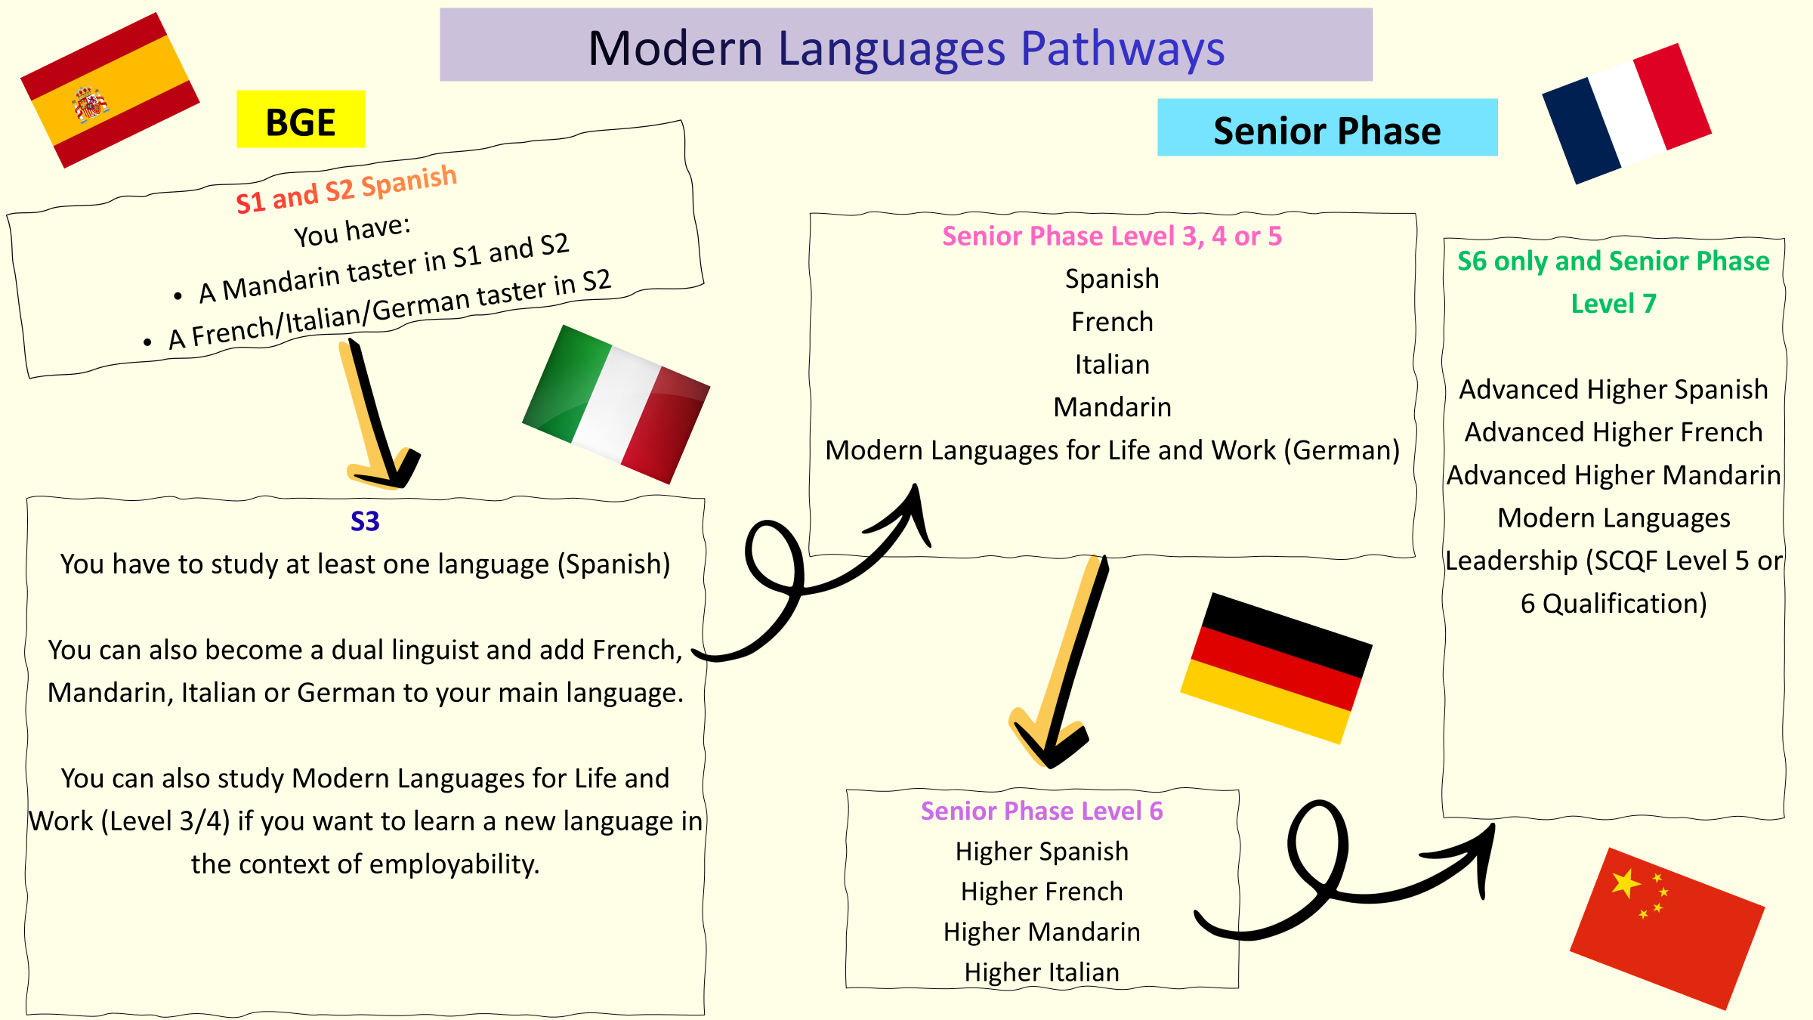
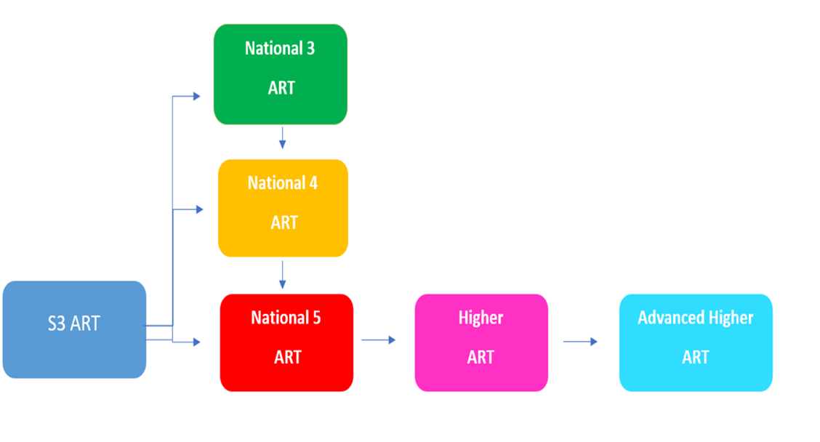
CREATIVE ARTS PATHWAYS – ART & DESIGN

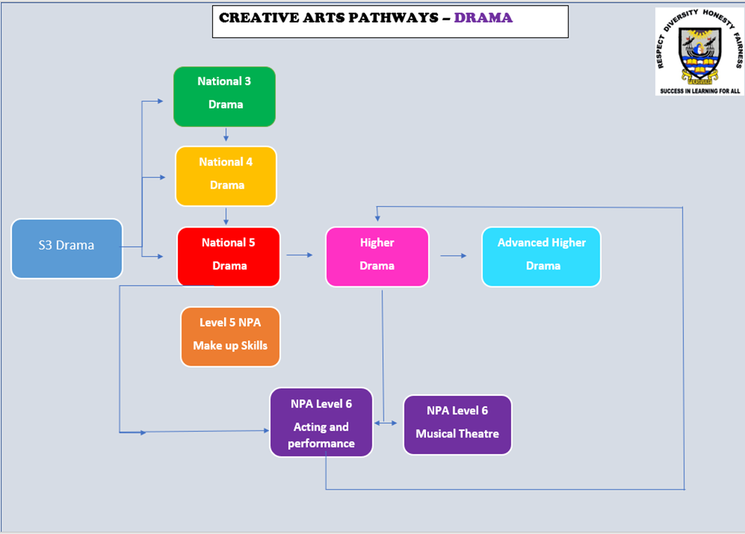
CREATIVE ARTS - MUSIC PATHWAYS
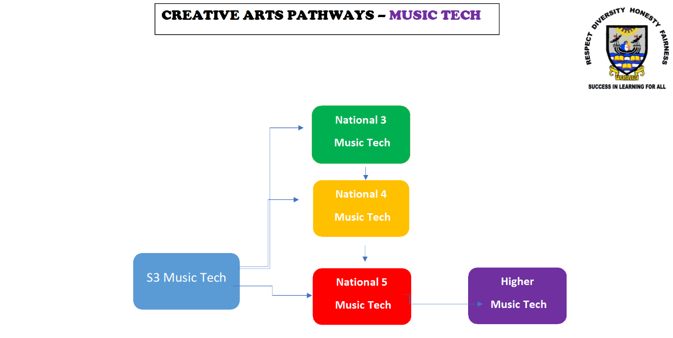
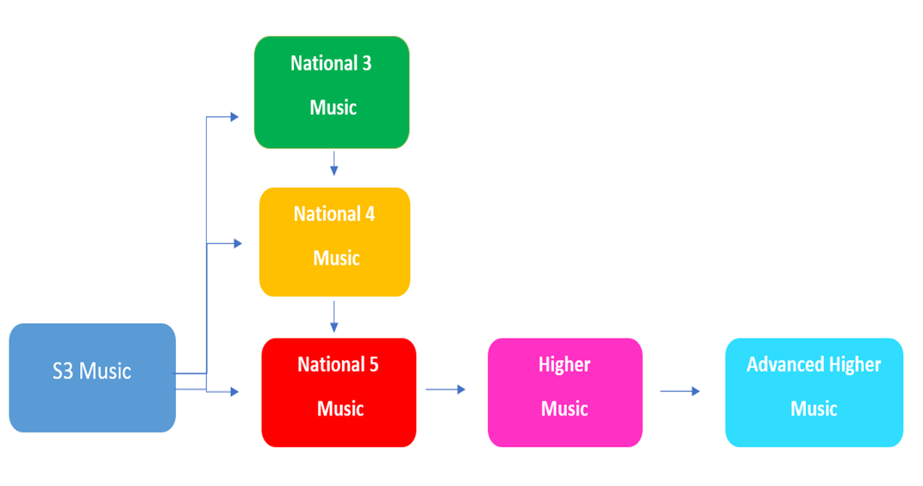

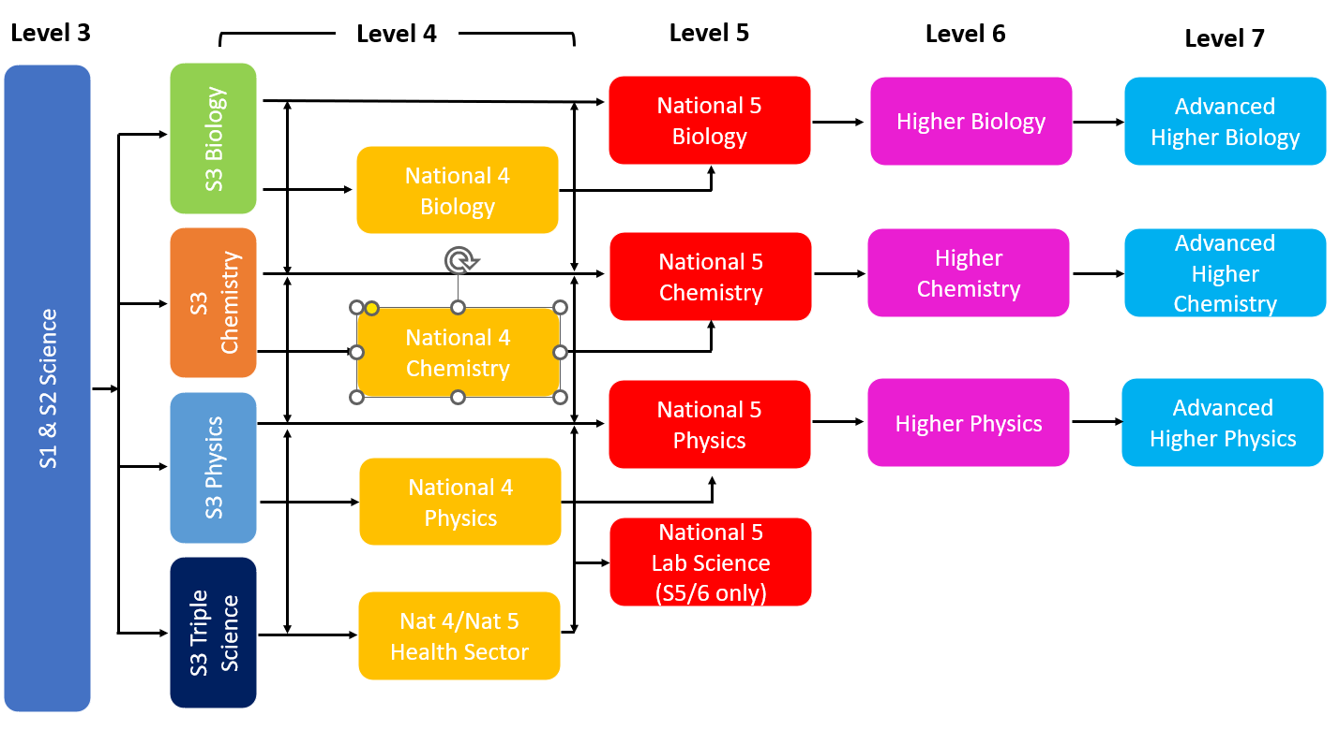
SCIENCE PATHWAYS
