Clubs
UKTC | Taekwondo | Leith Community Centre  Phone: 01786845060
 | Judo classes | Leith Newkirkgate  Phone: 07885386477
 | Hibernian Community Football | Leith  Age :3-14 years  Phone: 07475955429
 | No.1 Goalkeeping Academy | Southside/Northside  Age: 7-15+ years  Phone:07808845172
 | LA Football Development Centre | Meadowbank Sports Centre  EH76AE  Phone: 07494516564
 | The Keepers Academy | Edinburgh Academy  EH3 5PL  Ages:10-17 years  Phone:07584437491
 | Spartans Community Foundation | Ages: 18 months – 14 years 11 months  Phone:01315527854
 | DM Elite Football Academy | Portobello  All ages  Phone: 07487843621
 | SuperNetters  Girls Netball Coaching | Email: info@suppernetters.com  Phone:07909898037
 | RMB Dance | Ages:3-18 years  Phone: 07340225766
 | LBA Dance and Performing Arts Studio | Email: label learns.co.uk  Phone:07525423414
 | GC Gymnastics/Corstorphine Sports and Activities Club | Phone: 07854249104
 | The Scottish Theatre and Music School  EH2 3JZ | Ages 6-16 years  Phone:  07555215855
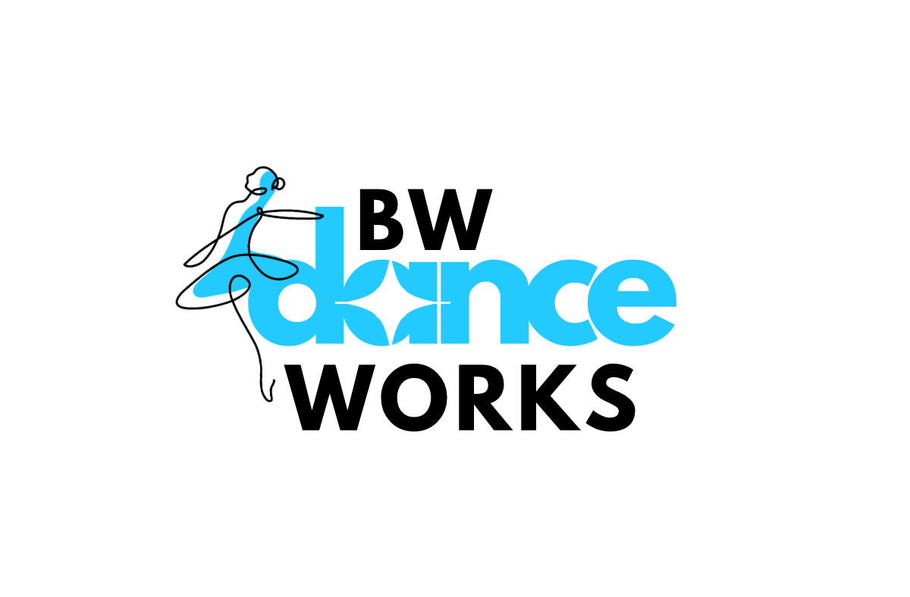 | BW Dance Works  Edinburgh Academy | Phone:  07496513916
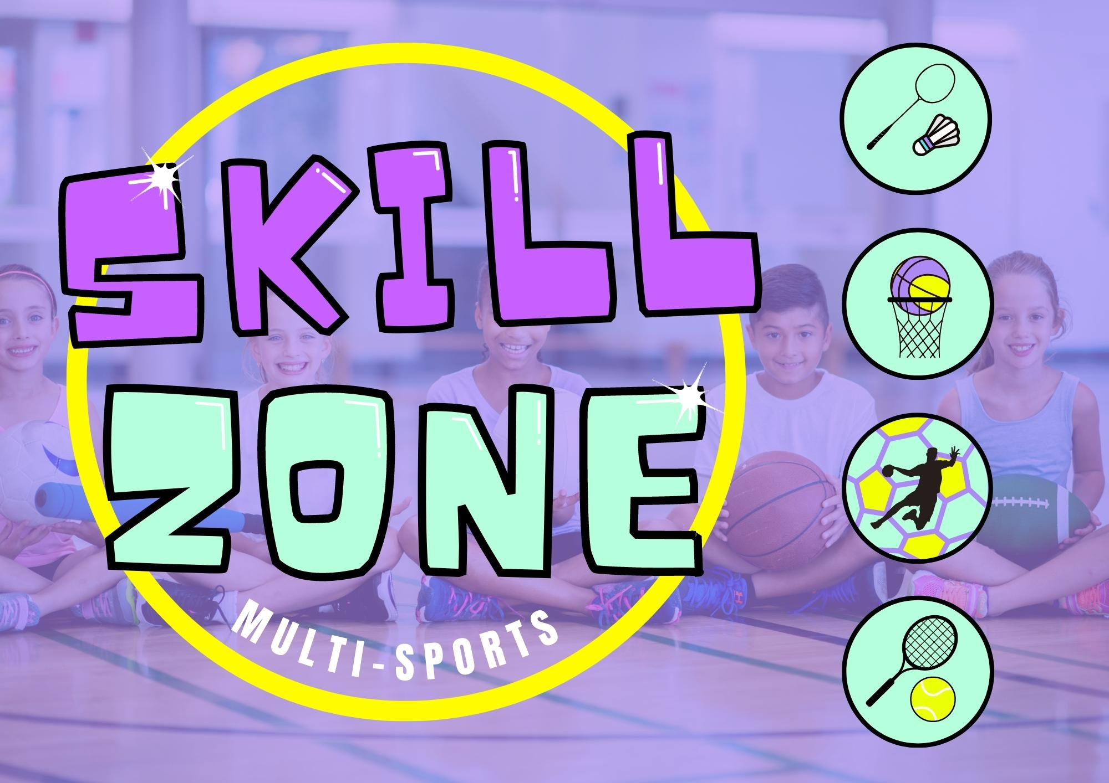 | Skill zone multi-sports  Badminton/Basketball/Handball  @James Gillespies | Phone:  07715219883
  I | First Step Robotics  Royston Wardieburn Community Centre | Age:7-11 & 12-17 years  Phone:  07898746166
 | Aerial Art House  101 Restalrig Road  EH67NY | Age:5-17 years  Email: aerial art house.com  07759653023
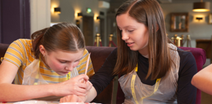 | Edinburgh playhouse “makeup masterclasses” | Age: 14-18 years  Creative learning team:  01315243302
 | Art Leith School of Art  Art & Design Foundation Diploma | Phone:  01315545761  Enquiries@leithschoolofart.ac.uk
 | Art Kids Classes  Studio 48  EH65QB | Age: 6-16  Phone:  07864735746
 | Forth School of Music | Age: Primary 1 – S3  Phone:  07803549241
 | Girotendo  Italian School  Broughton High School | Web:  https://girotondo-italian-school.classforkids.io/info/243
 | El Recreo Spanish  Edinburgh  Southside Community Centre  EH89ER | Age: 6 months – 14 years
UKTUTORS.COM | Education Tutors Edinburgh | Uktutors.com
 | CITY OF Edinburgh Gymnastics | All ages  Email: enquiries@edinburghgymnastics.org
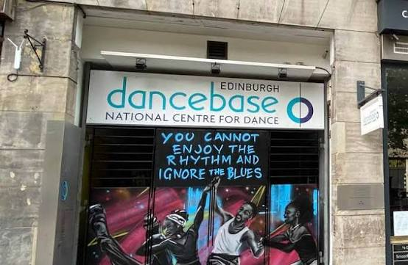 | Dance Base  14-16 Grassmarket  Edinburgh | All ages  Variety of dance class styles  Phone: 01312255525
 | Dance Discovery  FREE TRIALS - Leith | All ages  Phone 07926546862  Web: dancediscovery.co.uk
 | The Crags Centre  Basketball | Ages: Primary 4 - Adult  Email: hello@weplaytogether.scot
 | City of Edinburgh Basketball Club | All ages  Email: cityofedinburgh@gmail.com
 | BATS girls Rugby  Bangholm outdoor centre | Ages: Primary 1 – 18  Email: fraser@edinburghbatsrugby.co.uk
 | Hearts of Midlothian Swimming Club – supporting swimmers since 1885 | All ages  Email:secretary@swimhearts.com  Web:swimhearts.com/contact-us/
The Language Institute  EDINBURGH  (EAL) | English courses/Group Courses with opportunities to meet others. | All ages  Phone: 01312855539  Email: info@tlieurope.com
THE COOK ACADEMY | Cook and bake like a pro!  Teen classes.  Holiday clubs available | Address:  St George’s School Lower School, Coltbridge Terrace, Edinburgh, EH12 6BG  Web:https://www.thecookacademy.co.uk/location

