Youth Summit ‘26

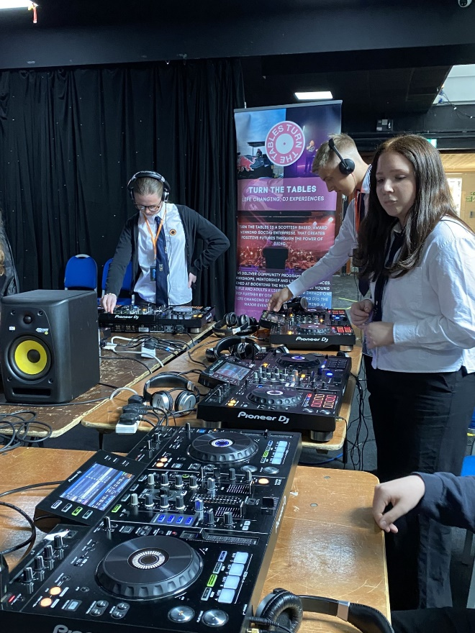
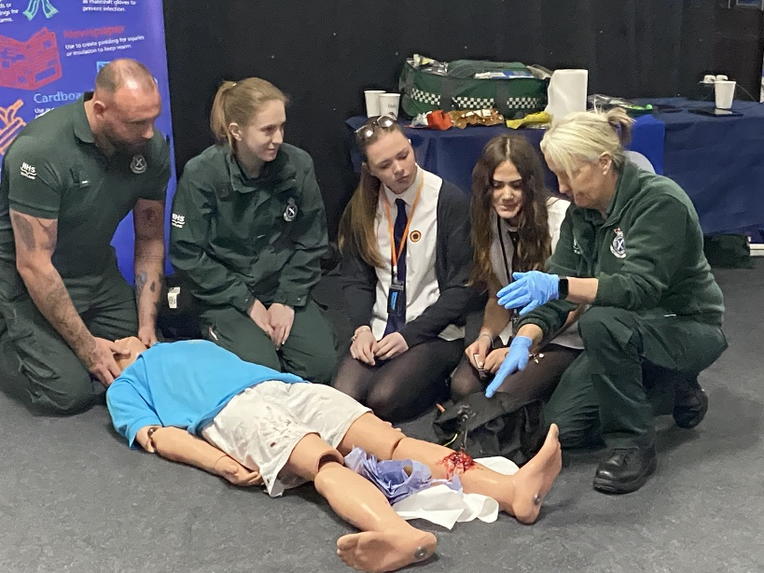
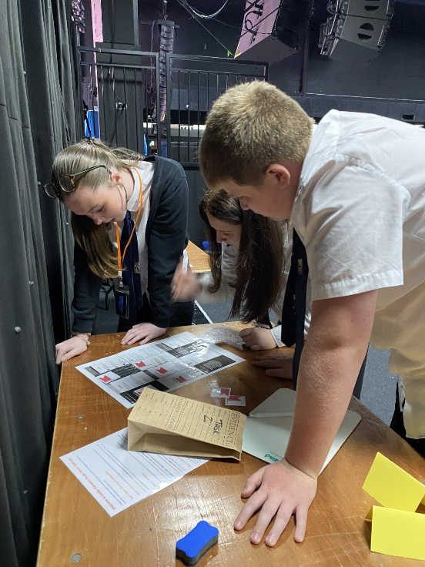
This was an incredible opportunity to learn a lot about safety and how to act responsibly as a young person. Sometimes public areas can be intimidating for teens and there are lots of potential dangers but yesterday really help prepare us for future situations and it also reinforced the expectations which the public might expect from a young person like me. I now feel ready to keep myself and others safe when I'm outside this summer.

Thanks to the Ambulance Service, Stellar Omada, Turn the Tables, Police Scotland, Fearless, Lothian Buses and many other organisations which ran such informative and helpful workshops.

Faye McCandless

